The Eﬀect of Benzo [A] Pyrene on Changes in the Proﬁle of CD11B + IL1 +, CD11B + IL17 +, CD4 + CD25 + in Mice (MUS
MUSCULUS, L) after Getting Paramicsovirus Vaccine
by Jurnal Scan

Submission date: 26-May-2021 11:35AM (UTC+0700)
Submission ID: 1594361697
File name: 11b--il1--cd11b--il17--cd4--cd25--in-mice-mus-musculus-l-aft.pdf (690.85K)
Word count: 3997
Character count: 20855

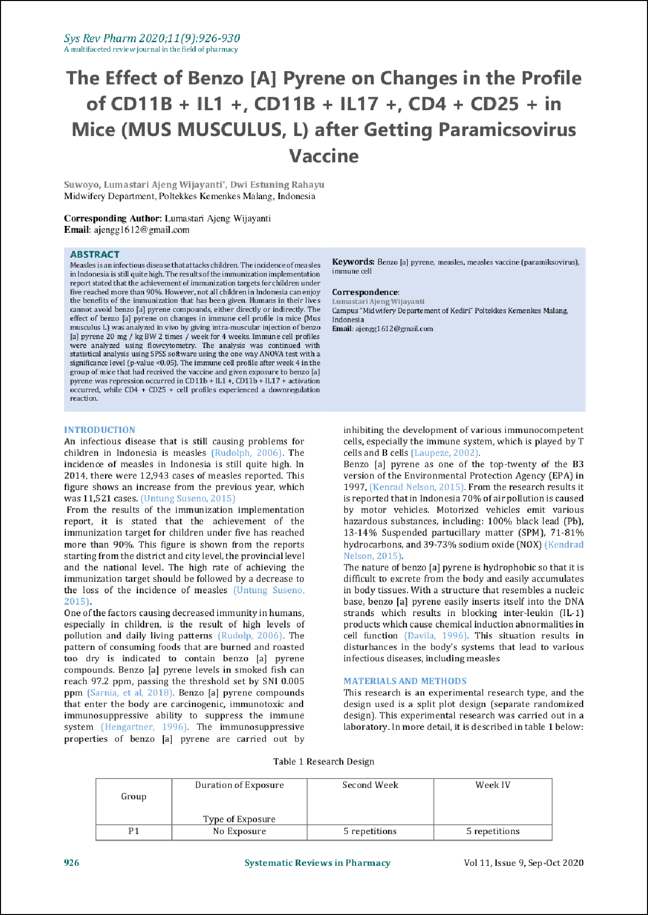
2

14
21
22

19

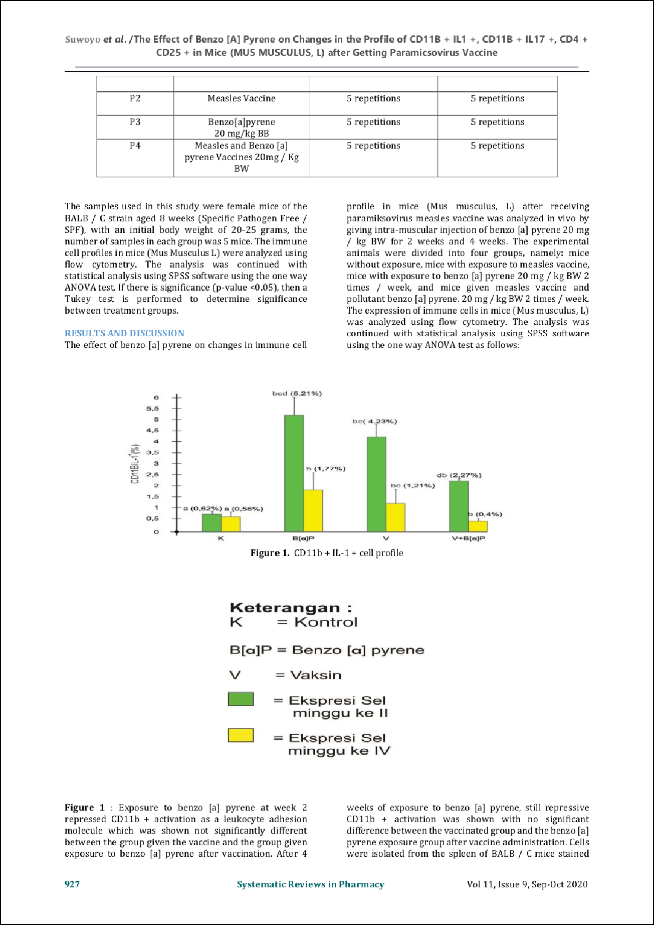
5

23

25

18

14

13

2

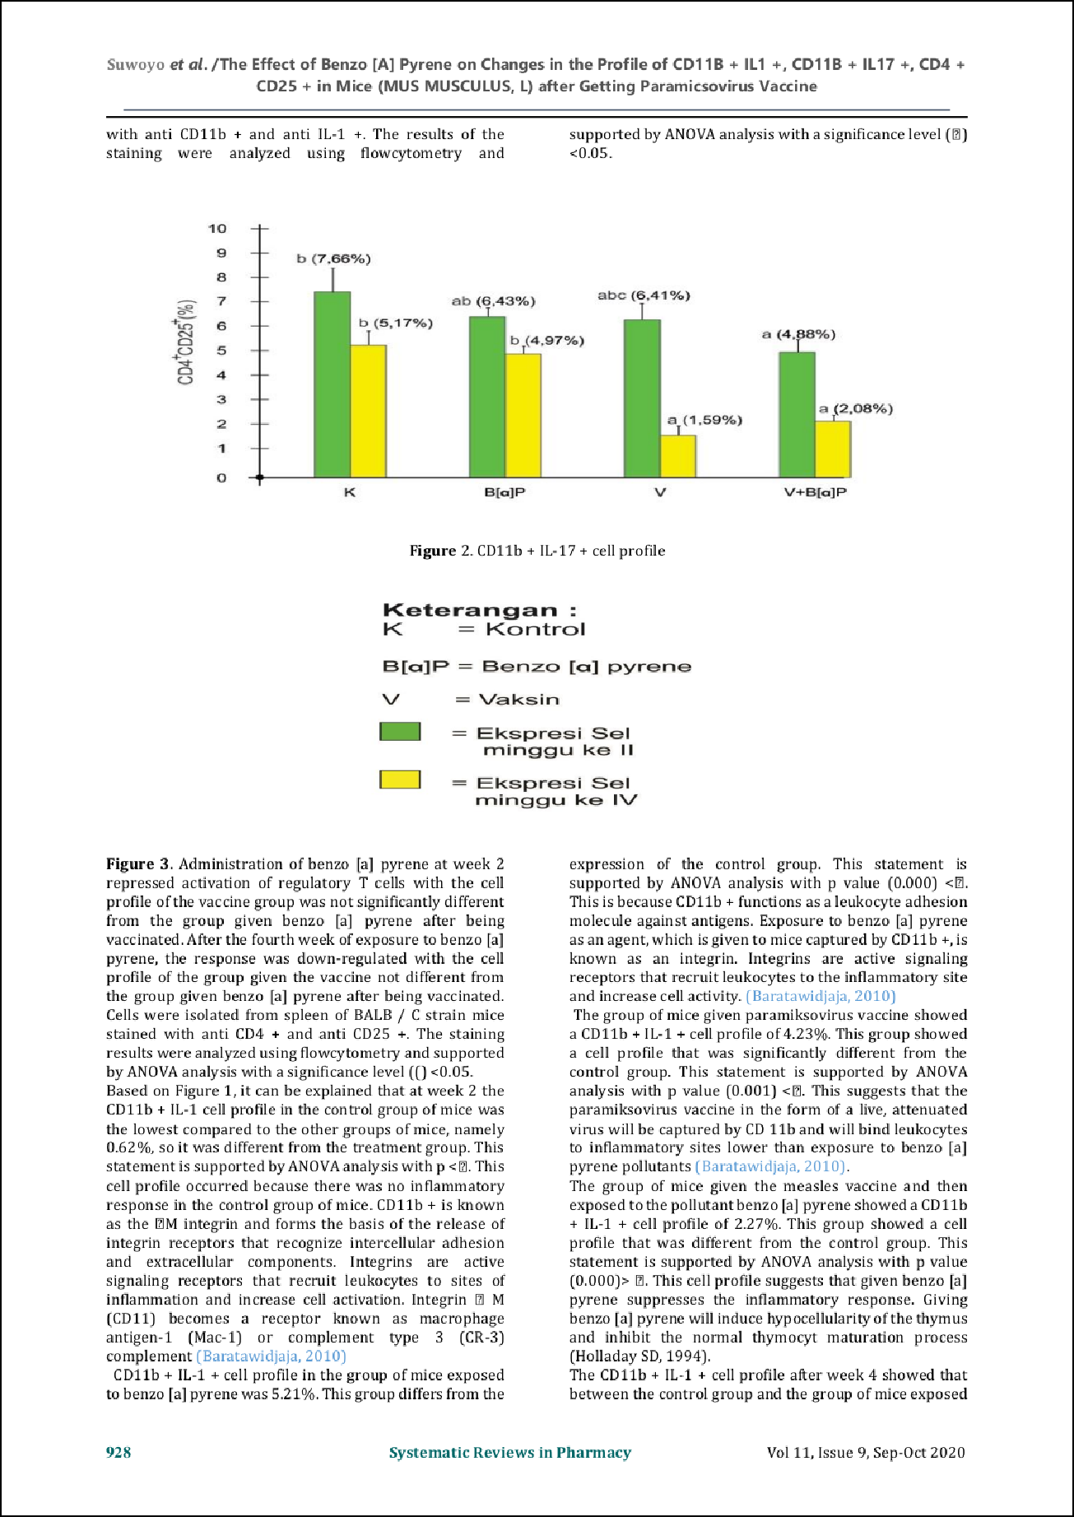
5

28

1

13

27

1

1

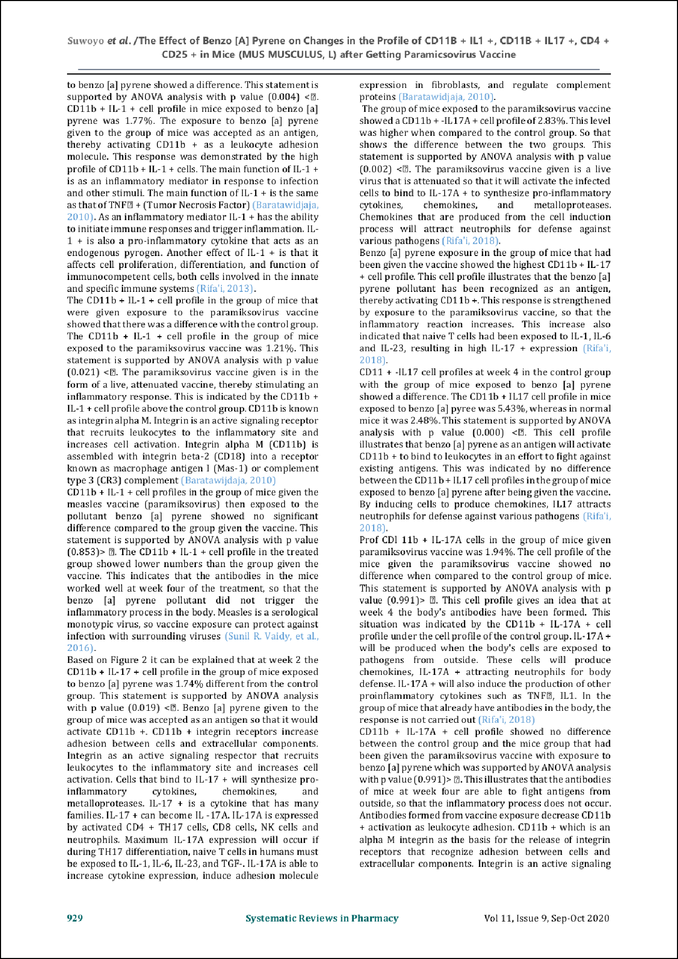
5

10

10

4

15
15

1

4

4

1
4

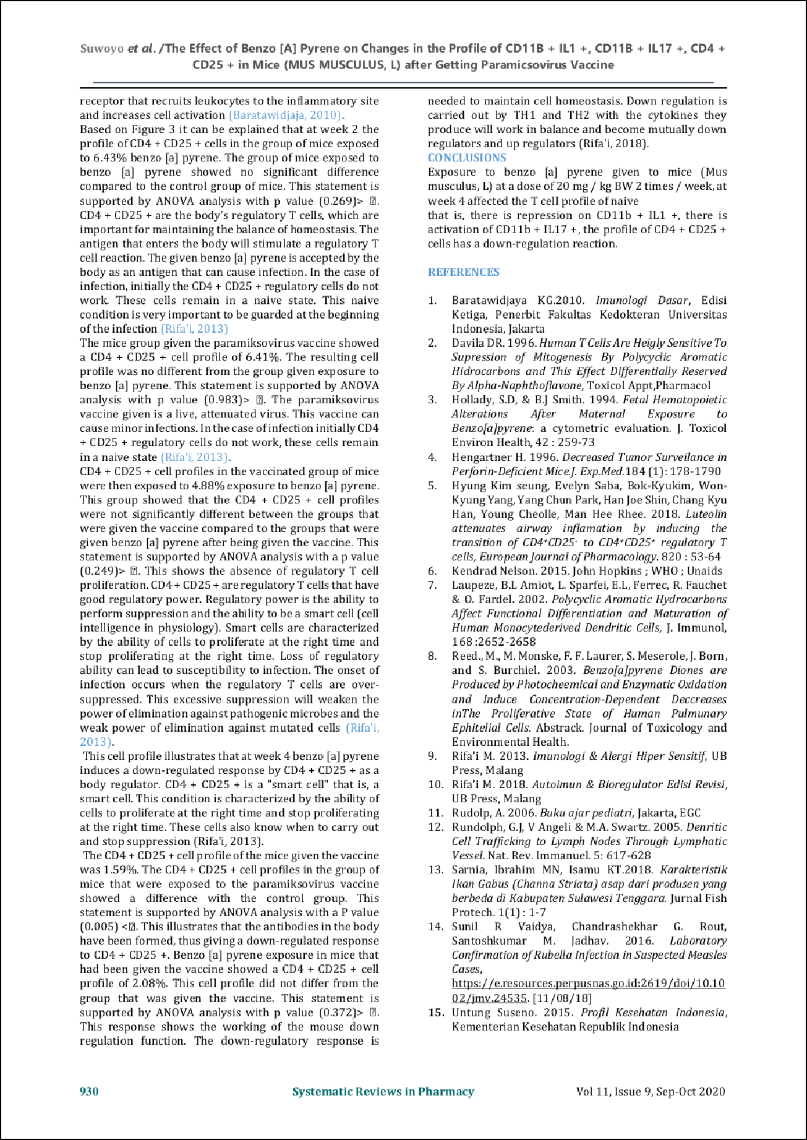
5

24
15
14
18

20
11

8

17
3

3
7

6

29

12

9

16

26

The Eﬀect of Benzo [A] Pyrene on Changes in the Proﬁle of CD11B + IL1 +, CD11B + IL17 +, CD4 + CD25 + in Mice (MUS
MUSCULUS, L) after Getting Paramicsovirus Vaccine
15
ORIGINALITY REPORT

%
SIMILARITY INDEX
10%
INTERNET SOURCES
10%
PUBLICATIONS
4%
STUDENT PAPERS

PRIMARY SOURCES
2
www.sigmaaldrich.com
Internet Source %
1
2

Submitted to Poltekkes Kemenkes Sorong
Student Paper %
2
1

onlinelibrary.wiley.com
Internet Source %
3
4
1%

Akdis, M.. "Interleukins, from 1 to 37, and interferon-@c: Receptors, functions, and roles in diseases", The Journal of Allergy and Clinical Immunology, 201103
Publication
1

www.ccme.ca
Internet Source %
5
1

jvi.asm.org
Internet Source %
6
1

www.jimmunol.org
Internet Source %
7

jimmunol.highwire.org
8
Internet Source

ejournal.uncen.ac.id
9
Internet Source

Submitted to October University for Modern Sciences and Arts (MSA)
10
Student Paper

documents.mx
11
Internet Source

Submitted to Miami University of Ohio
12
Student Paper

Dan, N., T. Kanai, T. Totsuka, R. Iiyama, M. Yamazaki, T. Sawada, T. Miyata, H. Yagita, K. Okumura, and M. Watanabe. "Ameliorating eﬀect of anti-Fas ligand MAb on wasting disease in murine model of chronic colitis", AJP Gastrointestinal and Liver Physiology, 2003.
13
Publication

De Jong, W.. "Detection of immunotoxicity of benzo[a]pyrene in a subacute toxicity study after oral exposure in rats", Toxicological Sciences, 1999.
14
Publication

Holladay, Steven, Terry Hrubec, and Benny Blaylock. "Developmental Immunotoxicity of
15
1%
1%
1%
1%
<1%
<1%

<1%

<1%

16

17

18

19

20

21
Halogenated Aromatic Hydrocarbons and Polycyclic Aromatic Hydrocarbons", Developmental Immunotoxicology, 2004.
Publication

Nalini Ramamurty, Duraisamy Raja, Palani Gunasekaran, Elango Varalakshmi, Sambasivam Mohana, Li Jin. "Investigation of measles and rubella outbreaks in Tamil Nadu, India—2003", Journal of Medical Virology, 2006
Publication

Submitted to The University of Manchester
Student Paper

Yu-Wei Guo, Yue-Hwa Chen, Wan-Chun Chiu, Hsiang Liao, Shyh-Hsiang Lin. " Soy Saponins Meditate the Progression of Colon Cancer in Rats by Inhibiting the Activity of - Glucuronidase and the Number of Aberrant Crypt Foci but Not Cyclooxygenase-2 Activity ", ISRN Oncology, 2013
Publication

repo-dosen.ulm.ac.id
Internet Source

repository.unair.ac.id
Internet Source

Xunyu Song, Yinghua Luo, Lingjun Ma, Xiaosong Hu, Jesus Simal-Gandara, Li-Shu

<1%

<1%
<1%

<1%
<1%
<1%

22

23

24

25

26

27
Wang, Vivek K. Bajpai, Jianbo Xiao, Fang Chen. "Recent trends and advances in the epidemiology, synergism, and delivery system of lycopene as an anti-cancer agent", Seminars in Cancer Biology, 2021
Publication

ﬁle.scirp.org
Internet Source

Rabinder N. Kurl, Karm C. Chaudhary, Claude
A. Villee. "Characterization and Control of Cytosolic Binding Proteins for 2,3,7,8- Tetrachlorodibenzo-p-Dioxin (TCDD) in the Rat Lung", Pharmacology, 1986
Publication

Sang-Ik Lee, Pung-Mi Hyun, Seung-Hyung Kim, Kyoung-Shin Kim, Sang-Keun Lee, Byoung-Soo Kim, Pil Jae Maeng, Jong-Soon Lim. "Suppression of the onset and progression of collagen-induced arthritis by chebulagic acid screened from a natural product library", Arthritis & Rheumatism, 2005
Publication

academic.oup.com
Internet Source

digilib.unila.ac.id
Internet Source

oehha.ca.gov
Internet Source

<1%
<1%

<1%

<1%
<1%

28

29

Marek Jutel, Mübeccel Akdis, Ferah Budak, Carmen Aebischer-Casaulta, Maria Wrzyszcz, Kurt Blaser, Cezmi A. Akdis. "IL-10 and TGF-β cooperate in the regulatory T cell response to mucosal allergens in normal immunity and speciﬁc immunotherapy", European Journal of Immunology, 2003
Publication

Peter P. Fu, Qingsu Xia, Xin Sun, Hongtao Yu. "Phototoxicity and Environmental Transformation of Polycyclic Aromatic Hydrocarbons (PAHs)—Light-Induced Reactive Oxygen Species, Lipid Peroxidation, and DNA Damage", Journal of Environmental Science and Health, Part C, 2012
Publication
<1%
<1%

<1%

Exclude quotes Oﬀ Exclude bibliography Oﬀ
Exclude matches Oﬀ

