Lampiran-lampiran

Lampiran 1
Formulir Penilaian Organoleptik
Uji Skala Kesukaan (Hedonik Scale Test)

Nama : .......................................................................................
Tanggal : .......................................................................................
Petunjuk : ......................................................................................
Dihadapan saudara disajikan produk makanan berupa siomay ikan. Saudara diminta untuk memberikan penilaian terhadap karakteristik mutu warna, aroma, tekstur, dan rasa dengan menggunakan skala penilaian sebagai berikut :
4 = Sangat Suka
3 = Suka
2 = Tidak Suka
1 = Sangat Tidak Suka
Kode Sampel | Skor Penilaian Kesukaan
 | Warna | Aroma | Tekstur | Rasa
102
222
427
532

Komentar :
................................................................................................................................................................................................................................................................................................................................................................................................

Lampiran 2
Formulasi Produk
Bahan | Energi dan Zat Gizi (100 gram bahan)
 | Energi | Protein | Lemak | KH
Tenggiri | 112 | 21.4 | 2.3 | 0
Lele | 158.9 | 16.3 | 10.4 | 0
Kelor | 92 | 6.8 | 1.7 | 12.5
Telur Ayam | 155.1 | 12.6 | 10.6 | 1.1
Labu Siam | 20.1 | 0.9 | 0.3 | 4.3
Tepung Sagu | 381 | 0.3 | 0.1 | 91.3
Gula Pasir | 387 | 0 | 0 | 99.9
Kulit Pangsit | 124 | 3.3 | 3.21 | 20.22

Tabel P0 (100:0:0)
Bahan | Berat | Energi dan Zat Gizi
 |  | Energi | Protein | Lemak | KH
Tenggiri | 166 | 185.92 | 35.52 | 3.82 | 0.00
Lele | 0 | 0.00 | 0.00 | 0.00 | 0.00
Kelor | 0 | 0.00 | 0.00 | 0.00 | 0.00
Telur Ayam | 60 | 93.06 | 7.56 | 6.36 | 0.66
Labu Siam | 133 | 26.73 | 1.20 | 0.40 | 5.72
Tepung Sagu | 133 | 506.73 | 0.40 | 0.13 | 121.43
Gula Pasir | 10 | 38.70 | 0.00 | 0.00 | 9.99
Kulit Pangsit | 60 | 74.40 | 1.98 | 1.93 | 12.13
Total | 562.00 | 925.54 | 46.66 | 12.64 | 149.93

Tabel P1 (15:70:15)
Bahan | Berat | Energi dan Zat Gizi
 |  | Energi | Protein | Lemak | KH
Tenggiri | 24.9 | 27.89 | 5.33 | 0.57 | 0.00
Lele | 116.2 | 184.64 | 18.94 | 12.08 | 0.00
Kelor | 24.9 | 22.91 | 1.69 | 0.42 | 3.11
Telur Ayam | 60 | 93.06 | 7.56 | 6.36 | 0.66
Labu Siam | 133 | 26.73 | 1.20 | 0.40 | 5.72
Tepung Sagu | 133 | 506.73 | 0.40 | 0.13 | 121.43
Gula Pasir | 10 | 38.70 | 0.00 | 0.00 | 9.99
Kulit Pangsit | 60 | 74.40 | 1.98 | 1.93 | 12.13
Total | 562.00 | 975.06 | 37.10 | 21.90 | 153.04

Tabel P2 (10:80:10)
Bahan | Berat | Energi dan Zat Gizi (per resep)
 |  | Energi | Protein | Lemak | KH
Tenggiri | 16.6 | 18.59 | 3.55 | 0.38 | 0.00
Lele | 132.8 | 211.02 | 21.65 | 13.81 | 0.00
Kelor | 16.6 | 15.27 | 1.13 | 0.28 | 2.08
Telur Ayam | 60 | 93.06 | 7.56 | 6.36 | 0.66
Labu Siam | 133 | 26.73 | 1.20 | 0.40 | 5.72
Tepung Sagu | 133 | 506.73 | 0.40 | 0.13 | 121.43
Gula Pasir | 10 | 38.70 | 0.00 | 0.00 | 9.99
Kulit Pangsit | 60 | 74.40 | 1.98 | 1.93 | 12.13
Total | 562.00 | 984.51 | 37.46 | 23.29 | 152.01

Tabel P3 (0:95:5)
Bahan | Berat | Energi dan Zat Gizi (per resep)
 |  | Energi | Protein | Lemak | KH
Tenggiri | 0 | 0.00 | 0.00 | 0.00 | 0.00
Lele | 157.7 | 250.59 | 25.71 | 16.40 | 0.00
Kelor | 8.3 | 7.64 | 0.56 | 0.14 | 1.04
Telur Ayam | 60 | 93.06 | 7.56 | 6.36 | 0.66
Labu Siam | 133 | 26.73 | 1.20 | 0.40 | 5.72
Tepung Sagu | 133 | 506.73 | 0.40 | 0.13 | 121.43
Gula Pasir | 10 | 38.70 | 0.00 | 0.00 | 9.99
Kulit Pangsit | 60 | 74.40 | 1.98 | 1.93 | 12.13
Total | 562.00 | 997.84 | 37.41 | 25.36 | 150.97

Lampiran 3. Formulir Penentuan Taraf Perlakuan Terbaik
PENENTUAN TARAF PERLAKUAN TERBAIK
Nama :
Produk : Substitusi Ikan Lele (Clarias Sp.) Dan Daun Kelor (Moringa Oleifera) Pada Siomay Ikan Tenggiri Sebagai Pemberian Makanan Tambahan (PMT) Pada Balita Gizi Kurang
Petunjuk :
Bapak/Ibu/Saudara dimohon untuk mengemukakan pendapat tentang urutan (ranking) pentingnya variabel berikut terhadap mutu produk Siomay subtitusi ikan lele dan daun kelor, dengan mengurutkan 10 variabel dari tertinggi ke terendah dengan mencantumkan angka 1 – 10. Angka terendah untuk variabel kurang penting dan angka tertinggi untuk variabel terpenting. Pemberian nilai boleh sama apabila dirasa variabel yang dinilai sama pentingnya.
Variabel | Ranking
Nilai Energi
Kadar Karbohidrat
Kadar Protein
Kadar Lemak
Kadar Air
Kadar Abu
Aroma
Warna
Rasa
Tekstur

Terimakasih atas partisipasinya ☺

Lampiran 4. Output SPSS Hasil Analisis Kadar Air Siomay
Kadar Air Siomay Ikan Lele pada Setiap Taraf Perlakuan
Taraf Perlakuan | Kadar Air
 | 1 | 2 | 3
P0 | 33,26 | 271,1 | 32,24
P1 | 25,94 | 34,26 | 33,33
P2 | 28,16 | 34,34 | 32,46
P3 | 31,78 | 32,39 | 33,72

Descriptives
Kadar_Air
 | N | Mean | Std. Deviation | Std. Error | 95% Confidence Interval for Mean |  | Minimum |  |  | Maximum
 |  |  |  |  | Lower Bound | Upper Bound
P0 | 3 | 30.8667 | 3.30166 | 1.90621 | 22.6649 | 39.0684 | 27.10 |  |  | 33.26
P1 | 3 | 31.1767 | 4.55886 | 2.63206 | 19.8518 | 42.5015 | 25.94 |  |  | 34.26
P2 | 3 | 31.6533 | 3.16799 | 1.82904 | 23.7836 | 39.5230 | 28.16 |  |  | 34.34
P3 | 3 | 32.6300 | .99202 | .57274 | 30.1657 | 35.0943 | 31.78 |  |  | 33.72
Total | 12 | 31.5817 | 2.87223 | .82914 | 29.7567 | 33.4066 | 25.94 |  |  | 34.34
Hasil Analisis Kadar Air Siomay Ikan Lele Substitusi Daun Kelor dengan Uji Oneway Anova pada Tingkat Kepercayaan 95%
ANOVA
Kadar_Air
 | Sum of Squares | Df | Mean Square | F | Sig.
Between Groups | 5.338 | 3 | 1.779 | .167 | .916
Within Groups | 85.409 | 8 | 10.676
Total | 90.747 | 11

Lampiran 5. Output SPSS Hasil Analisis Kadar Abu Siomay
Hasil Analisis Kadar Abu Siomay Ikan Lele
Taraf Perlakuan | Kadar Abu
 | 1 | 2 | 3
P0 | 0,86 | 1,54 | 0,91
P1 | 1,1 | 1,29 | 0,63
P2 | 1,18 | 1,06 | 0,41
P3 | 0,9 | 1,01 | 1,08

Hasil Analisis Kadar Abu Siomay Ikan Lele Substitusi Daun Kelor dengan Uji Oneway Anova pada Tingkat Kepercayaan 95%
Descriptives
Kadar_Abu
 | N | Mean | Std. Deviation | Std. Error | 95% Confidence Interval for Mean |  | Minimum |  |  | Maximum
 |  |  |  |  | Lower Bound | Upper Bound
P0 | 3 | 1.1033 | .37899 | .21881 | .1619 | 2.0448 | .86 |  |  | 1.54
P1 | 3 | 1.0067 | .33975 | .19616 | .1627 | 1.8507 | .63 |  |  | 1.29
P2 | 3 | .8833 | .41429 | .23919 | -.1458 | 1.9125 | .41 |  |  | 1.18
P3 | 3 | .9967 | .09074 | .05239 | .7713 | 1.2221 | .90 |  |  | 1.08
Total | 12 | .9975 | .29400 | .08487 | .8107 | 1.1843 | .41 |  |  | 1.54

ANOVA
Kadar_Abu
 | Sum of Squares | df | Mean Square | F | Sig.
Between Groups | .073 | 3 | .024 | .222 | .879
Within Groups | .878 | 8 | .110
Total | .951 | 11

Lampiran 6. Output SPSS Hasil Analisis Kadar Protein Siomay
Hasil Analisis Kadar Protein Siomay Ikan Lele
Taraf Perlakuan | Kadar Protein
 | 1 | 2 | 3
P0 | 3,12 | 4,02 | 4,88
P1 | 5,11 | 4,26 | 4,54
P2 | 5,33 | 5,57 | 4,56
P3 | 6,24 | 5,22 | 6,24

Hasil Analisis Kadar Protein Siomay Ikan Lele Substitusi Daun Kelor dengan Uji Oneway Anova pada Tingkat Kepercayaan 95%
Descriptives
Kadar_Protein
 | N | Mean | Std. Deviation | Std. Error | 95% Confidence Interval for Mean |  | Minimum | Maximum
 |  |  |  |  | Lower Bound | Upper Bound
P0 | 3 | 4.0067 | .88008 | .50811 | 1.8204 | 6.1929 | 3.12 | 4.88
P1 | 3 | 4.6367 | .43317 | .25009 | 3.5606 | 5.7127 | 4.26 | 5.11
P2 | 3 | 5.1533 | .52767 | .30465 | 3.8425 | 6.4641 | 4.56 | 5.57
P3 | 3 | 5.8900 | .58043 | .33511 | 4.4481 | 7.3319 | 5.22 | 6.24
Total | 12 | 4.9217 | .89870 | .25943 | 4.3507 | 5.4927 | 3.12 | 6.24

ANOVA
Kadar_Protein
 | Sum of Squares | df | Mean Square | F | Sig.
Between Groups | 5.729 | 3 | 1.910 | 4.843 | .033
Within Groups | 3.155 | 8 | .394
Total | 8.884 | 11

Hasil Analisis Lanjut Kadar Protein Siomay Ikan Lele dengan Duncan Multiple Random Test (DMRT) pada Tingkat Kepercayaan 95%
Perlakuan | N | Subset for alpha = 0.05
 |  | 1 | 2
0 | 3 | 4.0067
1 | 3 | 4.6367
2 | 3 | 5.1533 | 5.1533
3 | 3 |  | 5.8900
Sig. |  | .064 | .189
Means for groups in homogeneous subsets are displayed.

Lampiran 7. Output SPSS Hasil Analisis Kadar Lemak Siomay
Hasil Analisis Kadar Lemak Siomay Ikan Lele
Taraf Perlakuan | Kadar Lemak
 | 1 | 2 | 3
P0 | 1,88 | 2,01 | 1,71
P1 | 1,53 | 2,04 | 2,49
P2 | 2,29 | 2,31 | 1,52
P3 | 1,65 | 1,59 | 2,03

Hasil Analisis Kadar Lemak Siomay Ikan Lele Substitusi Daun Kelor dengan Uji Oneway Anova pada Tingkat Kepercayaan 95%
Descriptives
Kadar_Lemak
 | N | Mean | Std. Deviation | Std. Error | 95% Confidence Interval for Mean |  | Minimum |  |  | Maximum
 |  |  |  |  | Lower Bound | Upper Bound
P0 | 3 | 1.8667 | .15044 | .08686 | 1.4929 | 2.2404 | 1.71 |  |  | 2.01
P1 | 3 | 2.0200 | .48031 | .27731 | .8268 | 3.2132 | 1.53 |  |  | 2.49
P2 | 3 | 2.0400 | .45044 | .26006 | .9210 | 3.1590 | 1.52 |  |  | 2.31
P3 | 3 | 1.7567 | .23861 | .13776 | 1.1639 | 2.3494 | 1.59 |  |  | 2.03
Total | 12 | 1.9208 | .32865 | .09487 | 1.7120 | 2.1296 | 1.52 |  |  | 2.49

ANOVA
Kadar_Lemak
 | Sum of Squares | df | Mean Square | F | Sig.
Between Groups | .162 | 3 | .054 | .420 | .744
Within Groups | 1.026 | 8 | .128
Total | 1.188 | 11

Lampiran 8. Output SPSS Hasil Analisis Kadar Karbohidrat Siomay
Hasil Analisis Kadar Karbohidrat Siomay Ikan Lele
Taraf Perlakuan | Kadar Abu
 | 1 | 2 | 3
P0 | 60,88 | 65,33 | 60,26
P1 | 66,32 | 58,15 | 59,01
P2 | 63,04 | 56,72 | 61,05
P3 | 59,46 | 59,79 | 56,93

Hasil Analisis Kadar Karbohidrat Siomay Ikan Lele Substitusi Daun Kelor dengan Uji Oneway Anova pada Tingkat Kepercayaan 95%

Descriptives
Karbohidrat
 | N | Mean | Std. Deviation | Std. Error | 95% Confidence Interval for Mean |  |  | Minimum | Maximum
 |  |  |  |  | Lower Bound | Upper Bound
P0 | 3 | 62.1567 | 2.76562 | 1.59673 | 55.2865 | 69.0268 |  | 60.26 | 65.33
P1 | 3 | 61.1600 | 4.48933 | 2.59192 | 50.0079 | 72.3121 |  | 58.15 | 66.32
P2 | 3 | 60.2700 | 3.23139 | 1.86565 | 52.2428 | 68.2972 |  | 56.72 | 63.04
P3 | 3 | 58.7267 | 1.56468 | .90337 | 54.8398 | 62.6136 |  | 56.93 | 59.79
Total | 12 | 60.5783 | 3.02182 | .87232 | 58.6584 | 62.4983 |  | 56.72 | 66.32

ANOVA
Karbohidrat
 | Sum of Squares | df | Mean Square | F | Sig.
Between Groups | 19.060 | 3 | 6.353 | .625 | .619
Within Groups | 81.386 | 8 | 10.173
Total | 100.445 | 11

Lampiran 9. Hasil Analisis Energi Siomay Ikan Lele
Taraf Perlakuan | Nilai Energi
 | 1 | 2 | 3
P0 | 272,92 | 295,49 | 275,95
P1 | 299,49 | 268 | 276,61
P2 | 294,09 | 269,95 | 276,12
P3 | 277,53 | 274,35 | 270,95

Descriptives
Energi
 | N | Mean | Std. Deviation | Std. Error | 95% Confidence Interval for Mean |  | Minimum |  |  | Maximum
 |  |  |  |  | Lower Bound | Upper Bound
P0 | 3 | 2.8145E2 | 12.25015 | 7.07263 | 251.0223 | 311.8844 | 272.92 |  |  | 295.49
P1 | 3 | 2.8137E2 | 16.27496 | 9.39635 | 240.9374 | 321.7959 | 268.00 |  |  | 299.49
P2 | 3 | 2.8005E2 | 12.54146 | 7.24082 | 248.8986 | 311.2080 | 269.95 |  |  | 294.09
P3 | 3 | 2.7428E2 | 3.29061 | 1.89984 | 266.1023 | 282.4510 | 270.95 |  |  | 277.53
Total | 12 | 2.7929E2 | 10.74599 | 3.10210 | 272.4598 | 286.1152 | 268.00 |  |  | 299.49

ANOVA
Energi
 | Sum of Squares | df | Mean Square | F | Sig.
Between Groups | 104.126 | 3 | 34.709 | .238 | .867
Within Groups | 1166.114 | 8 | 145.764
Total | 1270.240 | 11

Lampiran 10. Output SPSS Hasil Analisis Mutu Organoleptik Warna Siomay
Hasil Analisis Mutu Organoleptik Warna Siomay Ikan Lele Substitusi Daun Kelor
Panelis | Taraf Perlakuan
 | P0 | P1 | P2 | P3
1 | 4 | 4 | 4 | 4
2 | 2 | 2 | 4 | 4
3 | 4 | 3 | 3 | 3
4 | 3 | 2 | 2 | 2
5 | 3 | 3 | 3 | 3
6 | 4 | 4 | 4 | 4
7 | 3 | 4 | 3 | 4
8 | 3 | 3 | 4 | 3
9 | 3 | 3 | 4 | 3
10 | 4 | 3 | 2 | 3
11 | 3 | 3 | 4 | 4
12 | 2 | 3 | 4 | 3
13 | 3 | 3 | 3 | 3
14 | 4 | 3 | 2 | 3
15 | 2 | 2 | 3 | 3
16 | 4 | 2 | 1 | 2
17 | 4 | 4 | 4 | 4
18 | 3 | 4 | 2 | 4
19 | 3 | 3 | 3 | 4
20 | 4 | 3 | 3 | 3
Jumlah | 65 | 61 | 62 | 66
Modus | 3 | 3 | 4 | 3
Rata-Rata | 3.25 | 3.05 | 3.1 | 3.3
Tingkat Penerimaan (100%) | 85 | 80 | 75 | 90

Hasil Analisis Tingkat Kesukaan terhadap Warna Siomay Ikan Lele Substitusi Daun Kelor dengan Uji Kruskal-Wallis pada Tingkat Kepercayaan 95%
Descriptive Statistics
 | N | Mean | Std. Deviation | Minimum | Maximum
Warna | 80 | 3.1750 | .74247 | 1.00 | 4.00
Taraf_Perlakuan | 80 | 1.5000 | 1.12509 | .00 | 3.00

Ranks
 | Taraf_Perlakuan |  |  | N | Mean Rank
Warna | 0 |  |  | 20 | 42.45
 | 1 |  |  | 20 | 36.25
 | 2 |  |  | 20 | 39.60
 | 3 |  |  | 20 | 43.70
 | Total |  |  | 80
Test Statistics^{a,b}
 |  | Warna
Chi-Square |  | 1.435
Df |  | 3
Asymp. Sig. |  | .697
a. Kruskal Wallis Test
b. Grouping Variable: Taraf_Perlakuan

Lampiran 11. Output SPSS Hasil Analisis Mutu Organoleptik Rasa Siomay
Hasil Analisis Mutu Organoleptik Rasa Siomay Ikan Tenggiri Substitusi Ikan Lele Dan Daun Kelor
Panelis | Taraf Perlakuan
 | P0 | P1 | P2 | P3
1 | 4 | 3 | 3 | 3
2 | 2 | 2 | 3 | 3
3 | 2 | 2 | 2 | 2
4 | 3 | 3 | 3 | 4
5 | 3 | 2 | 2 | 2
6 | 4 | 2 | 2 | 3
7 | 3 | 3 | 3 | 2
8 | 2 | 3 | 4 | 3
9 | 2 | 3 | 4 | 3
10 | 3 | 1 | 2 | 2
11 | 2 | 2 | 3 | 2
12 | 3 | 4 | 4 | 4
13 | 1 | 3 | 3 | 2
14 | 3 | 2 | 2 | 3
15 | 2 | 1 | 3 | 4
16 | 3 | 3 | 2 | 3
17 | 3 | 4 | 3 | 4
18 | 2 | 4 | 4 | 2
19 | 3 | 2 | 4 | 2
20 | 3 | 2 | 1 | 3
Jumlah | 53 | 51 | 57 | 56
Modus | 3 | 2 | 3 | 2,3
Rata-Rata | 2.65 | 2.55 | 2.85 | 2.8
Tingkat Penerimaan (100%) | 65 | 50 | 65 | 60

Hasil Analisis Tingkat Kesukaan terhadap Aroma Siomay Ikan Lele Substitusi Daun Kelor dengan Uji Kruskal-Wallis pada Tingkat Kepercayaan 95%
Descriptive Statistics
 |  | N |  |  | Mean | Std. Deviation |  | Minimum | Maximum
Rasa |  | 80 |  |  | 2.7125 | .81433 |  | 1.00 | 4.00
Taraf_Perlakuan |  | 80 |  |  | 1.5000 | 1.12509 |  | .00 | 3.00
Ranks
 | Taraf_Perlakuan |  | N | Mean Rank
Rasa | 0 |  | 20 | 39.12
 | 1 |  | 20 | 36.38
 | 2 |  | 20 | 44.20
 | 3 |  | 20 | 42.30
 | Total |  | 80

Test Statistics^{a,b}
 | Rasa
Chi-Square | 1.514
Df | 3
Asymp. Sig. | .679
a. Kruskal Wallis Test
b. Grouping Variable: Taraf_Perlakuan

Lampiran 12. Output SPSS Hasil Analisis Mutu Organoleptik Aroma Siomay
Hasil Analisis Mutu Organoleptik Aroma Siomay Ikan Lele Substitusi Daun Kelor
Panelis | Taraf Perlakuan
 | P0 | P1 | P2 | P3
1 | 2 | 4 | 4 | 2
2 | 3 | 4 | 3 | 3
3 | 2 | 3 | 2 | 4
4 | 4 | 3 | 3 | 3
5 | 4 | 3 | 3 | 3
6 | 3 | 3 | 3 | 3
7 | 3 | 4 | 3 | 3
8 | 2 | 3 | 4 | 2
9 | 2 | 3 | 4 | 2
10 | 4 | 3 | 3 | 3
11 | 2 | 2 | 4 | 4
12 | 2 | 3 | 4 | 4
13 | 2 | 3 | 3 | 3
14 | 4 | 4 | 4 | 4
15 | 2 | 3 | 3 | 4
16 | 3 | 3 | 2 | 2
17 | 4 | 4 | 4 | 4
18 | 3 | 4 | 2 | 3
19 | 3 | 4 | 4 | 2
20 | 4 | 2 | 2 | 4
Jumlah | 58 | 65 | 64 | 62
Modus | 2 | 3 | 3,4 | 3
Rata-Rata | 2.9 | 3.25 | 3.2 | 3.1
Tingkat Penerimaan (100%) | 60 | 90 | 80 | 75

Hasil Analisis Tingkat Kesukaan terhadap Aroma Siomay Ikan Lele Substitusi Daun Kelor dengan Uji Kruskal-Wallis pada Tingkat Kepercayaan 95%
Descriptive Statistics
 | N | Mean | Std. Deviation | Minimum | Maximum
Aroma | 80 | 3.1125 | .76297 | 2.00 | 4.00
Taraf_Perlakuan | 80 | 1.5000 | 1.12509 | .00 | 3.00

Ranks
 | Taraf_Perlakuan | N | Mean Rank
Aroma | 0 | 20 | 34.75
 | 1 | 20 | 44.08
 | 2 | 20 | 43.00
 | 3 | 20 | 40.18
 | Total | 80

Test Statistics^{a,b}
 | Aroma
Chi-Square | 2.213
Df | 3
Asymp. Sig. | .529
a. Kruskal Wallis Test
b. Grouping Variable: Taraf_Perlakuan

Lampiran 13. Output SPSS Hasil Analisis Mutu Organoleptik Tekstur Siomay
Hasil Analisis Mutu Organoleptik Tekstur Siomay Ikan Lele Substitusi Daun Kelor
Panelis | Taraf Perlakuan
 | P0 | P1 | P2 | P3
1 | 4 | 4 | 2 | 4
2 | 4 | 4 | 4 | 4
3 | 3 | 3 | 3 | 4
4 | 4 | 3 | 2 | 4
5 | 4 | 2 | 2 | 2
6 | 4 | 3 | 2 | 3
7 | 3 | 4 | 4 | 3
8 | 3 | 3 | 4 | 3
9 | 3 | 3 | 4 | 3
10 | 3 | 4 | 3 | 4
11 | 4 | 3 | 4 | 4
12 | 4 | 3 | 4 | 3
13 | 2 | 3 | 3 | 2
14 | 3 | 3 | 3 | 3
15 | 2 | 1 | 3 | 2
16 | 4 | 4 | 4 | 4
17 | 3 | 4 | 4 | 4
18 | 3 | 3 | 2 | 3
19 | 3 | 4 | 3 | 3
20 | 3 | 3 | 3 | 3
Jumlah | 66 | 64 | 63 | 65
Modus | 3 | 3 | 4 | 3
Rata-Rata | 3.3 | 3.2 | 3.15 | 3.25
Tingkat Penerimaan (100%) | 90 | 90 | 75 | 85

Hasil Analisis Tingkat Kesukaan terhadap Aroma Siomay Ikan Lele Substitusi Daun Kelor dengan Uji Kruskal-Wallis pada Tingkat Kepercayaan 95%

 | N | Mean | Std. Deviation | Minimum | Maximum
Tekstur | 80 | 3.2250 | .72871 | 1.00 | 4.00
Taraf_Perlakuan | 80 | 1.5000 | 1.12509 | .00 | 3.00

Ranks
 | Taraf_Perlakuan | N | Mean Rank
Tekstur | 0 | 20 | 42.20
 | 1 | 20 | 40.20
 | 2 | 20 | 38.60
 | 3 | 20 | 41.00
 | Total | 80

Test Statistics^{a,b}
 | Tekstur
Chi-Square | .301
df | 3
Asymp. Sig. | .960
a. Kruskal Wallis Test
b. Grouping Variable: Taraf_Perlakuan

Lampiran 14. Hasil Penentuan Taraf Perlakuan Terbaik
Variabel | Panelis |  |  |  |  |  |  |  |  |  | Jumlah | Rata-rata | Ranking | BV | BN
 | 1 | 2 | 3 | 4 | 5 | 6 | 7 | 8 | 9 | 10
Nilai Energi | 10 | 9 | 9 | 10 | 10 | 3 | 9 | 10 | 10 | 10 | 90 | 9 | 1 | 1.00 | 0.13
Kadar Air | 5 | 3 | 5 | 9 | 3 | 2 | 2 | 2 | 8 | 4 | 43 | 4.3 | 9 | 0.48 | 0.06
Kadar Abu | 4 | 4 | 5 | 9 | 2 | 1 | 1 | 1 | 8 | 3 | 38 | 3.8 | 10 | 0.42 | 0.06
Kadar Karbohidrat | 9 | 8 | 6 | 9 | 8 | 4 | 5 | 8 | 10 | 8 | 75 | 7.5 | 4 | 0.83 | 0.11
Kadar Protein | 10 | 10 | 10 | 10 | 9 | 6 | 4 | 9 | 10 | 7 | 85 | 8.5 | 2 | 0.94 | 0.12
Kadar Lemak | 9 | 7 | 5 | 9 | 7 | 5 | 3 | 7 | 10 | 6 | 68 | 6.8 | 6 | 0.76 | 0.10
Aroma | 8 | 6 | 7 | 10 | 6 | 9 | 6 | 5 | 9 | 6 | 72 | 7.2 | 5 | 0.80 | 0.11
Warna | 6 | 6 | 7 | 9 | 5 | 8 | 7 | 4 | 9 | 6 | 67 | 6.7 | 7 | 0.74 | 0.10
Rasa | 8 | 5 | 8 | 10 | 10 | 10 | 10 | 6 | 9 | 5 | 81 | 8.1 | 3 | 0.90 | 0.12
Tekstur | 7 | 5 | 8 | 9 | 4 | 7 | 8 | 3 | 9 | 5 | 65 | 6.5 | 8 | 0.72 | 0.10

Lampiran 15. Perhitungan Ne dan Nh pada Setiap Taraf Perlakuan
No | Variabel | Bobot Variabel | Bobot Normal | Taraf Perlakuan
 |  |  |  | P0 |  | P1 |  | P2 |  | P3
 |  |  |  | Ne | Nh | Ne | Nh | Ne | Nh | Ne | Nh
1 | Nilai Energi | 1.00 | 0.13 | 1.05 | 0.14 | 0.38 | 0.05 | 0.45 | 0.06 | 0.40 | 0.05
2 | Kadar Air | 0.48 | 0.06 | 0.57 | 0.04 | 0.63 | 0.04 | 0.57 | 0.04 | 0.50 | 0.03
3 | Kadar Abu | 0.42 | 0.06 | 0.30 | 0.02 | 0.57 | 0.03 | 0.61 | 0.03 | 0.60 | 0.03
4 | Kadar Karbohidrat | 0.83 | 0.11 | 0.96 | 0.10 | 0.49 | 0.05 | 0.43 | 0.05 | 0.46 | 0.05
5 | Kadar Protein | 0.94 | 0.03 | 0.33 | 0.01 | 0.44 | 0.01 | 0.59 | 0.02 | 0.70 | 0.02
6 | Kadar Lemak | 0.76 | 0.10 | 0.45 | 0.05 | 0.51 | 0.05 | 0.66 | 0.07 | 0.45 | 0.05
7 | Aroma | 0.80 | 0.11 | 0.00 | 0.00 | 1.00 | 0.11 | 0.88 | 0.09 | 0.61 | 0.06
8 | Warna | 0.74 | 0.10 | 0.75 | 0.07 | 0.00 | 0.00 | 0.45 | 0.04 | 1.10 | 0.11
9 | Rasa | 0.90 | 0.12 | 0.30 | 0.04 | 0.00 | 0.00 | 1.00 | 0.12 | 0.82 | 0.10
10 | Tekstur | 0.72 | 0.09 | 0.90 | 0.09 | 0.44 | 0.04 | 0.00 | 0.00 | 0.67 | 0.06
 |  | 7.59 |  |  | 0.55 |  | 0.39 |  | 0.51 |  | 0.57

Lampiran. 16 Hasil Analisis Proksimat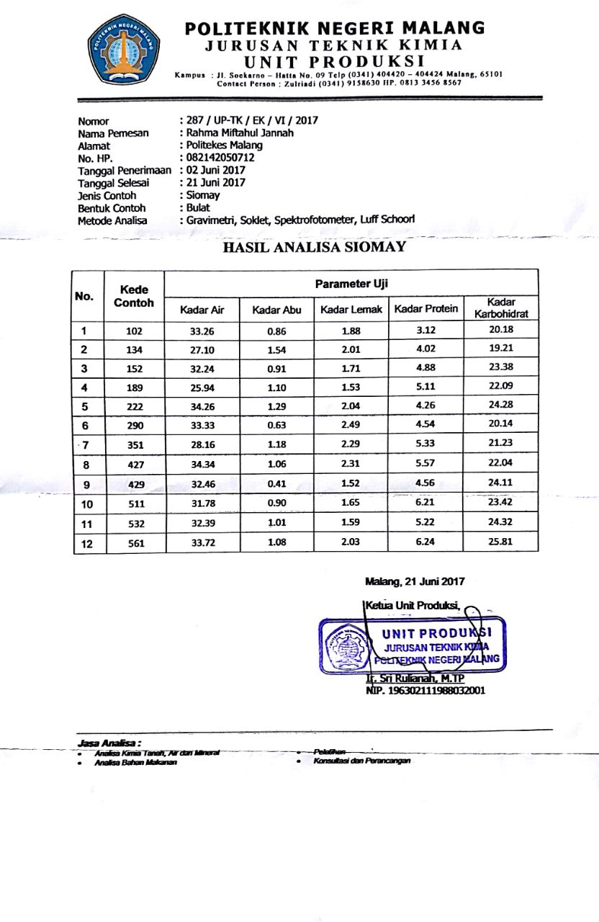
Lampiran. 17 Dokumentasi
- Penimbangan
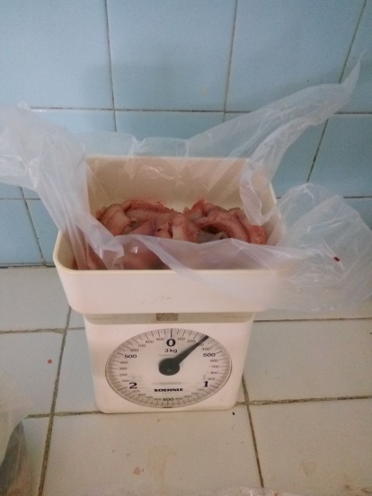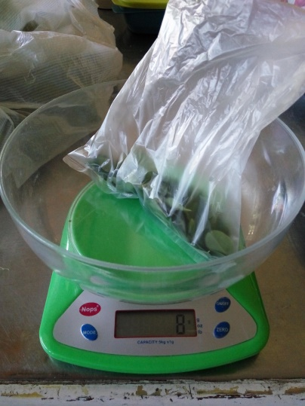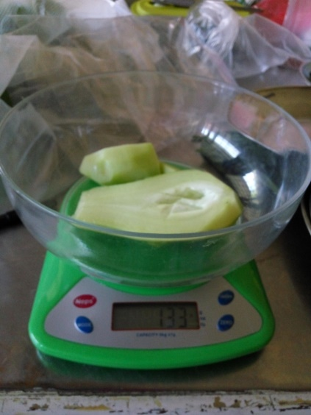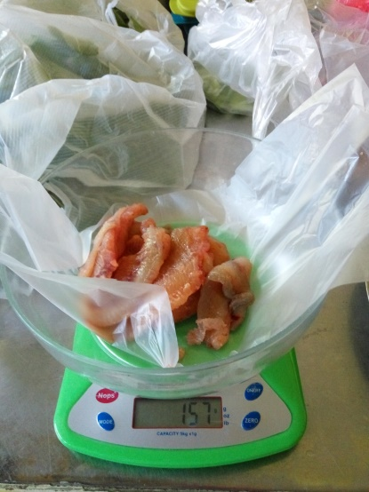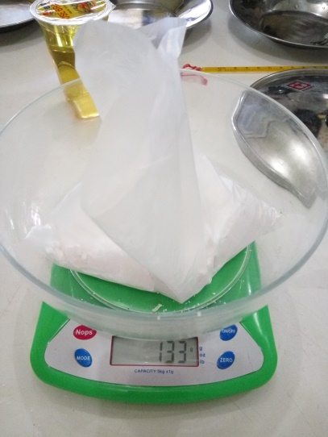

- Pengolahan
