LAMPIRAN
Lampiran 1
Surat Izin Penelitian dari Poltekkes Kemenkes Malang
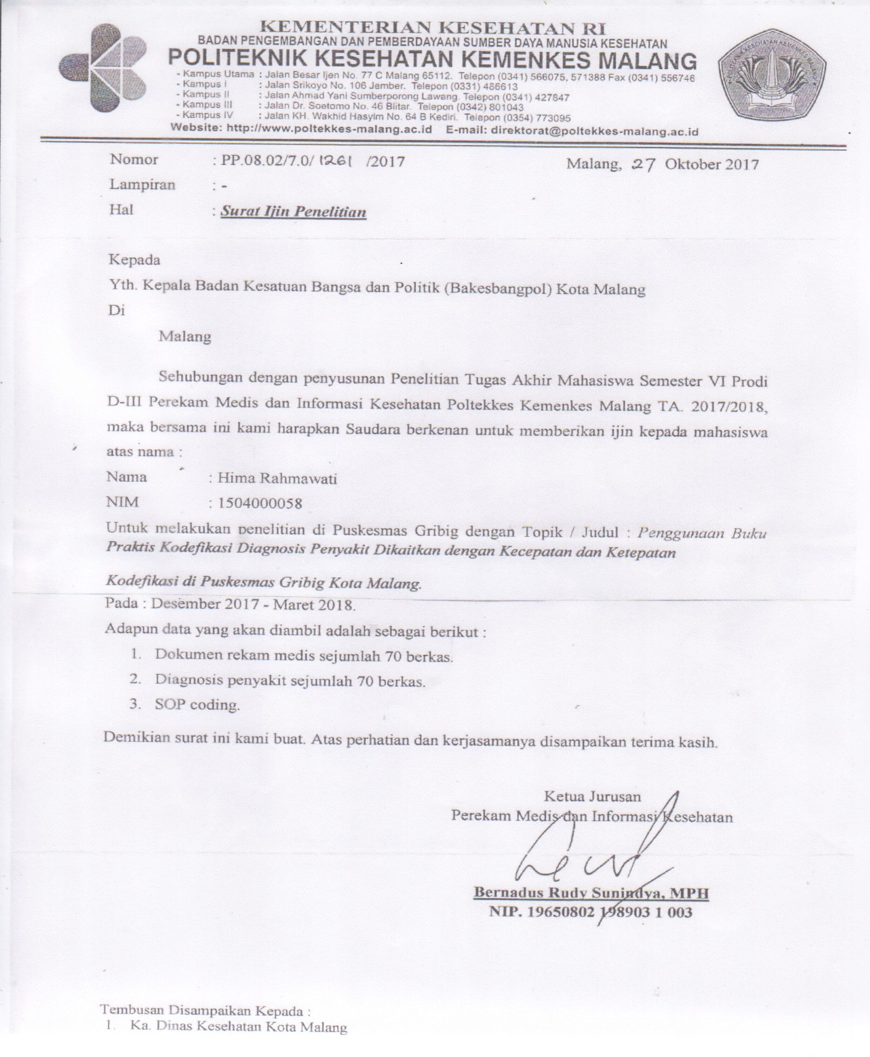
Lampiran 2
Surat Rekomendasi Pelaksanaan Penelitian oleh Badan Kesatuan
Bangsa dan Politik
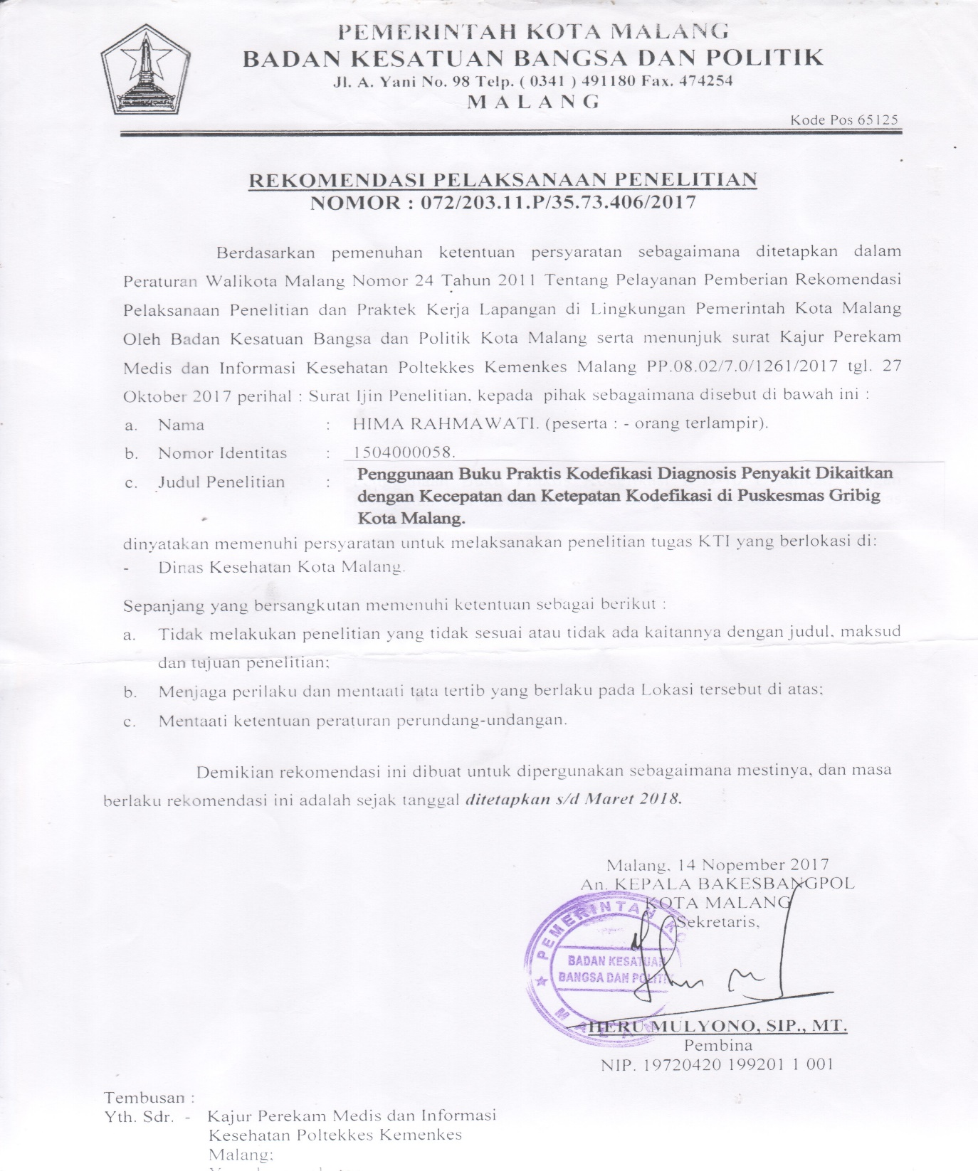
Lampiran 3
Surat Izin Penelitian dari Dinas Kesehatan Kota Malang
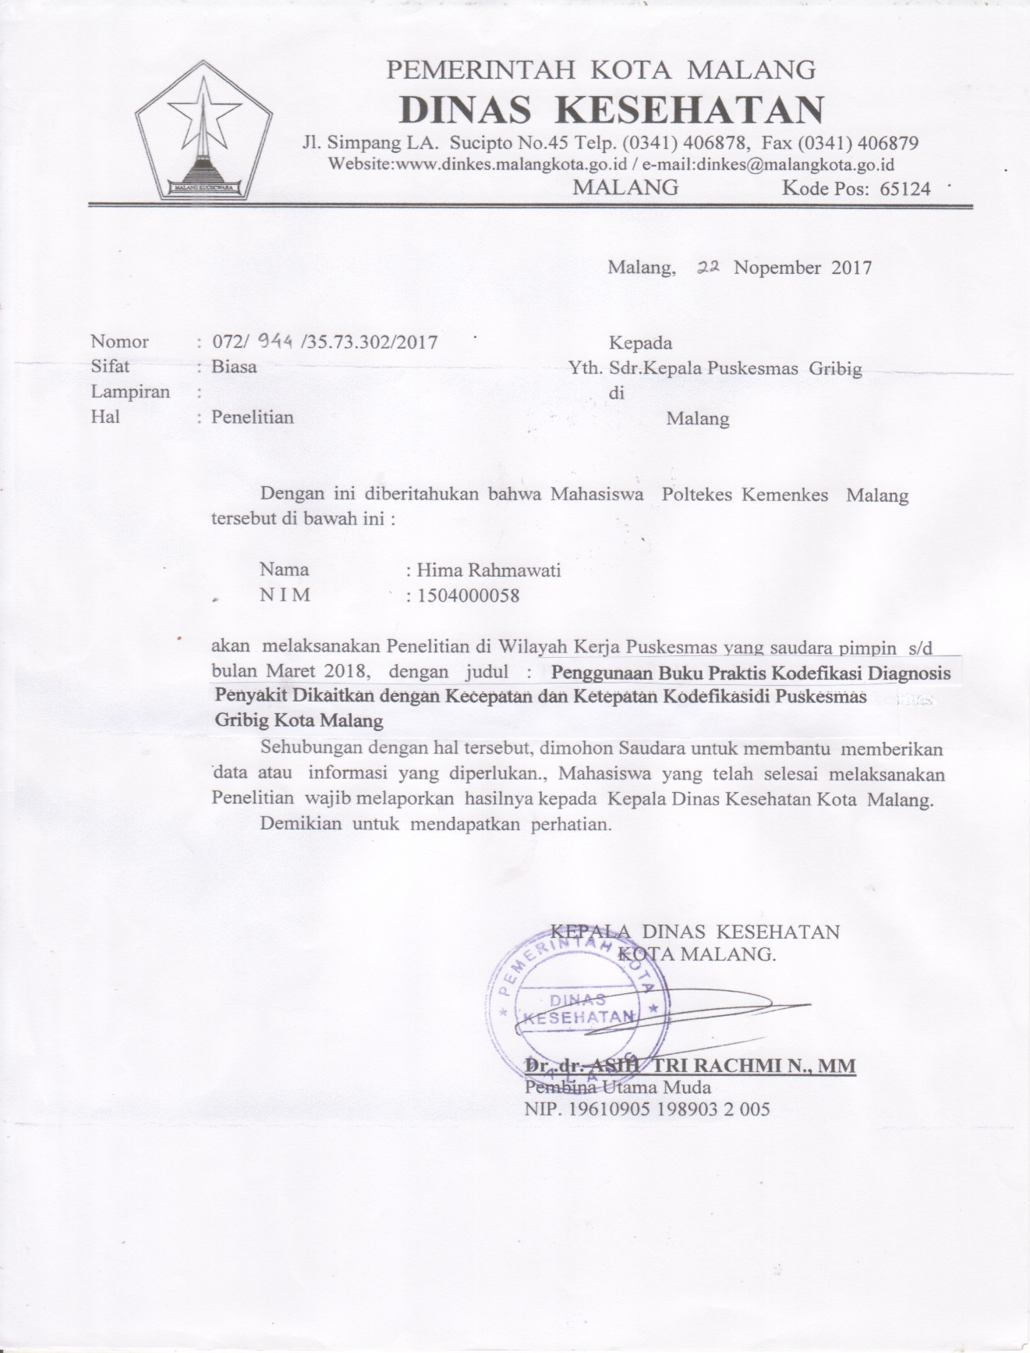
Lampiran 4
Persetujuan Kesediaan Menjadi Responden Penelitian (Informed Consent)
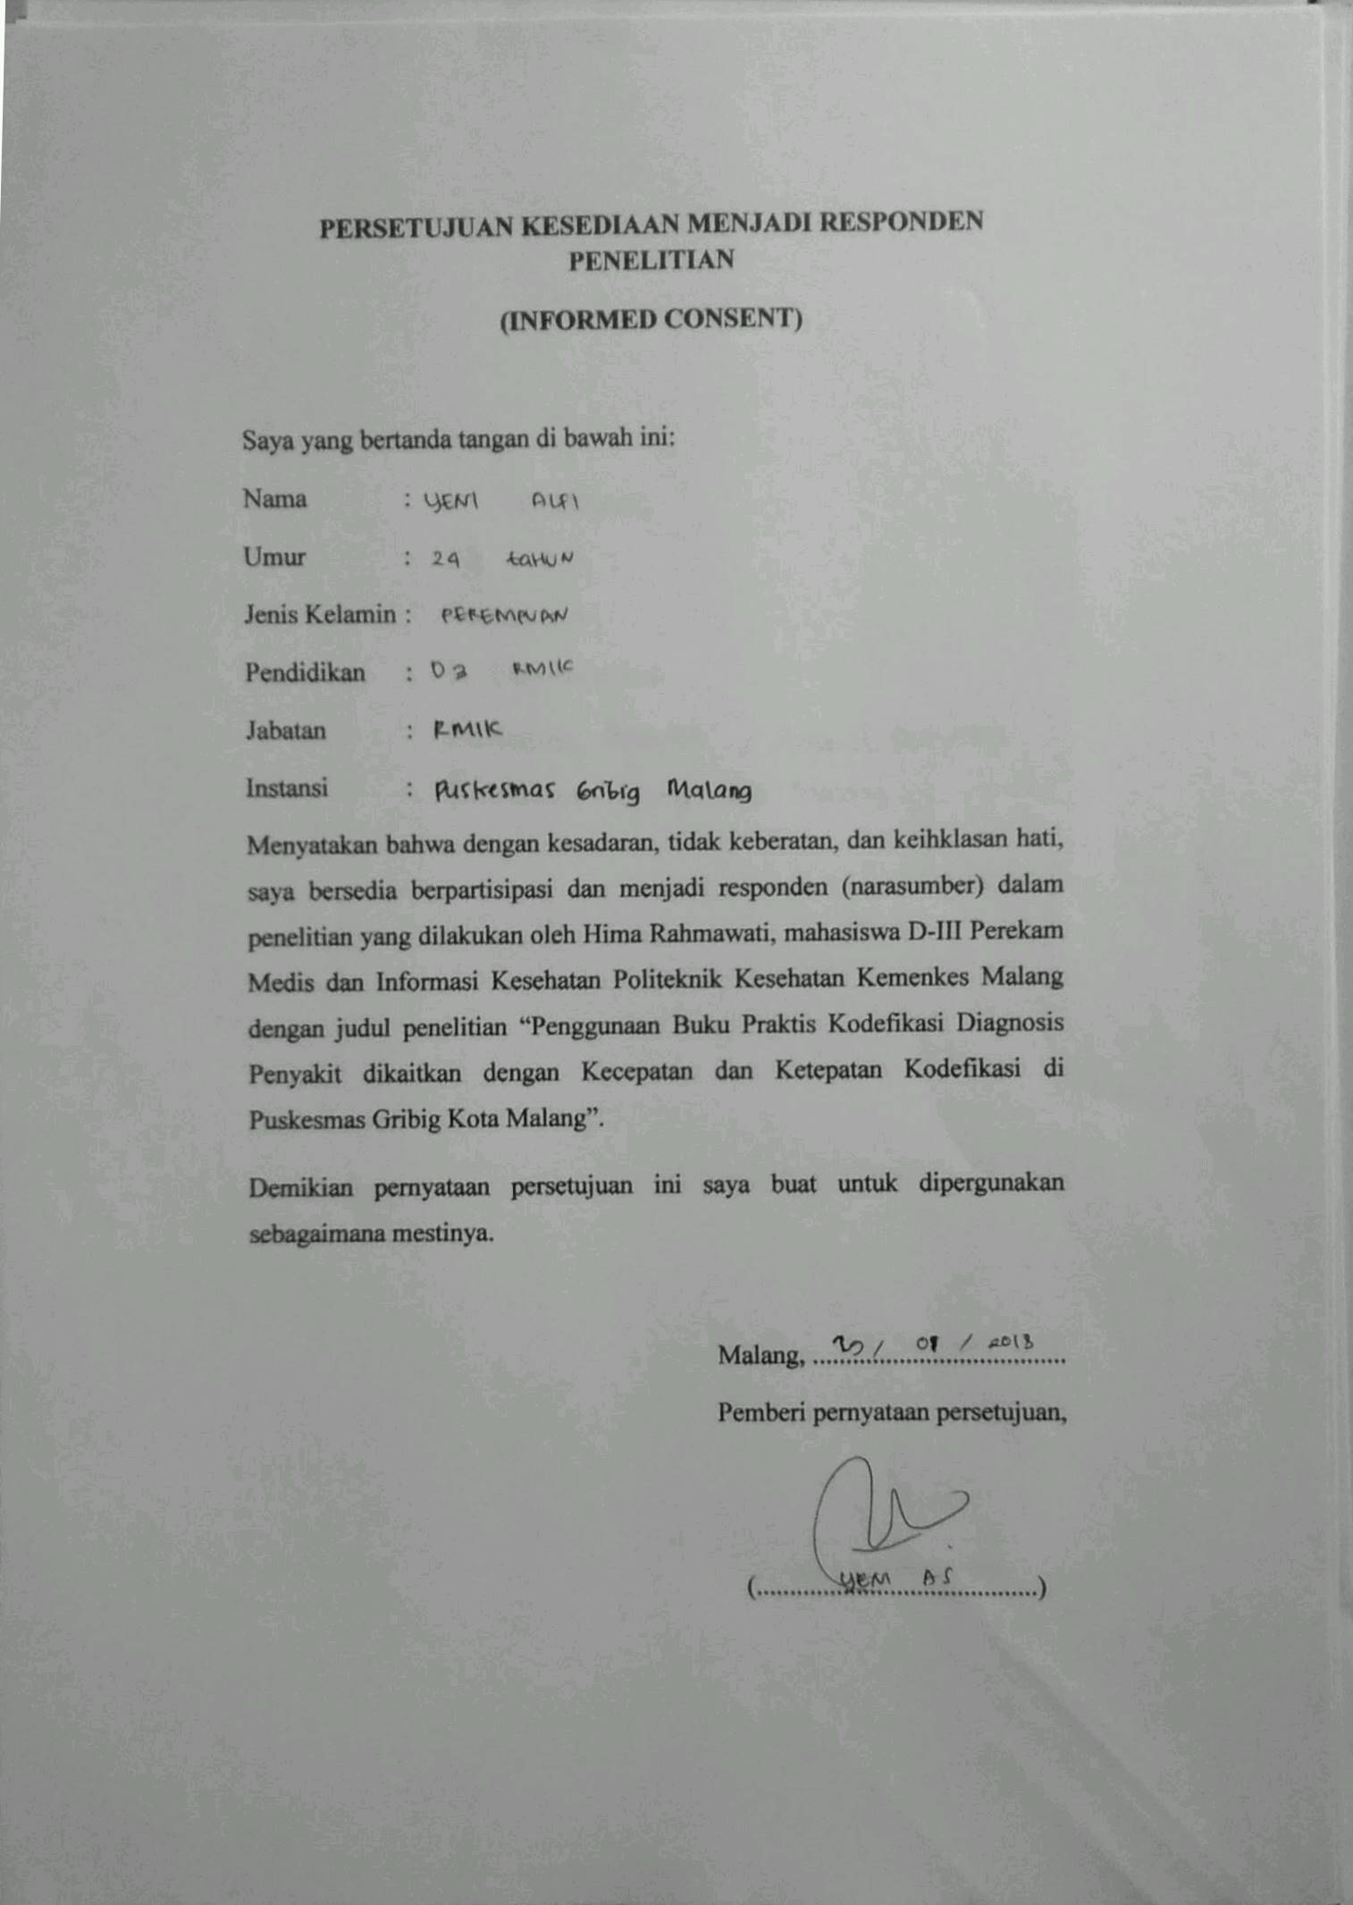
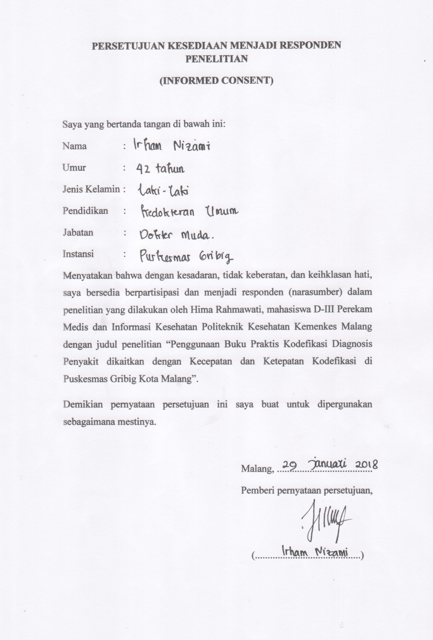
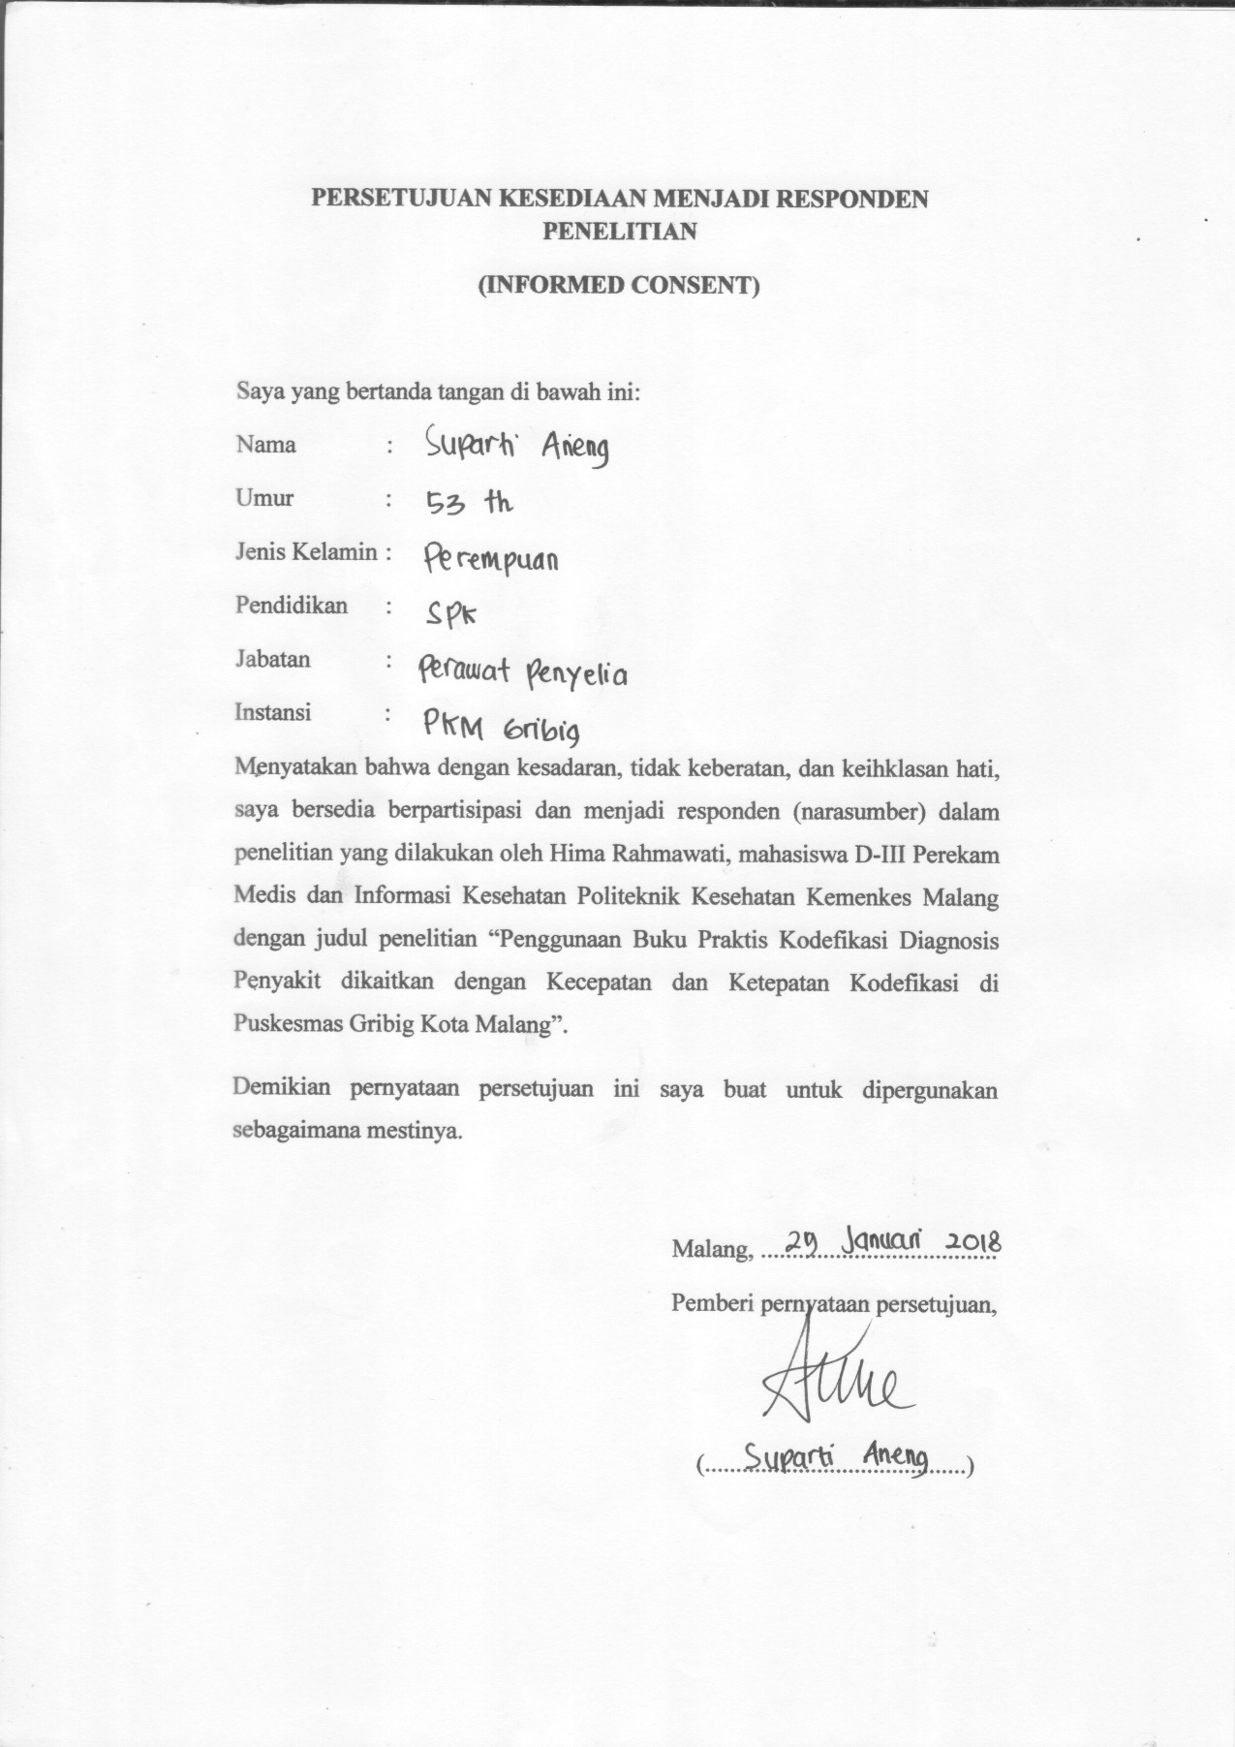
Lampiran 5
Daftar Diagnosis Penyakit dan Kode Penyakit di Puskesmas Gribig
No | Diagnosis Penyakit | Kode ICD-10
1 | Nasofaringitis akut | J00
2 | Sinusitis akut | J01
3 | Faringitis akut | J02
4 | Tonsilitis akut | J03
5 | Flu | J11
6 | Rhinitis alergi | J30.3
7 | Bronchitis | J44
8 | COPD eksaserbasi akut | J44.9
9 | Asma | J45
10 | Typhoid fever | A01.0
11 | Amebiasis | A06
12 | Dysenteric | A09
13 | Multiple dislokasi leher | S13
14 | TB addison's disease | A18
15 | Herpes-viral infection | B00
16 | Varicella [chickenpox] cacar air | B01
17 | Herpes zoster | B02
18 | HIV | B20
19 | AIDS | B24
20 | Mumps tanpa komplikasi [parotitis] | B26
21 | Scabies | B86
22 | Kanker payudara | C50
23 | Kanker servix uteri | C53
24 | Neoplasma jinak pada payudara | D24
25 | Trigonitis | E05
26 | Glaucoma lain | H40.8
27 | DM tipe II | E11
28 | DM ketoacidosis | E11.1
29 | DM multiple complications | E11.7
30 | DM unspecified complications | E11.8
31 | Disorder metabolism glikoprotein | E77
32 | Skizofrenia | F20
33 | Psychosis | F29
34 | Depresi ringan | F32.0
35 | Parkinson's disease | G20
36 | Epilepsi | G40
37 | Ganglionitis genikulat | G51
38 | Migraine | G43
39 | Chalazion | H00
40 | Inflamasi eyelid | H01
41 | Conjunctivitis | H10
42 | Disorder conjunctiva | H11
43 | Cataract senile | H25.9
44 | Cataract | H26
45 | Glaucoma | H40
46 | Low vision pada satu mata | H54
47 | Otitis media | H66
48 | Tinnitus | H93.1
49 | Distrofi kornea herediter | H18.5
50 | Pemphigus | L10
51 | Kelainan akantolitik | L11
52 | Angina pectoris | I20
53 | Miocardial infarction akut | I21
54 | Aterosklerotik jantung | I25
55 | Aneurisme arteri koronaria | I25.4
56 | Aritmia jantung | I49
57 | Rheumatic pericarditis akut | I01.0
58 | HF | I50
59 | Infark serebri | I63
60 | Stroke | I64
61 | Sequelae other cerebrovascular diseases | I69
62 | Hemoroid | I84
63 | Varicocele | I86.1
64 | Hipotensi | I95
65 | Stomatitis | K12
66 | Ulkus gaster | K25
67 | Dyspepsia | K30
68 | Appendisitis akut | K35
69 | Hernia inguinal unilateral | K40.9
70 | Abses | L02
71 | Limfadenitis | L04
72 | Dermatitis alergi | L23
73 | Dermatitis infektif | L30.3
74 | Urtikaria | L50
75 | Yellow nail syndrome | L60
76 | Artritis rematoid | M06
77 | Gonarthrosis primer, bilateral | M17.0
78 | Arthrosis | M19
79 | Lupus eritematosus sistemik | M32
80 | Radiculopathy | M54.1
81 | Mialgia | M79.1
82 | Neuralgia and neuritis | M79.2
83 | Renal failure kronik | N18
84 | Calculus pada ginjal dan ureter | N20
85 | Cystitis | N30
86 | Hiperplasia prostate | N40
87 | Leukorrhoea | N89.8
88 | Menstruasi iregular | N92
89 | Cough | R05
90 | Chest pain | R07.4
91 | Abdomen dan pelvic pain | R10.9
92 | Nausea | R11
93 | Heartburn | R12
94 | Dizziness and giddiness | R42
95 | Shock | R57
96 | Edema | R60
97 | Burn pada kepala dan leher | T20
98 | Fall | W19
99 | Contact with sharp glass | W25
100 | Ledakan dan pecahnya tabung gas | W36
101 | Pemeriksaan pendengaran | Z01.1
102 | Pemeriksaan darah | Z01.3
103 | Pemeriksaan laboratorium | Z01.7
104 | Pemeriksaan gigi | Z01.2
105 | Pemeriksaan general | Z00.0

Lampiran 6
Lembar Observasi Kecepatan dan Ketepatan Kodefikasi Diagnosis Penyakit Sebelum Penggunaan Buku Praktis Kodefikasi Berdasarkan ICD-10 di Puskesmas Gribig
NO | NO. RM | DIAGNOSIS | KODE | KETEPATAN |  | WAKTU
 |  |  |  | YA | TIDAK
1. | 1597 | Dyspepsia | K29 |  | v | 00:00:18:78
2. | 1596 | Cough | R05 | v |  | 00:00:15:70
3. | 1592 | Gonarthrosis | M17 |  | v | 00:01:12:09
4. | 1591 | ISPA | J00 |  | v | 00:00:10:43
5. | 1590 | Lipoma | D21.9 |  | v | 00:00:16:48
6. | 1589 | ISPA | J00 |  | v | 00:00:08:66
7. | 2763 | CVA | I69 |  | v | 00:00:25:81
8. | 2761 | Imunisasi campak | Z23.5 |  | v | 00:01:18:14
9. | 2759 | Imunisasi polio | Z23.5 |  | v | 00:01:21:52
10. | 2758 | Cough | R05 | v |  | 00:00:08:43
11. | 2755 | Mialgia | M79.1 | v |  | 00:00:18:67
12. | 2754 | Cough | R05 | v |  | 00:00:08:02
13. | 2752 | ISPA | J00 |  | v | 00:00:08:65
14. | 2751 | DM tipe II | E11 |  | v | 00:00:16:90
15. | 1185 | Varicella | B50 |  | v | 00:01:22:34
16. | 1184 | Migrain | G45 |  | v | 00:01:20:48
17. | 2854 | DM tipe II | E11 |  | v | 00:00:21:78
18. | 1182 | Imunisasi BCG | Z23.5 |  | v | 00:00:20:24
19. | 1181 | Nasofaringitis akut | J00 | v |  | 00:02:11:48
20. | 1180 | ISPA | J00 |  | v | 00:00:08:14
21. | 1179 | DM tipe II dengan komplikasi | E11.7 | v |  | 00:02:11:63
22. | 3573 | Calculus | K05.1 |  | v | 00:03:18:33
23. | 2477 | Gastroenteritis | A09 | v |  | 00:00:57:54
24. | 3570 | Kronik renal failure | N18 |  | v | 00:02:43:87
25. | 3568 | Cough | R05 | v |  | 00:00:25:77
26. | 3566 | Gastroenteritis | A09 | v |  | 00:00:26:09
27. | 2474 | Mialgia | M17.0 |  | v | 00:00:18:08
28. | 2480 | HT | I10 | v |  | 00:00:11:12
29. | 2479 | TB paru | A15 |  | v | 00:00:38:25
30. | 2473 | Nasofaringitis akut | J00 | v |  | 00:00:47:64
31. | 2472 | Cepalgia | R51 | v |  | 00:02:15:16
32. | 2471 | Skizofrenia | F20 |  | v | 00:02:19:10
33. | 1002 | DM tipe II | E11 |  | v | 00:00:17:18
34. | 1001 | Appendicitis akut | K35 |  | v | 00:02:02:07
35. | 999 | Common cold | J00 | v |  | 00:00:35:78
36. | 2340 | ISPA | J00 |  | v | 00:00:11:11
37. | 996 | HT | I10 | v |  | 00:00:11:17
38. | 2345 | Imunisasi folio | Z23.5 |  | v | 00:00:18:58
39. | 2343 | ISPA | J00 |  | v | 00:00:18:78
40. | 2342 | HF | I50 |  | v | 00:00:20:95
41. | 2341 | Faringitis akut | J02 |  | v | 00:00:58:88
42. | 2274 | Glaucoma lain | H40.8 | v |  | 00:02:05:07
43. | 2273 | Faringitis akut | J02 |  | v | 00:00:30:56
44. | 2272 | ISPA | J00 |  | v | 00:00:09:89
45. | 2271 | DM tipe II | E11 |  | v | 00:00:16:76
46. | 2270 | DM tipe II | E11 |  | v | 00:00:14:94
47. | 2269 | Cepalgia | R51 | v |  | 00:00:56:11
48. | 2201 | Nasofaringitis akut | J00 | v |  | 00:00:26:06
49. | 2200 | Influenza | J11 | v |  | 00:00:12:21
50. | 2199 | ISPA | J00 |  | v | 00:00:12:11
51. | 2198 | ISPA | J00 |  | v | 00:00:10:71
52. | 2197 | ISPA | J00 |  | v | 00:00:11:56
53. | 2194 | Faringitis akut | J02 |  | v | 00:00:28:90
54. | 3518 | ISPA | J00 |  | v | 00:00:11:06
55. | 1170 | Cepalgia | R51 | v |  | 00:01:57:34
56. | 3516 | Demam | R05 |  | v | 00:00:23:12
57. | 3014 | Diare | A09 | v |  | 00:00:17:70
58. | 3447 | Parkinson’s disease | G20 |  |  | 00:02:05:48
59. | 3606 | Gastroenteritis akut | A09 | v |  | 00:00:34:11
60. | 3505 | Demam | R05 |  | v | 00:00:14:08
61. | 3504 | Cough | R05 | v |  | 00:00:10:06
62. | 1295 | ISPA | J00 |  | v | 00:00:09:77
63. | 1290 | Dyspepsia | K30 | v |  | 00:00:19:72
64. | 1289 | Mialgia | M79.1 | v |  | 00:00:44:07
65. | 929 | ISPA | J00 |  | v | 00:00:09:08
66 | 337 | HT | I10 | v |  | 00:00:08:15
67. | 31 | Hordeolum | H00 |  | v | 00:01:11:58
68. | 1181 | Dyspepsia | K30 | v |  | 00:00:34:44
69 | 1168 | Dermatitis alergi | L20 |  | v | 00:00:18:18
70. | 15 | Diare | K29 |  | v | 00:00:15:06

Lampiran 7
Lembar Observasi Kecepatan dan Ketepatan Kodefikasi Diagnosis Penyakit Sesudah Penggunaan Buku Praktis Kodefikasi Berdasarkan ICD-10 di Puskesmas Gribig
NO | NO. RM | DIAGNOSIS | KODE | KETEPATAN |  | WAKTU
 |  |  |  | YA | TIDAK
1. | 1597 | Dyspepsia | K30 | v |  | 00:00:07:19
2. | 1596 | Cough | R05 | v |  | 00:00:07:70
3. | 1592 | Gonarthrosis | M17.9 | v |  | 00:00:05:67
4. | 1591 | ISPA | J06.9 | v |  | 00:00:10:43
5. | 1590 | Lipoma | D21.9 |  | v | 00:00:20:14
6. | 1589 | ISPA | J06.9 | v |  | 00:00:08:66
7. | 2763 | CVA | I64 | v |  | 00:00:18:95
8. | 2761 | Imunisasi campak | Z23.5 |  | v | 00:00:18:11
9. | 2759 | Imunisasi polio | Z27.3 | v |  | 00:00:11:57
10. | 2758 | Cough | R05 | v |  | 00:00:06:45
11. | 2755 | Mialgia | M79.1 | v |  | 00:00:05:69
12. | 2754 | Cough | R05 | v |  | 00:00:06:08
13. | 2752 | ISPA | J06.9 | v |  | 00:00:07:01
14. | 2751 | DM tipe II | E11.9 | v |  | 00:00:05:57
15. | 1185 | Varicella | B01.9 | v |  | 00:00:09:34
16. | 1184 | Migrain | G43.9 | v |  | 00:00:04:89
17. | 2854 | DM tipe II | E11.9 | v |  | 00:00:14:19
18. | 1182 | Imunisasi BCG | Z23.2 | v |  | 00:00:12:22
19. | 1181 | Nasofaringitis akut | J00 | v |  | 00:00:09:14
20. | 1180 | ISPA | J06.9 | v |  | 00:00:05:04
21. | 1179 | DM tipe II dengan komplikasi | E11.9 |  | v | 00:00:13:31
22. | 3573 | Calculus | K05.1 |  | v | 00:00:08:12
23. | 2477 | Gastroenteritis | A09 | v |  | 00:00:05:05
24. | 3570 | Kronik renal failure | N18.9 | v |  | 00:00:11:17
25. | 3568 | Cough | R05 | v |  | 00:00:05:23
26. | 3566 | Gastroenteritis | A09 | v |  | 00:00:06:91
27. | 2474 | Mialgia | M79.1 | v |  | 00:00:07:18
28. | 2480 | HT | I10 | v |  | 00:00:09:11
29. | 2479 | TB paru | A15 |  | v | 00:00:16:09
30. | 2473 | Nasofaringitis akut | J00 | v |  | 00:00:06:34
31. | 2472 | Cepalgia | R51 | v |  | 00:00:07:01
32. | 2471 | Skizofrenia | F20.9 | v |  | 00:00:08:14
33. | 1002 | DM tipe II | E11.9 | v |  | 00:00:09:87
34. | 1001 | Appendicitis akut | K35.9 | v |  | 00:00:08:03
35. | 999 | Common cold | J00 | v |  | 00:00:18:70
36. | 2340 | ISPA | J06.9 | v |  | 00:00:07:11
37. | 996 | HT | I10 | v |  | 00:00:11:15
38. | 2345 | Imunisasi folio | Z27.3 | v |  | 00:00:06:33
39. | 2343 | ISPA | J06.9 | v |  | 00:00:08:65
40. | 2342 | HF | I50.9 | v |  | 00:00:08:34
41. | 2341 | Faringitis akut | J02.9 | v |  | 00:00:08:17
42. | 2274 | Glaucoma lain | H40.8 | v |  | 00:00:05:08
43. | 2273 | Faringitis akut | J02.9 | v |  | 00:00:07:56
44. | 2272 | ISPA | J06.9 | v |  | 00:00:08:99
45. | 2271 | DM tipe II | E11.9 | v |  | 00:00:10:09
46. | 2270 | DM tipe II | E11.9 | v |  | 00:00:06:56
47. | 2269 | Cepalgia | R51 | v |  | 00:00:07:18
48. | 2201 | Nasofaringitis akut | J00 | v |  | 00:00:08:08
49. | 2200 | Influenza | J11.1 | v |  | 00:00:08:90
50. | 2199 | ISPA | J06.9 | v |  | 00:00:06:56
51. | 2198 | ISPA | J06.9 | v |  | 00:00:04:12
52. | 2197 | ISPA | J06.9 | v |  | 00:00:06:16
53. | 2194 | Faringitis akut | J02.9 | v |  | 00:00:05:48
54. | 3518 | ISPA | J06.9 | v |  | 00:00:07:16
55. | 1170 | Cepalgia | R51 | v |  | 00:00:07:34
56. | 3516 | Demam | R05.9 | v |  | 00:00:12:12
57. | 3014 | Diare | A09 | v |  | 00:00:08:90
58. | 3447 | Parkinson’s disease | G20 | v |  | 00:00:05:98
59. | 3606 | Gastroenteritis akut | A09 | v |  | 00:00:05:78
60. | 3505 | Demam | R05.9 | v |  | 00:00:09:04
61. | 3504 | Cough | R05 | v |  | 00:00:03:89
62. | 1295 | ISPA | J06.9 | v |  | 00:00:15:22
63. | 1290 | Dyspepsia | K30 | v |  | 00:00:04:12
64. | 1289 | Mialgia | M79.1 | v |  | 00:00:05:34
65. | 929 | ISPA | J06.9 | v |  | 00:00:07:32
66 | 337 | HT | I10 | v |  | 00:00:08:02
67. | 31 | Hordeolum | H00 |  | v | 00:00:14:08
68. | 1181 | Dyspepsia | K30 | v |  | 00:00:06:33
69 | 1168 | Dermatitis alergi | L23.9 | v |  | 00:00:06:12
70. | 15 | Diare | A09 | v |  | 00:00:04:09

Lampiran 8
Buku Praktis Kodefikasi Diagnosis Penyakit di Puskesmas Gribig
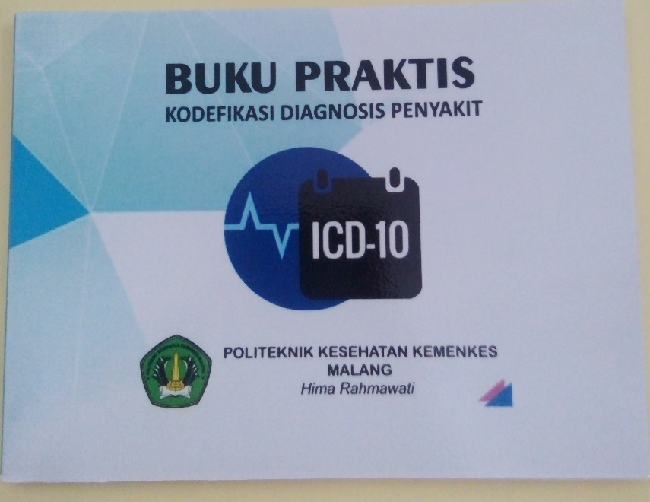
Cover Depan Buku Praktis Kodefikasi Diagnosis Penyakit

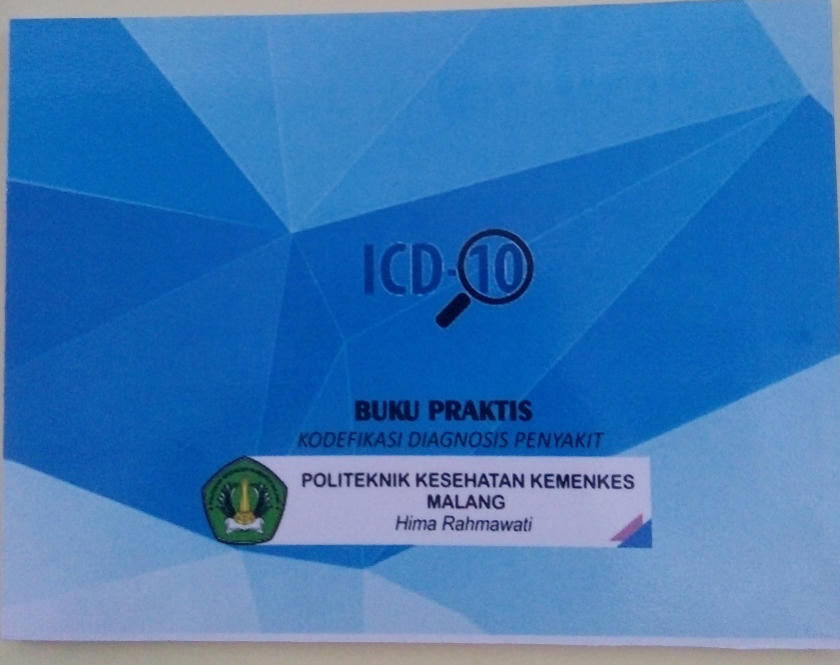
Cover Belakang Buku Praktis Kodefikasi Diagnosis Penyakit
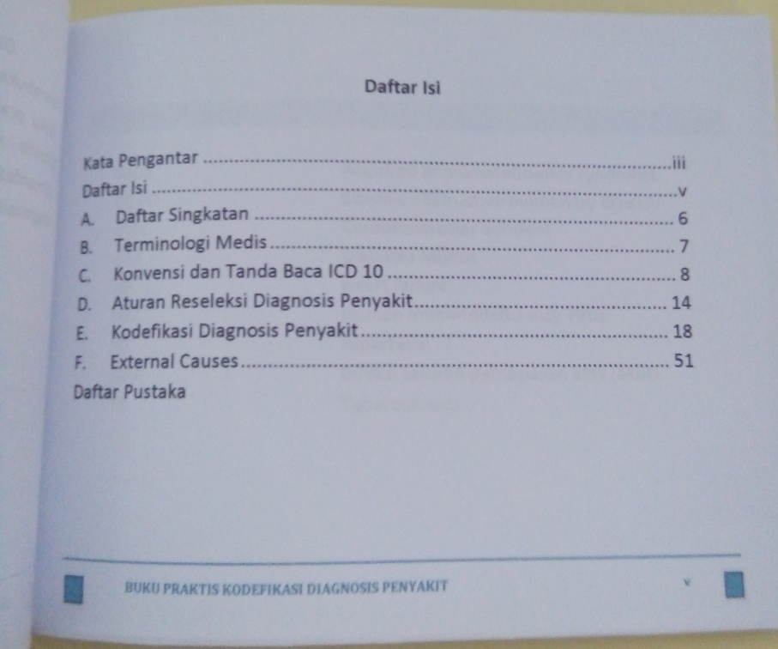
Daftar Isi Buku Praktis Kodefikasi Diagnosis Penyakit

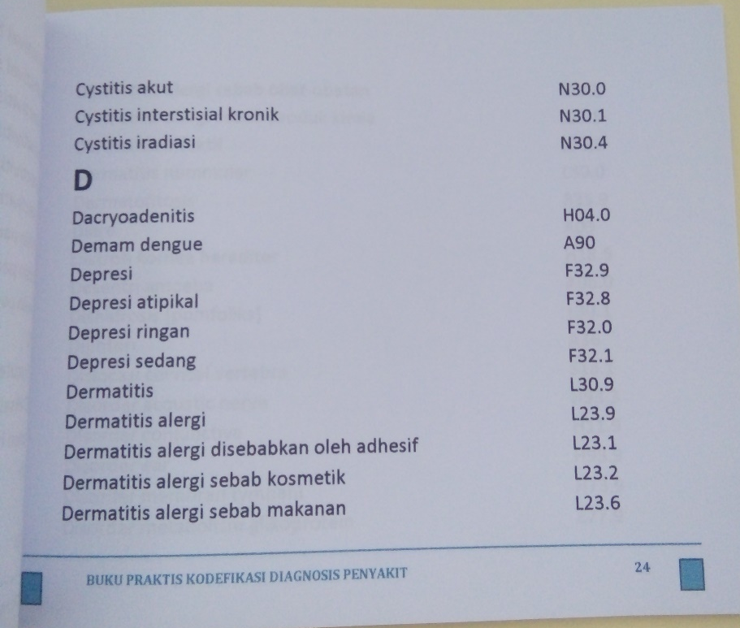
Halaman Kodefikasi Buku Praktis Kodefikasi Diagnosis Penyakit
Lampiran 9
SURAT PERNYATAAN VALIDASI
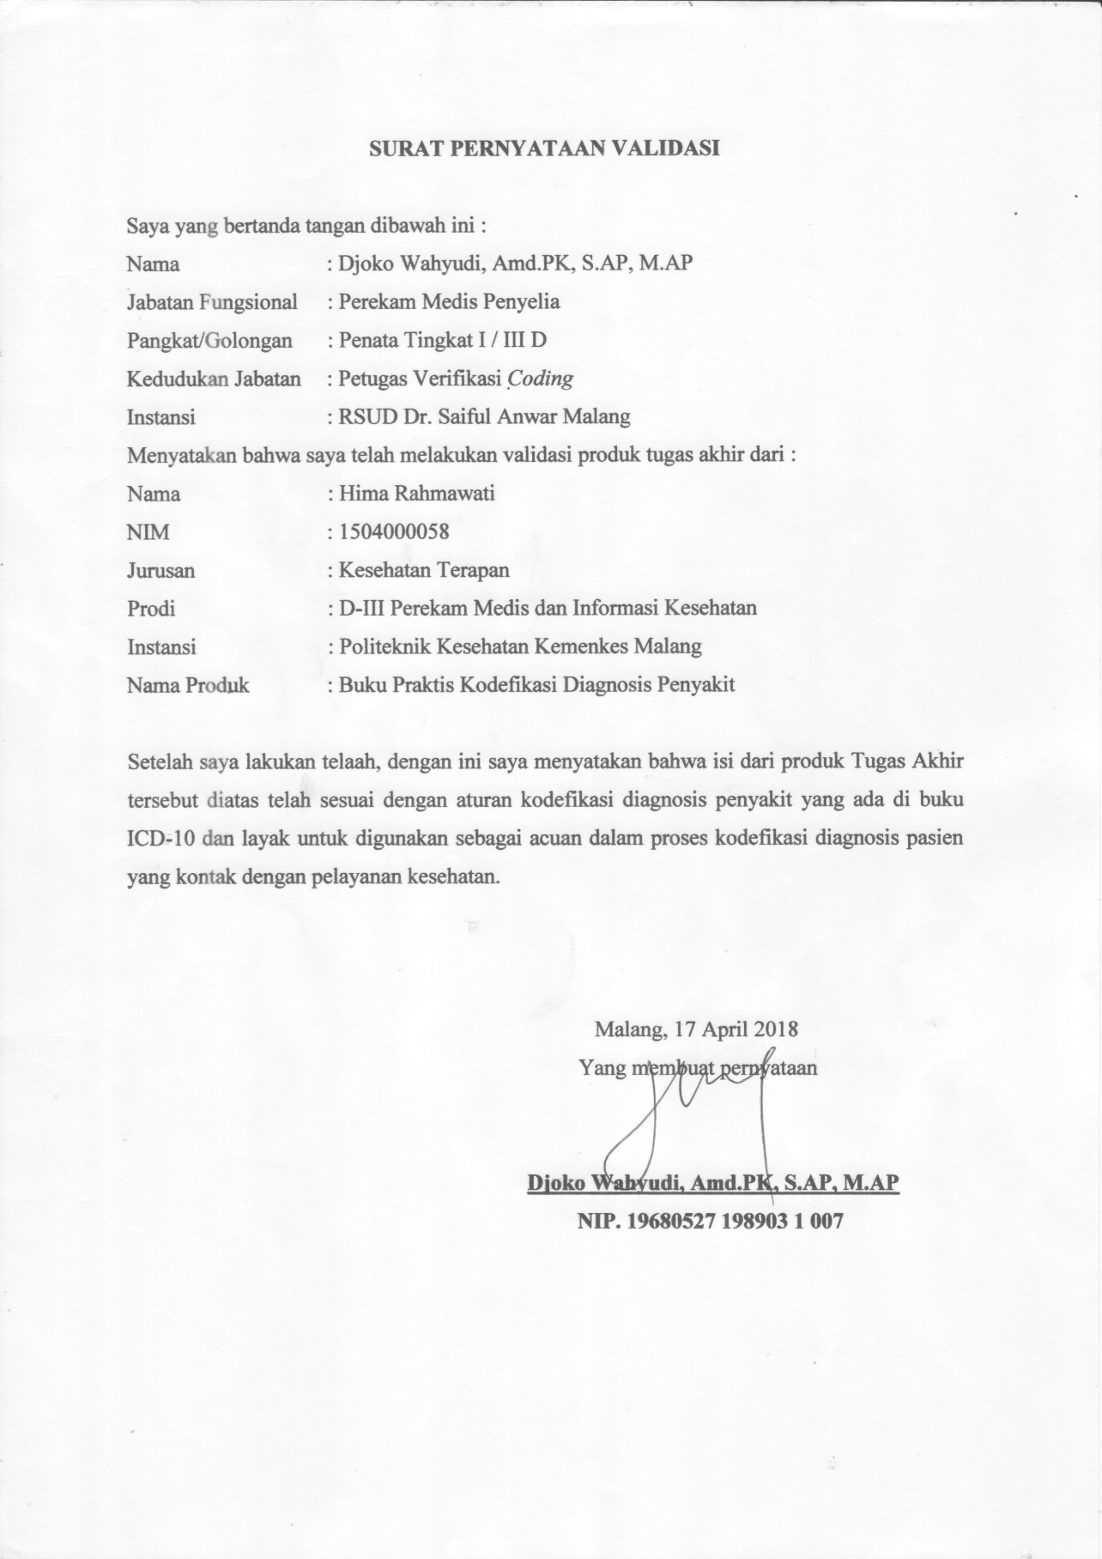
Lampiran 10
Lembar Pedoman Wawancara Penggunaan Buku Praktis Kodefikasi Diagnosis Penyakit di Puskesmas Gribig Kota Malang
- Apakah bahasa dan istilah medis yang digunakan dalam buku praktis kodefikasi mudah dipahami oleh petugas?
- Apakah buku praktis kodefikasi dapat membantu petugas dalam menentukan kodefikasi diagnosis penyakit?
- Apakah dengan adanya buku praktis kodefikasi petugas lebih cepat dalam menentukan kode diagnosis penyakit?
- Apakah daftar penyakit di dalam buku praktis kodefikasi sudah mewakili seluruh penyakit yang ada di Puskesmas Gribig?
- Apakah petugas mau menggunakan buku praktis kodefikasi dalam melakukan kodefikasi di Puskesmas Gribig?

Lampiran 11
Rekapitulasi Hasil Wawancara kepada Responden di Puskesmas Gribig
No | Pertanyaan | Jumlah Responden Menjawab
 |  | Ya | Tidak
1. | Apakah bahasa dan istilah medis yang digunakan dalam buku praktis kodefikasi mudah dipahami oleh petugas? | 3 | 0
2. | Apakah buku praktis kodefikasi dapat membantu petugas dalam menentukan kodefikasi diagnosis penyakit? | 3 | 0
3. | Apakah dengan adanya buku praktis kodefikasi petugas lebih cepat dalam menentukan kode diagnosis penyakit? | 3 | 0
4. | Apakah daftar penyakit di dalam buku praktis kodefikasi sudah mewakili seluruh penyakit yang ada di Puskesmas Gribig? | 3 | 0
5. | Apakah petugas mau menggunakan buku praktis kodefikasi dalam melakukan kodefikasi di Puskesmas Gribig? | 3 | 0
Jumlah |  | 15 | 0

Lampiran 12
Hasil Uji

Crosstabs

