LAMPIRAN

Lampiran 1

LEMBAR PERSETUJUAN
(INFORMED CONSENT)

Yang bertanda tangan dibawah ini:
Nama :
Umur :
Alamat :

Setelah mendapat penjelasan tentang manfaat dan resiko dari penelitian yang akan dilakukan yang berjudul : “Hubungan Antara Tingkat Konsumsi Energi, Protein, Fe Dan Vitamin C, Status Gizi Dan Status Anemia Terhadap Konsentrasi Kerja Tenaga Kesehatan Puskesmas Rawat Inap Kota Malang” menyatakan bersedia menjadi responden, dengan catatan bila sewaktu-waktu merasa dirugikan dalam bentuk apapun berhak membatalkan persetujuan ini, saya percaya dengan apa yang saya informasikan ini akan dijamin kerahasiaaannya.
Malang, ..........................
Responden

(………………………..)
Peneliti

Nursarita Intan O

Lampiran 2
FOOD RECALL 24 JAM
Nama :
Jenis kelamin :
Umur :
Tinggi badan :
Berat badan :
Berat badan Ideal :
IMT :

MENU | BAHAN MAKANAN | URT | BERAT (g)
PAGI

SIANG

SORE

Tanggal _____________________

Lampiran 3
Soal Tes Pauli
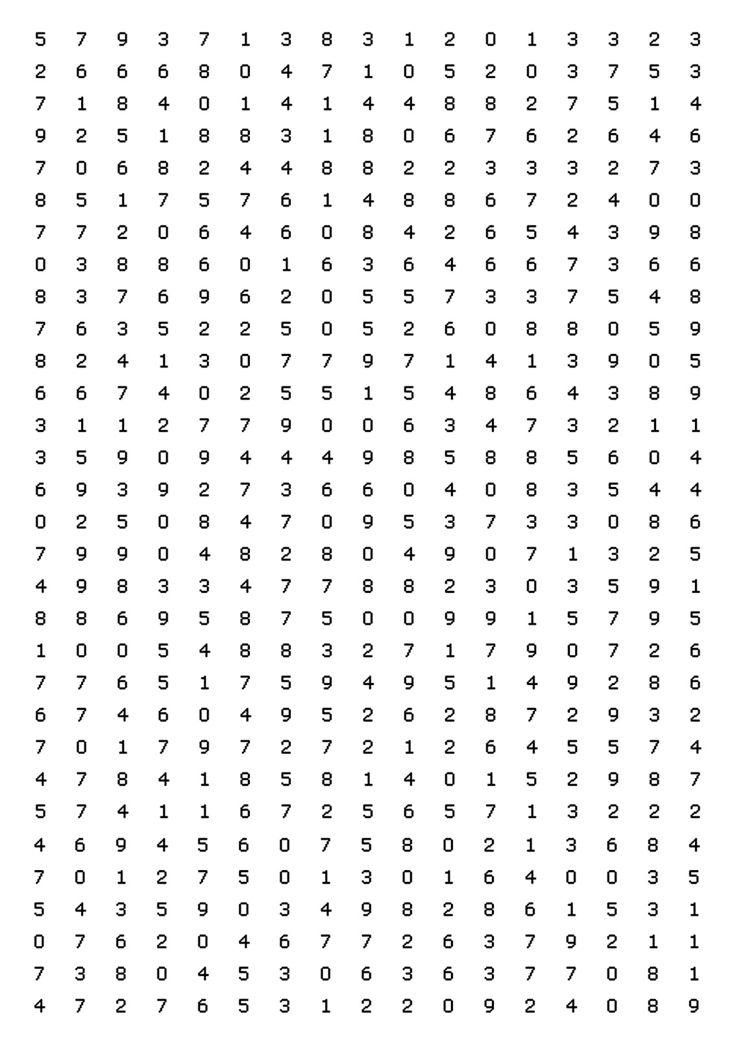
Lampiran 4
PROSEDUR PENGAMBILAN DATA BERAT BADAN
Responden diminta melepas alas kaki
↓
Responden diminta naik diatas timbangan injak
↓
Responden diminta pandangan lurus kedepan
↓
Responden diminta untuk merapatkan kaki
↓
Responden ditimbang berat badannya menggunakan timbangan injak merk camry
↓
Hasil timbang berat badan
↓
Berat badan
↓
Dihitung berat badan ideal

Lampiran 5
PROSEDUR PENGAMBILAN DATA TINGGI BADAN
Responden diminta melepas alas kaki
↓
Responden diminta bersandar pada dinding
↓
Responden diminta pandangan lurus kedepan
↓
Responden diminta untuk merapatkan kaki
↓
Responden diukur tinggi badannya menggunakan mikrotoise
↓
Hasil timbang tinggi badan
↓
Tinggi badan

Lampiran 6
PROSEDUR PEMERIKSAAN DARAH MENGGUNAKAN METODE CYANMETHEMOGLOBIN

Mencampur spesimen hingga homogen.
↓
Menyiapkan 2,5 ml reagen drabkins dalam tabung
↓
Mengambil 10 ul sample darah dan memasukkan kedalam tabung drabkins
↓
Mencampur hingga himogen dan inkubasi pada suhu kamar selama ± 5 menit
↓
Membaca pada fotometer dengan panjang gelombang 546 nm setelah reagensia blanko dan standar
↓
Mencatat hasil pemeriksaan dalam form hasil
↓
Mengklasifikasikan sesuai dengan nilai standar

Lampiran 7
PROSEDUR PELAKSANAAN TES PAULI

Persiapan; menyiapkan alat tulis, pencayahaan suasana tenang
↓
Pemberian penjelasan/arahan awal
↓
Responden diminta mengisi nama, tanggal lahir, tanggal dan waktu pemeriksaan
↓
Responden mulai mengerjakan setelah mendapat aba-aba dan instruksi
↓
Responden menjumlahan setiap angka dengan angka di bawahnya, dan hasilnya dituliskan disebelah kanan diantara kedua angka yang jumlahkan itu. Angka puluhan dihiraukan.
↓
Responden harus selalu memperhatikan aba-aba, pada setiap terdengar aba-aba GARIS, maka responden harus memberi garis di bawah angka hasil penjumlahan terakhir yang pada waktu itu sedang dihitung.
↓
Lanjutkan penjumlahan sampai terdengar aba-aba berhenti.
↓
Hasil dinilai
↓
Klasifikasi Hasil sesuai standar
Lampiran 8. Master Tabel

Lampiran 9. Hasil Tes Statistik Korelasi Tingkat Konsumsi Energi dan Protein Terhadap Status Gizi

Nonparametric Correlations

Correlations
 |  |  | TK_energi | IMT | TK_protein
Spearman's rho | TK_energi | Correlation Coefficient | 1.000 | .411* | .679**
 |  | Sig. (2-tailed) | . | .030 | .000
 |  | N | 28 | 28 | 28
 | IMT | Correlation Coefficient | .411* | 1.000 | .062
 |  | Sig. (2-tailed) | .030 | . | .755
 |  | N | 28 | 28 | 28
 | TK_protein | Correlation Coefficient | .679** | .062 | 1.000
 |  | Sig. (2-tailed) | .000 | .755 | .
 |  | N | 28 | 28 | 28
*. Correlation is significant at the 0.05 level (2-tailed).
**. Correlation is significant at the 0.01 level (2-tailed).

Lampiran 10. Hasil Tes Statistik Korelasi Tingkat Konsumsi Energi dan Protein Terhadap Status Anemia

Nonparametric Correlations

Correlations
 |  |  | TK_energi | TK_protein | Anemia
Spearman's rho | TK_energi | Correlation Coefficient | 1.000 | .679** | -.006
 |  | Sig. (2-tailed) | . | .000 | .976
 |  | N | 28 | 28 | 28
 | TK_protein | Correlation Coefficient | .679** | 1.000 | .151
 |  | Sig. (2-tailed) | .000 | . | .442
 |  | N | 28 | 28 | 28
 | Anemia | Correlation Coefficient | -.006 | .151 | 1.000
 |  | Sig. (2-tailed) | .976 | .442 | .
 |  | N | 28 | 28 | 28
**. Correlation is significant at the 0.01 level (2-tailed).

Lampiran 11. Hasil Tes Statistik Korelasi Tingkat Vitamin C dan Fe Terhadap Status Anemia

Nonparametric Correlations

Correlations
 |  |  | Anemia | TK_Fe | TK_vit_c
Spearman's rho | Anemia | Correlation Coefficient | 1.000 | .396* | .486**
 |  | Sig. (2-tailed) | . | .037 | .009
 |  | N | 28 | 28 | 28
 | TK_Fe | Correlation Coefficient | .396* | 1.000 | .690**
 |  | Sig. (2-tailed) | .037 | . | .000
 |  | N | 28 | 28 | 28
 | TK_vit_c | Correlation Coefficient | .486** | .690** | 1.000
 |  | Sig. (2-tailed) | .009 | .000 | .
 |  | N | 28 | 28 | 28
*. Correlation is significant at the 0.05 level (2-tailed).
**. Correlation is significant at the 0.01 level (2-tailed).

Lampiran 12. Hasil Tes Statistik Korelasi Status AnemiaTerhadap Tingkat konsentrasi Kerja

Nonparametric Correlations
Correlations
 |  |  | Anemia
Spearman's rho | Kesiapsiagaan | Correlation Coefficient | -.116
 |  | Sig. (2-tailed) | .556
 |  | N | 28
 | Daya_tahan | Correlation Coefficient | -.019
 |  | Sig. (2-tailed) | .924
 |  | N | 28
 | Energi_kerja | Correlation Coefficient | -.019
 |  | Sig. (2-tailed) | .924
 |  | N | 28
 | Ketelitian | Correlation Coefficient | .000
 |  | Sig. (2-tailed) | 1.000
 |  | N | 28
 | Konsentrasi | Correlation Coefficient | -.442*
 |  | Sig. (2-tailed) | .019
 |  | N | 28
 | Kemauan | Correlation Coefficient | -.190
 |  | Sig. (2-tailed) | .332
 |  | N | 28
 | pengarahan_energi_kerja | Correlation Coefficient | .284
 |  | Sig. (2-tailed) | .143
 |  | N | 28
 | Anemia | Correlation Coefficient | 1.000
 |  | Sig. (2-tailed) | .
 |  | N | 28
**. Correlation is significant at the 0.01 level (2-tailed).
*. Correlation is significant at the 0.05 level (2-tailed).

Lampiran 13. Hasil Tes Statistik Korelasi Konsumsi Energi Terhadap Tingkat konsentrasi Kerja
Correlations
 |  |  | TK_energi
Spearman's rho | Kesiapsiagaan | Correlation Coefficient | .216
 |  | Sig. (2-tailed) | .269
 |  | N | 28
 | Daya_tahan | Correlation Coefficient | .344
 |  | Sig. (2-tailed) | .074
 |  | N | 28
 | Energi_kerja | Correlation Coefficient | .344
 |  | Sig. (2-tailed) | .074
 |  | N | 28
 | Ketelitian | Correlation Coefficient | -.070
 |  | Sig. (2-tailed) | .723
 |  | N | 28
 | Konsentrasi | Correlation Coefficient | .037
 |  | Sig. (2-tailed) | .851
 |  | N | 28
 | Kemauan | Correlation Coefficient | -.031
 |  | Sig. (2-tailed) | .876
 |  | N | 28
 | pengarahan_energi_kerja | Correlation Coefficient | -.142
 |  | Sig. (2-tailed) | .472
 |  | N | 28
 | TK_energi | Correlation Coefficient | 1.000
 |  | Sig. (2-tailed) | .
 |  | N | 28
**. Correlation is significant at the 0.01 level (2-tailed).
*. Correlation is significant at the 0.05 level (2-tailed).

Lampiran 14. Booklet Pencegahan Anemia Pada Tenaga Kesehatan

