Lampiran 1. Keterangan Laik Etik

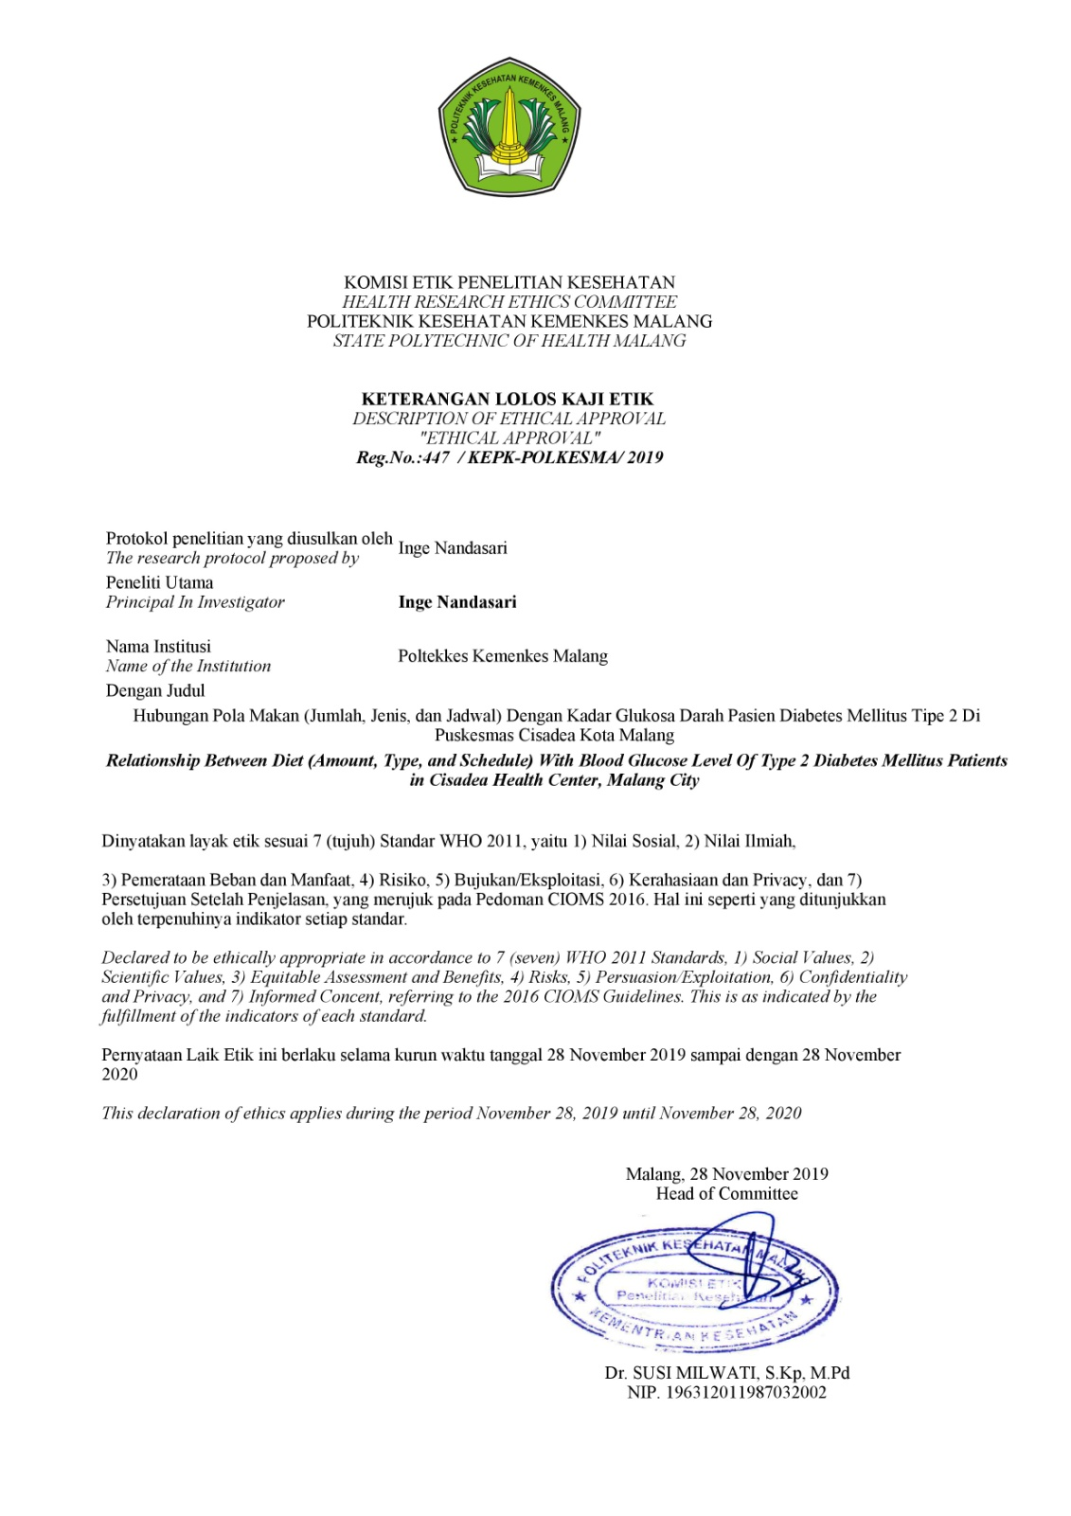

Lampiran 2. Surat Ijin Penelitian
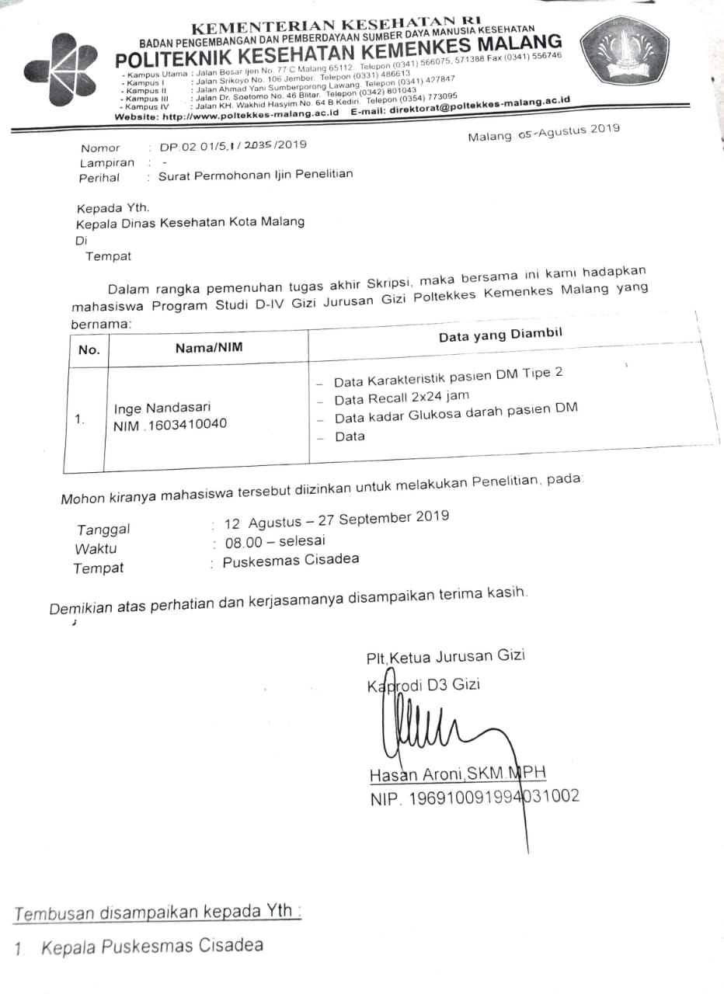
Lampiran 3. Master Tabel
No | Nama | Usia | J. Kelamin | Pendidikan | Pekerjaan | BB (kg) | TB (cm) | IMT (kg/m²) | Kadar Glukosa Darah (mg/dL) | Recall 1 |  |  | Recall 2 |  |  | Rata-rata
 |  |  |  |  |  |  |  |  |  | Protein 1 (g) | Lemak 1 (g) | Karbohidrat 1 (g) | Protein 2 (g) | Lemak 2 (g) | Karbohidrat 2 (g) | Protein | Lemak | Karbohidrat
1 | Ny. Sy | 63 | P | SD | IRT | 49 | 153 | 20,9 | 180 | 70,6 | 35,3 | 203,4 | 40,7 | 44,3 | 73,9 | 55,65 (14,4%) | 39,8 (23,3%) | 138,65 (36,1%)
2 | Ny. M | 63 | P | SMP | Penjahit | 70 | 156 | 29,7 | 163 | 22,6 | 18,6 | 197,2 | 18,7 | 12,6 | 64,3 | 20,65 (5,1%) | 15,6 (8,7%) | 130,7 (32,7%)
3 | Ny. BU | 57 | P | SMA | Tdk Bekerja | 57 | 157 | 23,1 | 200 | 13,6 | 18,6 | 99,2 | 24,2 | 19,6 | 132,5 | 18,9 (4,4%) | 19,1 (10,2%) | 115,85 (27,5%)
4 | Ny. TR | 59 | P | SMP | IRT | 54 | 152 | 23,3 | 127 | 39,7 | 52,4 | 135,3 | 21,6 | 29,6 | 75,9 | 30,65 (7,7%) | 41 (23,4%) | 105,6 (26,7%)
5 | Ny. St | 48 | P | SMP | IRT | 54 | 150 | 24 | 296 | 32,7 | 41,1 | 131,4 | 26,4 | 37,3 | 91,8 | 29,55 (7,4%) | 39,2 (22,1%) | 111,6 (9,7%)
6 | Ny. H | 70 | P | SMP | Wiraswasta | 56 | 160 | 21,8 | 197 | 63,1 | 40,7 | 174,2 | 31,2 | 24,4 | 146,7 | 47,15 (11,6%) | 32,55 (18,1%) | 160,45 (39,7%)
7 | Tn. SL | 76 | L | SMP | IRT | 51 | 162 | 19,4 | 126 | 19 | 19,5 | 111,1 | 41,6 | 36 | 190,1 | 30,3 (5,7%) | 27,75 (11,7%) | 150,6 (28,3%)
8 | Ny. L | 73 | P | SMP | Tdk Bekerja | 56 | 151 | 24,5 | 200 | 22,1 | 31,7 | 50,2 | 21 | 15,6 | 69,4 | 21,55 (6%) | 23,65 (14,8%) | 59,8 (16,6%)
9 | Tn. M | 66 | L | D2 | Wiraswasta | 90 | 180 | 27,7 | 170 | 32,1 | 31,1 | 118,6 | 20,3 | 12,5 | 68,6 | 26,2 (3,8%) | 21,8 (7,1%) | 93,6 (13,6%)
10 | Ny. K | 55 | P | SMP | IRT | 57 | 152 | 24,6 | 165 | 49,2 | 41,8 | 173,1 | 16,9 | 6,8 | 107 | 33,05 (8,3%) | 24,3 (13,8%) | 140,05 (35%)
11 | Ny. R | 50 | P | SMP | IRT | 72 | 165 | 26,4 | 133 | 17,4 | 9,7 | 111,5 | 16,6 | 8,2 | 98,2 | 17 (3,6%) | 8,95 (4,3%) | 104,85 (22,5%)
12 | Ny. Mn | 65 | P | SMA | IRT | 57 | 157 | 23,1 | 114 | 28,6 | 17 | 93,9 | 28,7 | 31,2 | 68,6 | 28,65 (7%) | 24,1 (13,4%) | 81,25 (20%)
13 | Tn. US | 75 | L | SMA | Tdk Bekerja | 51 | 171 | 17,4 | 129 | 36,1 | 19,4 | 204 | 34,2 | 23,7 | 139,4 | 35,15 (5,9%) | 21,55 (8,1%) | 171,7 (28,9%)
14 | Ny. Mj | 64 | P | SD | IRT | 57 | 142 | 28,2 | 257 | 21,8 | 20,2 | 57,6 | 17,8 | 9,6 | 94,6 | 19,8 (5,9%) | 14,9 (10,1%) | 76,1 (23%)
15 | Ny. Ht | 66 | P | SMP | IRT | 45 | 153 | 19,2 | 159 | 15,8 | 7,7 | 110,9 | 28 | 21,3 | 139,5 | 21,9 (5,7%) | 14,5 (8,4%) | 125,2 (32,5%)
16 | Ny. N | 51 | P | SMP | IRT | 48 | 146 | 22,5 | 134 | 22 | 3,7 | 125,6 | 35,3 | 26 | 106,2 | 28,65 (7,8%) | 14,85 (9,2%) | 115,9 (31,8%)
17 | Ny. SK | 70 | P | SMP | IRT | 51 | 156 | 20,9 | 112 | 6,8 | 11 | 34,5 | 19 | 36,2 | 94,1 | 12,9 (3,3%) | 23,6 (13,8%) | 64,3 (16,7%)
18 | Ny. Kt | 72 | P | SPG/SMA | Wiraswasta | 51 | 146 | 23,9 | 261 | 17,7 | 21,3 | 114,4 | 20,4 | 22,7 | 86,5 | 19,05 (5,6%) | 22 (14,7%) | 100,45 (29,9%)
19 | Ny. W | 70 | P | SMP | IRT | 59 | 149 | 26,5 | 110 | 33,8 | 70,8 | 164,4 | 34,2 | 23,7 | 139,4 | 34 (5,8%) | 47,25 (18,2%) | 151,9 (26%)
20 | Ny. J | 58 | P | SD | IRT | 54 | 155 | 22,4 | 188 | 16,3 | 15,1 | 152,6 | 42,9 | 60,8 | 191,3 | 29,5 (7,1%) | 37,9 (20,8%) | 171,95 (41,9%)
21 | Ny. Mr | 63 | P | SD | Wiraswasta | 72 | 178 | 22,7 | 134 | 36,9 | 31,1 | 183,2 | 45,7 | 19,9 | 141,1 | 41,3 (7,9%) | 25,5 (11%) | 162,15 (31,1%)
22 | Tn. S | 67 | L | SD | Tdk Bekerja | 65 | 159 | 25,7 | 108 | 44,3 | 38,7 | 162,1 | 40,1 | 33 | 116,7 | 42,2 (7,9%) | 35,85 (15,1%) | 139,4 (26,1%)
23 | Tn. MZ | 76 | L | SMA | Pensiunan | 80 | 170 | 27,6 | 149 | 26 | 22,6 | 63,7 | 41,2 | 33,8 | 119,6 | 33,6 (5,7%) | 28,2 (10,8%) | 91,65 (15,6%)
24 | Ny. SN | 73 | P | SD | IRT | 50,5 | 150 | 22,4 | 173 | 20,1 | 8,8 | 94,6 | 31,2 | 16,8 | 107,8 | 25,65 (7,2%) | 12,8 (8,1%) | 101,2 (28,5%)
25 | Tn. Sb | 80 | L | SMA | Pensiunan | 57 | 164 | 21,1 | 113 | 22 | 41,6 | 113,3 | 51,4 | 40,3 | 251,8 | 36,7 (6,7%) | 40,95 (16,9%) | 182,55 (33,5%)
26 | Ny. E | 71 | P | D3 | Pensiunan | 67 | 155 | 27,6 | 109 | 63,6 | 59 | 262,7 | 40,5 | 28,6 | 96 | 52,05 (13,7%) | 43,8 (26%) | 179,35 (47,4%)
27 | Ny. Sm | 69 | P | SMP | IRT | 46 | 142 | 22,8 | 136 | 19,1 | 18,8 | 96,3 | 29,7 | 27,9 | 200,1 | 24,4 (7,3%) | 23,35 (17%) | 148,2 (48%)
28 | Tn. P | 75 | L | SMA | Tdk Bekerja | 75 | 160 | 29,2 | 138 | 32,9 | 25,7 | 226,1 | 34,6 | 33,3 | 133,1 | 33,75 (6,5%) | 29,5 (12,8%) | 179,6 (34,6%)
29 | Ny. SS | 65 | P | SMA | IRT | 61 | 156 | 25 | 117 | 56,1 | 45,4 | 177,3 | 31,6 | 27,6 | 92,6 | 43,85 (13,3%) | 36,5 (25%) | 134,95 (41,2%)
30 | Tn. R | 68 | L | SMA | Tdk Bekerja | 58 | 168 | 20,5 | 113 | 51,7 | 63,5 | 161,2 | 43 | 67,6 | 217,2 | 47,35 (7,9%) | 65,55 (24,7%) | 189,2 (31,7%)
31 | Ny. Sh | 53 | P | SMP | IRT | 62 | 162 | 23,6 | 274 | 41,2 | 21,1 | 115,9 | 32,7 | 20,3 | 130,7 | 36,95 (8,2%) | 20,7 (10,4%) | 123,3 (27,5%)
32 | Tn. Sf | 72 | L | S1 | Tdk Bekerja | 65 | 160 | 25,3 | 130 | 68,9 | 55 | 178,4 | 32,2 | 16,5 | 115,7 | 50,55 (9,7%) | 35,75 (15,5%) | 147,05 (28,3%)
33 | Ny. SI | 68 | P | SMA | IRT | 58 | 153 | 24,7 | 189 | 27,5 | 28,7 | 118,1 | 34,9 | 32,8 | 79,1 | 31,2 (8,1%) | 30,75 (18%) | 98,6 (25,6%)
34 | Tn. SS | 73 | L | SMA | Pensiunan | 73 | 155 | 27,8 | 147 | 27,5 | 28,7 | 118,1 | 34,9 | 32,8 | 79,1 | 31,2 (6,4%) | 30,75 (14,2%) | 98,6 (20,2%)
35 | Ny. Sc | 56 | P | SMA | IRT | 57 | 154 | 24 | 137 | 39,3 | 10,9 | 140,7 | 22,1 | 11,6 | 81,8 | 30,7 (7,5%) | 11,25 (6,2%) | 111,25 (27,4%)
36 | Tn. H | 60 | L | SD | Tdk Bekerja | 71 | 165 | 26 | 162 | 39,3 | 10,9 | 140,7 | 22,1 | 11,6 | 81,8 | 30,7 (5,3%) | 11,25 (4,4%) | 111,25 (19,3%)
37 | Ny. A | 74 | P | SMP | IRT | 55 | 150 | 23,5 | 180 | 41 | 41,4 | 154,7 | 41,9 | 18,9 | 205,7 | 41,45 (11,6%) | 30,15 (19,1%) | 180,2 (50,8%)
38 | Ny. S | 62 | P | SD | IRT | 52 | 153 | 22,2 | 234 | 24,5 | 23,4 | 116,4 | 40,8 | 34,1 | 193,5 | 32,65 (8,5%) | 28,75 (16,8%) | 154,95 (40,3%)
39 | Tn. B | 69 | L | SMK | Pensiunan | 64 | 160 | 25 | 127 | 39,1 | 34,5 | 164,1 | 27,8 | 11,6 | 117,3 | 33,45 (6,1%) | 23,05 (9,6%) | 140,7 (26%)
40 | Ny. Mr | 62 | P | SMP | IRT | 65 | 158 | 26 | 130 | 20,8 | 20,4 | 103,2 | 21,2 | 10,2 | 107 | 21 (5,1%) | 15,3 (8,4%) | 105,1 (25,6%)
41 | Ny. Hy | 60 | P | SMP | IRT | 73 | 159 | 28,8 | 132 | 16,9 | 12,7 | 118 | 18 | 17,4 | 88,9 | 17,45 (4,2%) | 15,05 (8,1%) | 103,45 (24,9%)
42 | Ny. EY | 70 | P | SD | IRT | 57 | 150 | 25,3 | 189 | 21,6 | 30,1 | 97,8 | 40,7 | 44,3 | 73,9 | 31,15 (8,7%) | 37,2 (23,6%) | 85,85 (24,2%)
43 | Ny. Sa | 63 | P | S1 | Pensiunan | 59 | 158 | 23,6 | 176 | 39,8 | 24,5 | 199,7 | 60 | 60,9 | 350,6 | 49,9 (12,1%) | 42,7 (23,4%) | 275,15 (67,1%)
44 | Tn. So | 70 | L | SMA | Pensiunan | 82 | 173 | 27,3 | 105 | 52,7 | 34 | 136,4 | 6,6 | 7,2 | 35,4 | 29,65 (4,8%) | 20,6 (7,6%) | 85,9 (14,1%)
45 | Ny. I | 57 | P | SMA | IRT | 65 | 158 | 26 | 121 | 27,1 | 24 | 199,4 | 27,1 | 24 | 199,4 | 27,1 (6,3%) | 24 (12,6%) | 199,4 (46,8%)
46 | Tn. A | 58 | L | SD | Wiraswasta | 57 | 160 | 22,2 | 179 | 29,4 | 31,5 | 166,8 | 32 | 15,8 | 175,3 | 30,7 (5,4%) | 23,65 (9,4%) | 171,05 (30,4%)
47 | Tn. Mn | 63 | L | SD | Tdk bekerja | 71 | 165 | 26 | 134 | 14,9 | 3 | 163,8 | 18,1 | 17,3 | 74,7 | 16,5 (2,8%) | 10,15 (3,9%) | 119,2 (20,7%)
48 | Tn. Sc | 75 | L | STM/SMA | Pensiunan | 57 | 165 | 20,9 | 187 | 30 | 27,3 | 129,9 | 14,1 | 11,1 | 124,9 | 22,05 (3,9%) | 19,2 (7,8%) | 127,4 (23,1%)
49 | Ny. Ew | 66 | P | SMA | IRT | 59 | 155 | 24,5 | 115 | 21,2 | 20,2 | 60,1 | 30,6 | 13,3 | 60,5 | 25,9 (6,5%) | 16,75 (9,5%) | 60,3 (15,2%)
50 | Sukisno | 72 | L | SMA | Tdk bekerja | 80 | 172 | 27 | 189 | 8,9 | 22,6 | 44,1 | 30,6 | 13,3 | 60,5 | 19,75 (3,2%) | 17,95 (6,7%) | 52,3 (8,7%)
51 | Ny. Sd | 74 | P | SMP | IRT | 59 | 153 | 25,2 | 115 | 58,2 | 29,9 | 141,8 | 10,1 | 7,6 | 79,9 | 34,15 (9,2%) | 18,75 (11,4%) | 110,85 (30%)
52 | Ny. Sr | 55 | P | S1 | IRT | 45 | 149 | 20,2 | 210 | 58,2 | 29,9 | 141,8 | 56,6 | 17,9 | 68,5 | 57,4 (15,1%) | 23,9 (14,1%) | 105,15 (27,7%)

Lampiran 4. Statistic Descriptive
Descriptives
Notes
Output Created |  | 18-JAN-2020 10:18:23
Comments
Input | Active Dataset | DataSet0
 | Filter | <none>
 | Weight | <none>
 | Split File | <none>
 | N of Rows in Working Data File | 52
Missing Value Handling | Definition of Missing | User defined missing values are treated as missing.
 | Cases Used | All non-missing data are used.
Syntax |  | DESCRIPTIVES VARIABLES=USIA  /STATISTICS=MEAN SUM STDDEV VARIANCE RANGE MIN MAX SEMEAN.
Resources | Processor Time | 00:00:00,00
 | Elapsed Time | 00:00:00,06

Descriptive Statistics
 | N | Range | Minimum | Maximum | Sum | Mean
 | Statistic | Statistic | Statistic | Statistic | Statistic | Statistic | Std. Error
USIA | 52 | 32,00 | 48,00 | 80,00 | 3410,00 | 65,5769 | 1,05553
Valid N (listwise) | 52

Descriptive Statistics
 | Std. Deviation | Variance
 | Statistic | Statistic
USIA | 7,61151 | 57,935
Valid N (listwise)

Descriptives
Notes
Output Created |  | 18-JAN-2020 10:24:08
Comments
Input | Active Dataset | DataSet0
 | Filter | <none>
 | Weight | <none>
 | Split File | <none>
 | N of Rows in Working Data File | 52
Missing Value Handling | Definition of Missing | User defined missing values are treated as missing.
 | Cases Used | All non-missing data are used.
Syntax |  | DESCRIPTIVES VARIABLES=GDP USIA  /STATISTICS=MEAN SUM STDDEV VARIANCE RANGE MIN MAX SEMEAN.
Resources | Processor Time | 00:00:00,00
 | Elapsed Time | 00:00:00,01

Descriptive Statistics
 | N | Range | Minimum | Maximum | Sum | Mean
 | Statistic | Statistic | Statistic | Statistic | Statistic | Statistic | Std. Error
GDP | 52 | 191,00 | 105,00 | 296,00 | 8273,00 | 159,0962 | 6,38060
USIA | 52 | 32,00 | 48,00 | 80,00 | 3410,00 | 65,5769 | 1,05553
Valid N (listwise) | 52

Descriptive Statistics
 | Std. Deviation | Variance
 | Statistic | Statistic
GDP | 46,01119 | 2117,030
USIA | 7,61151 | 57,935
Valid N (listwise)

Lampiran 5. Hasil Uji Normalitas

REGRESSION

Variables Entered/Removedª
Model | Variables Entered | Variables Removed | Method
1 | JUM^{b} | . | Enter
a. Dependent Variable: GDP
b. All requested variables entered.

Model Summary^{b}
Model | R | R Square | Adjusted R Square | Std. Error of the Estimate
1 | ,060ª | ,004 | -,016 | ,42889
a. Predictors: (Constant), JUM
b. Dependent Variable: GDP

ANOVAª
Model |  | Sum of Squares | df | Mean Square | F | Sig.
1 | Regression | ,033 | 1 | ,033 | ,182 | ,671^{b}
 | Residual | 9,197 | 50 | ,184
 | Total | 9,231 | 51
a. Dependent Variable: GDP
b. Predictors: (Constant), JUM

Coefficientsª
Model |  | Unstandardized Coefficients |  | Standardized Coefficients | t | Sig.
 |  | B | Std. Error | Beta
1 | (Constant) | 1,558 | ,499 |  | 3,122 | ,003
 | JUM | ,109 | ,255 | ,060 | ,427 | ,671
a. Dependent Variable: GDP

One-Sample Kolmogorov-Smirnov Test
 |  | Unstandardized Residual
N |  | 52
Normal Parameters^{a,b} | Mean | ,0000000
 | Std. Deviation | ,42466316
Most Extreme Differences | Absolute | ,471
 | Positive | ,260
 | Negative | -,471
Kolmogorov-Smirnov Z |  | 3,394
Asymp. Sig. (2-tailed) |  | ,000
a. Test distribution is Normal.
b. Calculated from data.

REGRESSION

Variables Entered/Removedª
Model | Variables Entered | Variables Removed | Method
1 | JEM^{b} | . | Enter
a. Dependent Variable: GDP
b. All requested variables entered.

Model Summary^{b}
Model | R | R Square | Adjusted R Square | Std. Error of the Estimate
1 | ,112ª | ,013 | -,007 | ,42694
a. Predictors: (Constant), JEM
b. Dependent Variable: GDP

ANOVAª
Model |  | Sum of Squares | df | Mean Square | F | Sig.
1 | Regression | ,117 | 1 | ,117 | ,640 | ,427^{b}
 | Residual | 9,114 | 50 | ,182
 | Total | 9,231 | 51
a. Dependent Variable: GDP
b. Predictors: (Constant), JEM

Coefficientsª
Model |  | Unstandardized Coefficients |  | Standardized Coefficients | t | Sig.
 |  | B | Std. Error | Beta
1 | (Constant) | 1,625 | ,190 |  | 8,575 | ,000
 | JEM | ,095 | ,119 | ,112 | ,800 | ,427
a. Dependent Variable: GDP

Residuals Statisticsª
 | Minimum | Maximum | Mean | Std. Deviation | N
Predicted Value | 1,7200 | 1,8148 | 1,7692 | ,04783 | 52
Residual | -,81481 | ,28000 | ,00000 | ,42274 | 52
Std. Predicted Value | -1,029 | ,953 | ,000 | 1,000 | 52
Std. Residual | -1,908 | ,656 | ,000 | ,990 | 52
a. Dependent Variable: GDP

One-Sample Kolmogorov-Smirnov Test
 |  | Unstandardized Residual
N |  | 52
Normal Parameters^{a,b} | Mean | ,0000000
 | Std. Deviation | ,42273790
Most Extreme Differences | Absolute | ,439
 | Positive | ,254
 | Negative | -,439
Kolmogorov-Smirnov Z |  | 3,163
Asymp. Sig. (2-tailed) |  | ,000
a. Test distribution is Normal.
b. Calculated from data.

REGRESSION

Variables Entered/Removedª
Model | Variables Entered | Variables Removed | Method
1 | JAM^{b} | . | Enter
a. Dependent Variable: GDP
b. All requested variables entered.

Model Summary^{b}
Model | R | R Square | Adjusted R Square | Std. Error of the Estimate
1 | ,111ª | ,012 | -,008 | ,42703
a. Predictors: (Constant), JAM
b. Dependent Variable: GDP

ANOVAª
Model |  | Sum of Squares | df | Mean Square | F | Sig.
1 | Regression | ,113 | 1 | ,113 | ,620 | ,435^{b}
 | Residual | 9,118 | 50 | ,182
 | Total | 9,231 | 51
a. Dependent Variable: GDP
b. Predictors: (Constant), JAM

Coefficientsª
Model |  | Unstandardized Coefficients |  | Standardized Coefficients | t | Sig.
 |  | B | Std. Error | Beta
1 | (Constant) | 1,931 | ,214 |  | 9,016 | ,000
 | JAM | -,098 | ,124 | -,111 | -,788 | ,435
a. Dependent Variable: GDP

Residuals Statisticsª
 | Minimum | Maximum | Mean | Std. Deviation | N
Predicted Value | 1,7353 | 1,8333 | 1,7692 | ,04710 | 52
Residual | -,83333 | ,26471 | ,00000 | ,42282 | 52
Std. Predicted Value | -,721 | 1,361 | ,000 | 1,000 | 52
Std. Residual | -1,951 | ,620 | ,000 | ,990 | 52
a. Dependent Variable: GDP

One-Sample Kolmogorov-Smirnov Test
 |  | Unstandardized Residual
N |  | 52
Normal Parameters^{a,b} | Mean | ,0000000
 | Std. Deviation | ,42282076
Most Extreme Differences | Absolute | ,423
 | Positive | ,266
 | Negative | -,423
Kolmogorov-Smirnov Z |  | 3,047
Asymp. Sig. (2-tailed) |  | ,000
a. Test distribution is Normal.
b. Calculated from data.

Lampiran 6. Hasil Analisa Data Statistik

- JUMLAH MAKANAN DENGAN GLUKOSA DARAH

Case Processing Summary
 | Cases
 | Valid |  | Missing |  | Total
 | N | Percent | N | Percent | N | Percent
Jumlah Makanan * Glukosa Darah | 52 | 100,0% | 0 | 0,0% | 52 | 100,0%

Jumlah Makanan * Glukosa Darah Crosstabulation
Count
 |  | Glukosa Darah |  | Total
 |  | Terkontrol | Tidak Terkontrol
Jumlah Makanan | Baik | 1 | 2 | 3
 | Tidak Baik | 11 | 38 | 49
Total |  | 12 | 40 | 52

Chi-Square Tests
 | Value | df | Asymp. Sig. (2-sided) | Exact Sig. (2-sided) | Exact Sig. (1-sided)
Pearson Chi-Square | ,189ª | 1 | ,664
Continuity Correction^{b} | ,000 | 1 | 1,000
Likelihood Ratio | ,174 | 1 | ,677
Fisher's Exact Test |  |  |  | ,553 | ,553
Linear-by-Linear Association | ,185 | 1 | ,667
N of Valid Cases | 52
a. 2 cells (50,0%) have expected count less than 5. The minimum expected count is ,69.
b. Computed only for a 2x2 table

- JENIS MAKANAN DENGAN GLUKOSA DARAH

Case Processing Summary
 | Cases
 | Valid |  | Missing |  | Total
 | N | Percent | N | Percent | N | Percent
Jenis Makanan * Glukosa Darah | 52 | 100,0% | 0 | 0,0% | 52 | 100,0%

Jenis Makanan * Glukosa Darah Crosstabulation
Count
 |  | Glukosa Darah |  | Total
 |  | Terkontrol | Tidak Terkontrol
Jenis Makanan | Baik | 7 | 18 | 25
 | Tidak Baik | 5 | 22 | 27
Total |  | 12 | 40 | 52

Chi-Square Tests
 | Value | df | Asymp. Sig. (2-sided) | Exact Sig. (2-sided) | Exact Sig. (1-sided)
Pearson Chi-Square | ,657ª | 1 | ,417
Continuity Correction^{b} | ,232 | 1 | ,630
Likelihood Ratio | ,659 | 1 | ,417
Fisher's Exact Test |  |  |  | ,517 | ,315
Linear-by-Linear Association | ,645 | 1 | ,422
N of Valid Cases | 52
a. 0 cells (,0%) have expected count less than 5. The minimum expected count is 5,77.
b. Computed only for a 2x2 table

- JADWAL MAKAN DENGAN GLUKOSA DARAH

Case Processing Summary
 | Cases
 | Valid |  | Missing |  | Total
 | N | Percent | N | Percent | N | Percent
Jadwal Makan * Glukosa Darah | 52 | 100,0% | 0 | 0,0% | 52 | 100,0%

Jadwal Makan * Glukosa Darah Crosstabulation
Count
 |  | Glukosa Darah |  | Total
 |  | Terkontrol | Tidak Terkontrol
Jadwal Makan | Baik | 3 | 15 | 18
 | Tidak Baik | 9 | 25 | 34
Total |  | 12 | 40 | 52

Chi-Square Tests
 | Value | df | Asymp. Sig. (2-sided) | Exact Sig. (2-sided) | Exact Sig. (1-sided)
Pearson Chi-Square | ,637ª | 1 | ,425
Continuity Correction^{b} | ,205 | 1 | ,651
Likelihood Ratio | ,662 | 1 | ,416
Fisher's Exact Test |  |  |  | ,507 | ,332
Linear-by-Linear Association | ,625 | 1 | ,429
N of Valid Cases | 52
a. 1 cells (25,0%) have expected count less than 5. The minimum expected count is 4,15.
b. Computed only for a 2x2 table

