LAMPIRAN
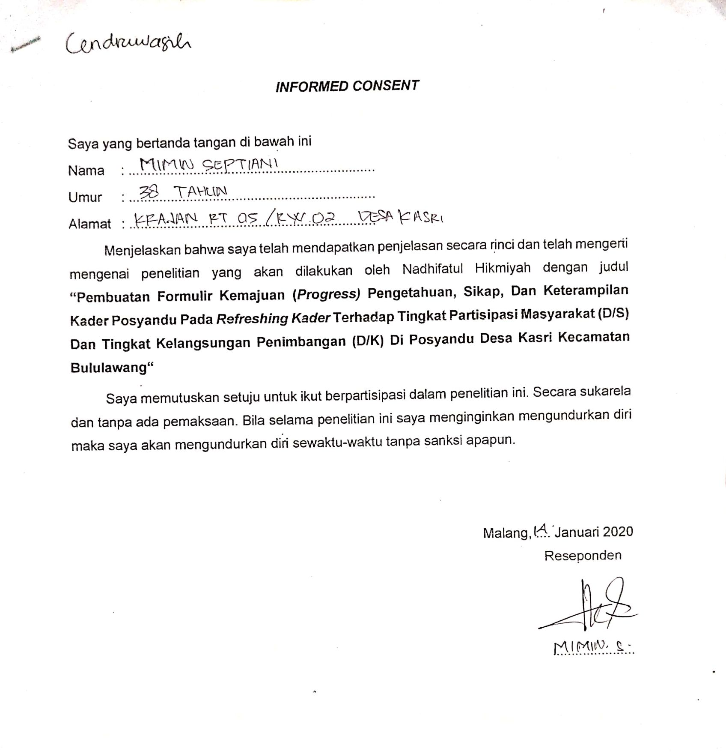
Lampiran 1. Lembar Persetujuan Responden

Lampiran 2. Kuesioner Tingkat pengetahuan, Sikap, dan Keterampilan Kader
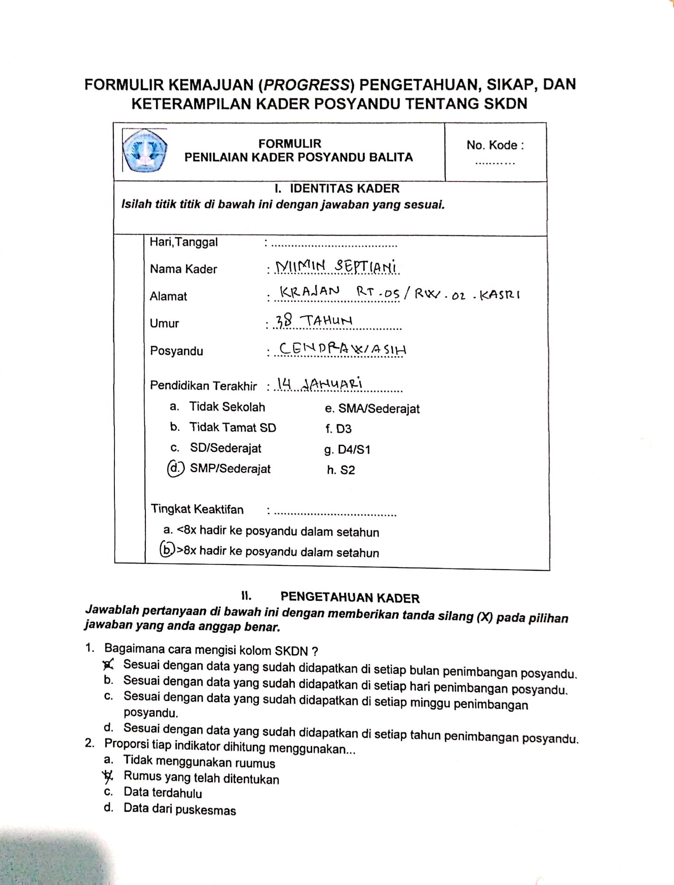
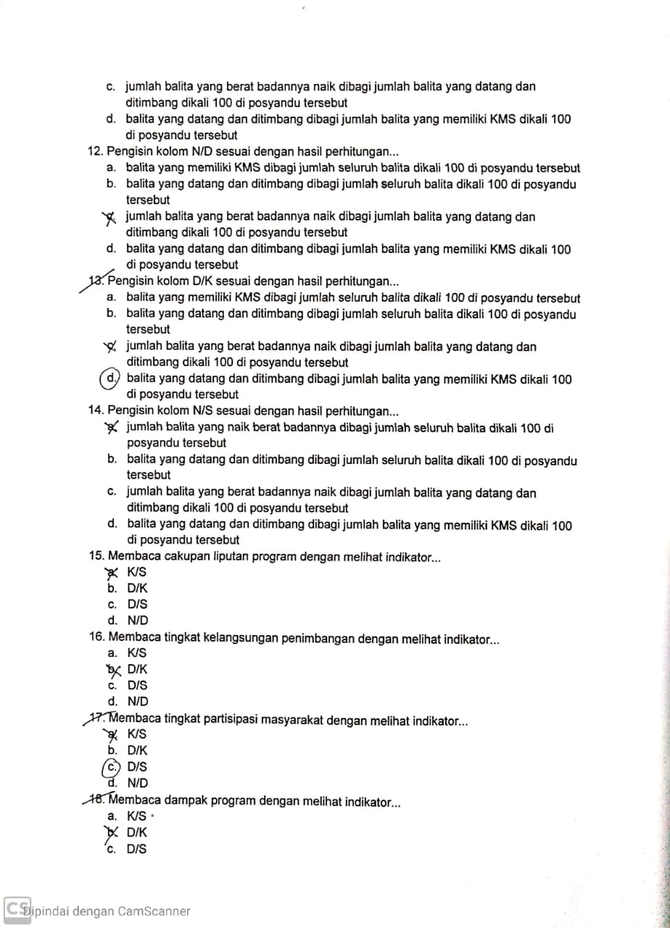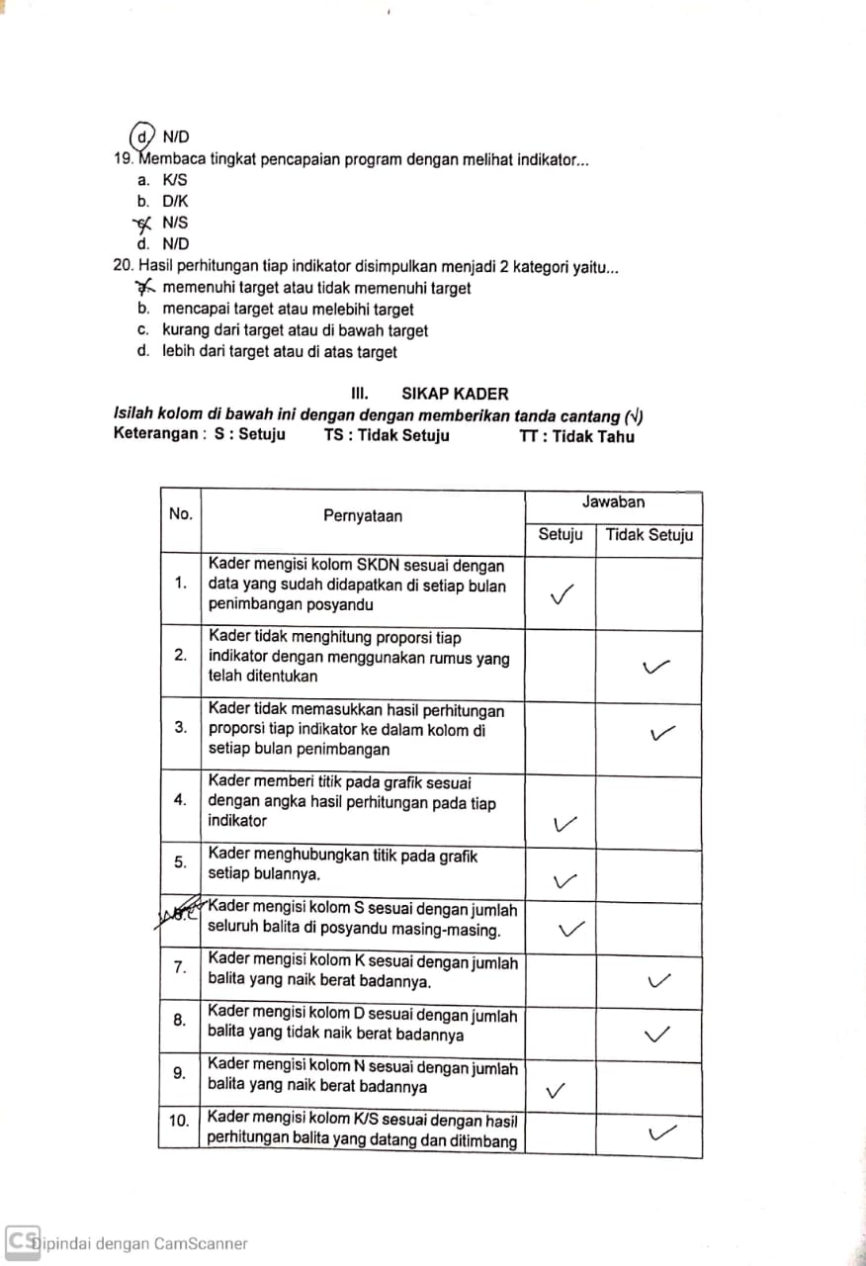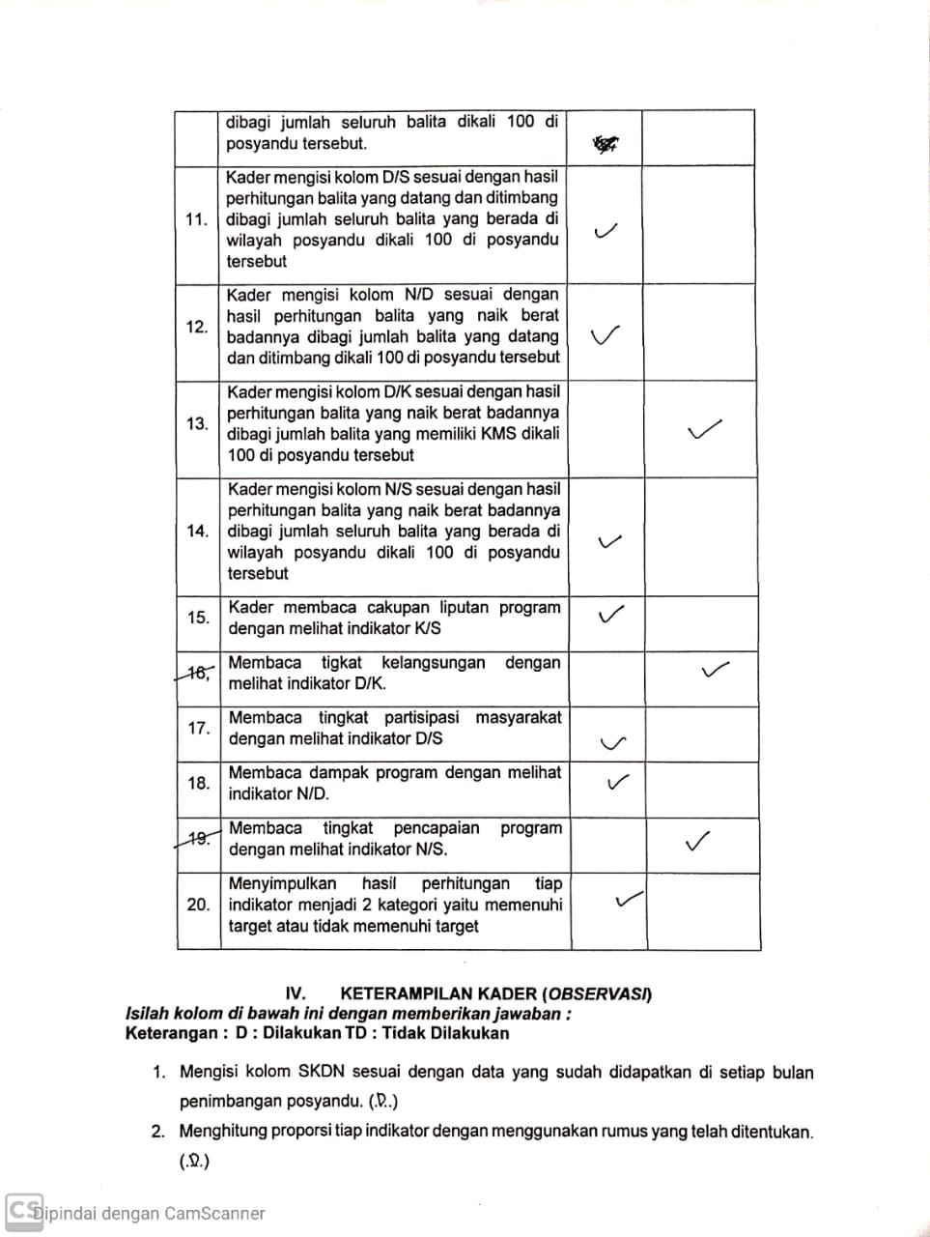
Lampiran 3. Uji Wilcoxon Signed Park Tingkat Pengetahuan

Descriptive Statistics
 | N | Mean | Std. Deviation | Minimal | Maximum
Pengetahuan_Pre | 23 | 67,17 | 19,990 | 0 | 85
Pengetahuan_Post | 23 | 81,74 | 17,556 | 15 | 100

Ranks
 |  | N | Mean Rank | Sum of Ranks
Pengetahuan_Post - Pengetahuan_Pre | Negative Ranks | 0ª | ,00 | ,00
 | Positive Ranks | 22^{b} | 11,50 | 253,00
 | Ties | 1^{c}
 | Total | 23
a. Pengetahuan_Post < Pengetahuan_Pre
b. Pengetahuan_Post > Pengetahuan_Pre
c. Pengetahuan_Post = Pengetahuan_Pre

Test Statisticsª
 | Pengetahuan_Post - Pengetahuan_Pre
Z | -4,156^{b}
Asymp. Sig. (2-tailed) | ,000
a. Wilcoxon Signed Ranks Test
b. Based on negative ranks.

Lampiran 4. Uji Wilcoxon Signed Park Sikap
Descriptive Statistics
 | N | Mean | Std. Deviation | Minimal | Maximum
Sikap_Pre | 23 | 76,30 | 17,788 | 0 | 90
Sikap_Post | 23 | 87,39 | 21,153 | 0 | 100

Ranks
 |  | N | Mean Rank | Sum of Ranks
Sikap_Post - Sikap_Pre | Negative Ranks | 0ª | ,00 | ,00
 | Positive Ranks | 19^{b} | 10,00 | 190,00
 | Ties | 4^{c}
 | Total | 23
a. Sikap_Post < Sikap_Pre
b. Sikap_Post > Sikap_Pre
c. Sikap_Post = Sikap_Pre

Test Statisticsª
 | Sikap_Post - Sikap_Pre
Z | -3,875^{b}
Asymp. Sig. (2-tailed) | ,000
a. Wilcoxon Signed Ranks Test
b. Based on negative ranks.

Lampiran 5. Uji Wilcoxon Signed Park Keterampilan
Descriptive Statistics
 | N | Mean | Std. Deviation | Minimal | Maximum
Keterampilan_Pre | 23 | 7,17 | 23,876 | 0 | 90
Keterampilan_Post | 23 | 87,17 | 16,640 | 60 | 100

Ranks
 |  | N | Mean Rank | Sum of Ranks
Keterampilan_Post - Keterampilan_Pre | Negative Ranks | 0ª | ,00 | ,00
 | Positive Ranks | 23^{b} | 12,00 | 276,00
 | Ties | 0^{c}
 | Total | 23
a. Keterampilan_Post < Keterampilan_Pre
b. Keterampilan_Post > Keterampilan_Pre
c. Keterampilan_Post = Keterampilan_Pre

Test Statisticsª
 | Keterampilan_Post - Keterampilan_Pre
Z | -4,263^{b}
Asymp. Sig. (2-tailed) | ,000
a. Wilcoxon Signed Ranks Test
b. Based on negative ranks.

Lampiran 6. Uji Wilcoxon Signed Park D/S

Descriptive Statistics
 | N | Mean | Std. Deviation | Minimal | Maximum
DS_Pre | 5 | 48,80 | 9,985 | 36 | 61
DS_Post | 5 | 67,00 | 10,173 | 53 | 77

Ranks
 |  | N | Mean Rank | Sum of Ranks
DS_Post - DS_Pre | Negative Ranks | 0ª | ,00 | ,00
 | Positive Ranks | 5^{b} | 3,00 | 15,00
 | Ties | 0^{c}
 | Total | 5
a. DS_Post < DS_Pre
b. DS_Post > DS_Pre
c. DS_Post = DS_Pre

Test Statisticsª
 | DS_Post - DS_Pre
Z | -2,023^{b}
Asymp. Sig. (2-tailed) | ,043
a. Wilcoxon Signed Ranks Test
b. Based on negative ranks.

Lampiran 7. Uji Wilcoxon Signed Park D/K
Descriptive Statistics
 | N | Mean | Std. Deviation | Minimal | Maximum
DK_Pre | 5 | 48,80 | 9,985 | 36 | 61
DK_Post | 5 | 65,60 | 8,706 | 53 | 77

Ranks
 |  | N | Mean Rank | Sum of Ranks
DK_Post - DK_Pre | Negative Ranks | 0ª | ,00 | ,00
 | Positive Ranks | 5^{b} | 3,00 | 15,00
 | Ties | 0^{c}
 | Total | 5
a. DK_Post < DK_Pre
b. DK_Post > DK_Pre
c. DK_Post = DK_Pre

Test Statisticsª
 | DK_Post - DK_Pre
Z | -2,023^{b}
Asymp. Sig. (2-tailed) | ,043
a. Wilcoxon Signed Ranks Test
b. Based on negative ranks.

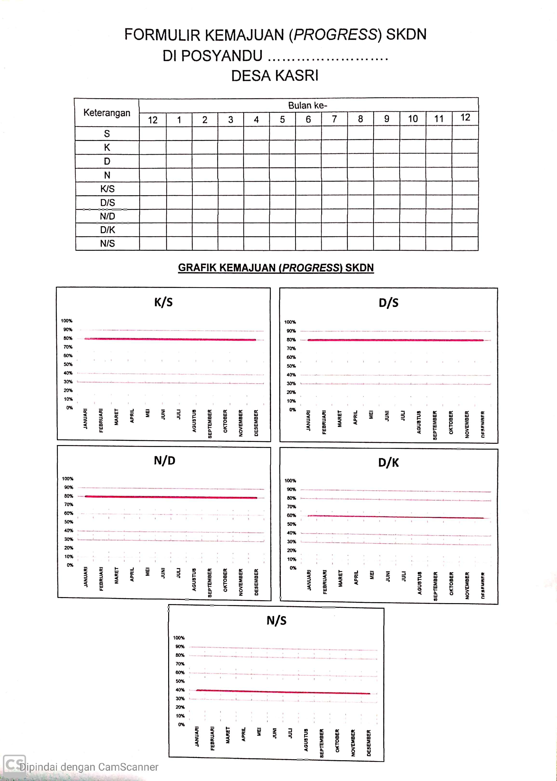
Lampiran 8. Formulir Kemajuan (Progress)
Lampiran 9. Surat Bangkespangpol
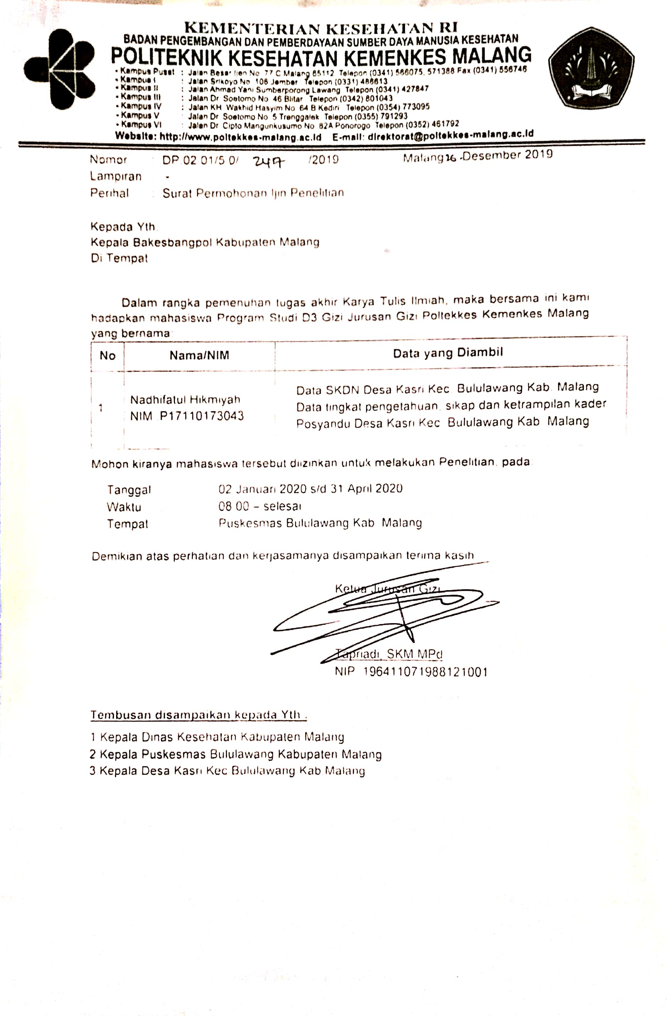
Lampiran 10. Surat Dinas Kesehatan Kabupaten Malang
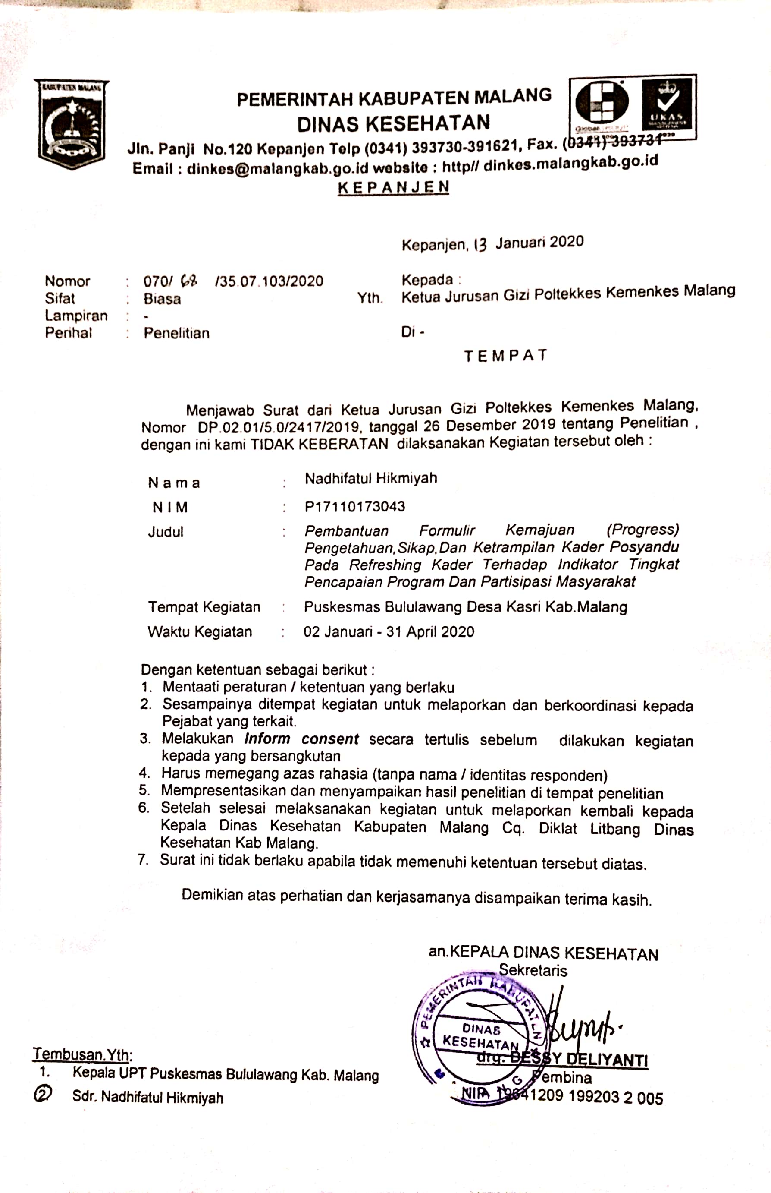
Lampiran 11. Dokumentasi Penelitian
