Lampiran 1. Surat ijin penelitian Bangkesbangpol

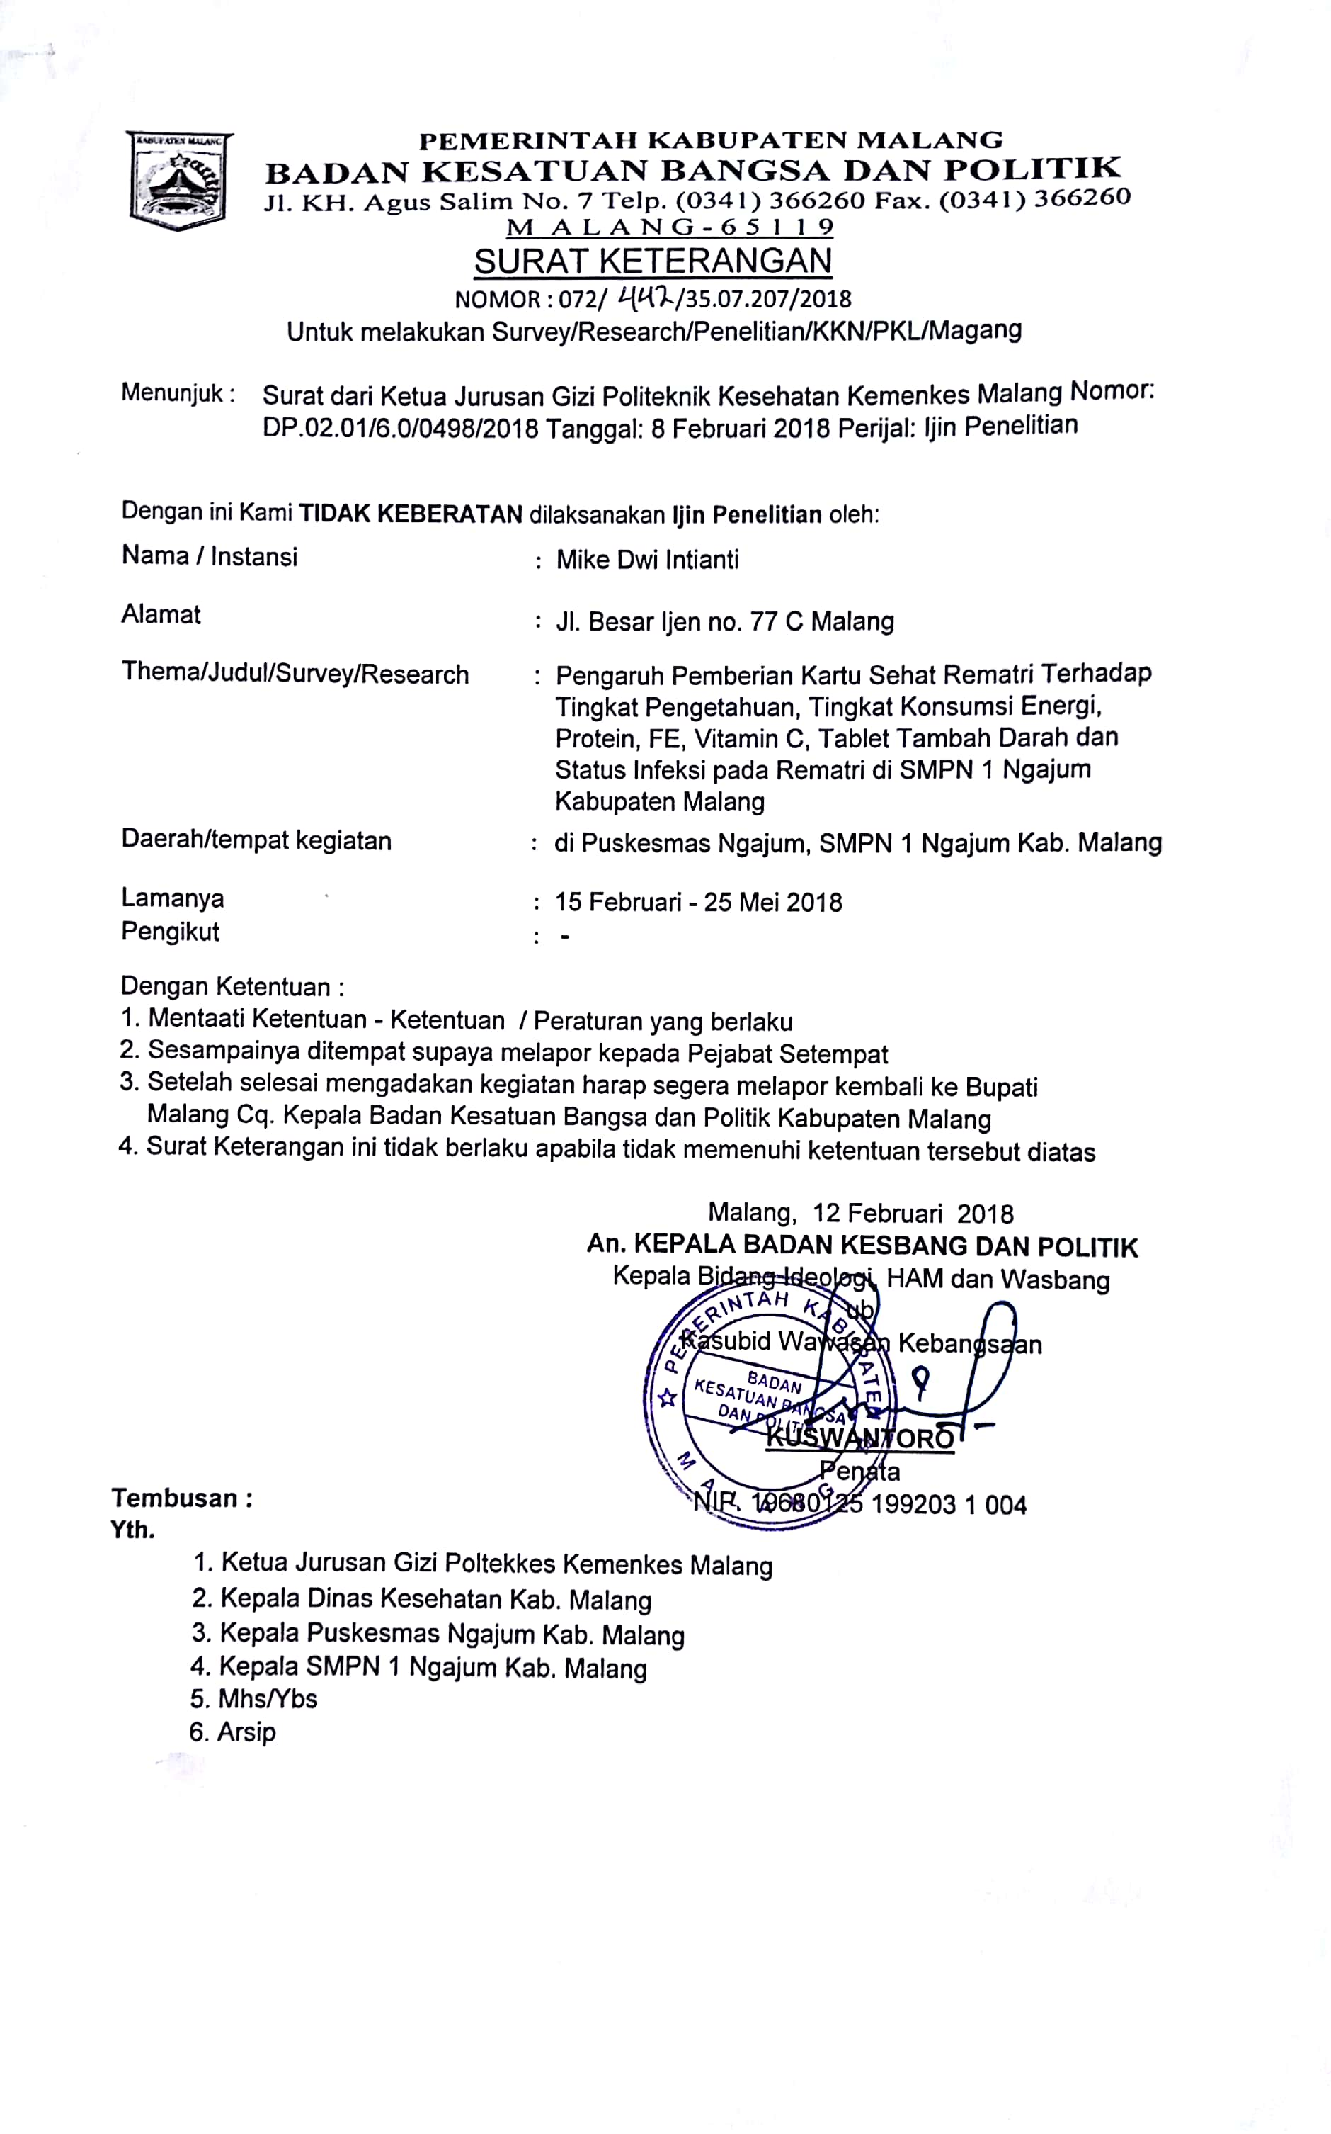

Lampiran 2. Rekomendasi persetujuan komite etik

**KOMISI ETIK PENELITIAN**

**POLITEKNIK KESEHATAN KEMENKES MALANG**

**REKOMENDASI PERSETUJUAN ETIK**

**ETHICAL APPROVAL RECOMMENDATION**

***Reg.No.:010 / KEPK-POLKESMA/ 2018***

Komisi Etik Penelitian Kesehatan Politeknik Kesehatan Malang telah menyelenggarakan Pertemuan pada tanggal 12 April 2018 untuk membahas protocol penelitian

*The Ethic Committee of Polytechnic of Health The Ministry of Health in Malang has convened a meeting on 12 April 2018 to discuss the research protocol*

|  |  |
| --- | --- |
| JudulPeneliti*Entitled* | **Pengaruh Pemberian Kartu Sehat Rematri terhadap Tingkat Pengetahuan, Tingkat Konsumsi Energi, Protein, Fe, Vitamin C, Tablet Tambah Darah dan Status Infeksi pada Rematri di SMPN 1 Ngajum Kabupaten Malang** |
|  | ***The Influence of Healthy Card on the Level of Knowledge, Energy, Protein, Fe, Vitamin C, Iron Supplement Consumption and Infection Status at Adolescent Girl in Ngajum Junior High School of Malang*** |
|  |  |
| Peneliti | MIKE DWI INTIATI |
| *Researcher* |  |

Dan menyimpulkan bahwa protocol tersebut **telah memenuhi semua persyaratan etik**

*And concluded that the protocol* ***has fulfilled all ethical requirements***

Malang, 12 April 2018



Dr. ANNASARI MUSTAFA.,MSc.

Head of Committee

Lampiran 3. Kartu sehat rematri

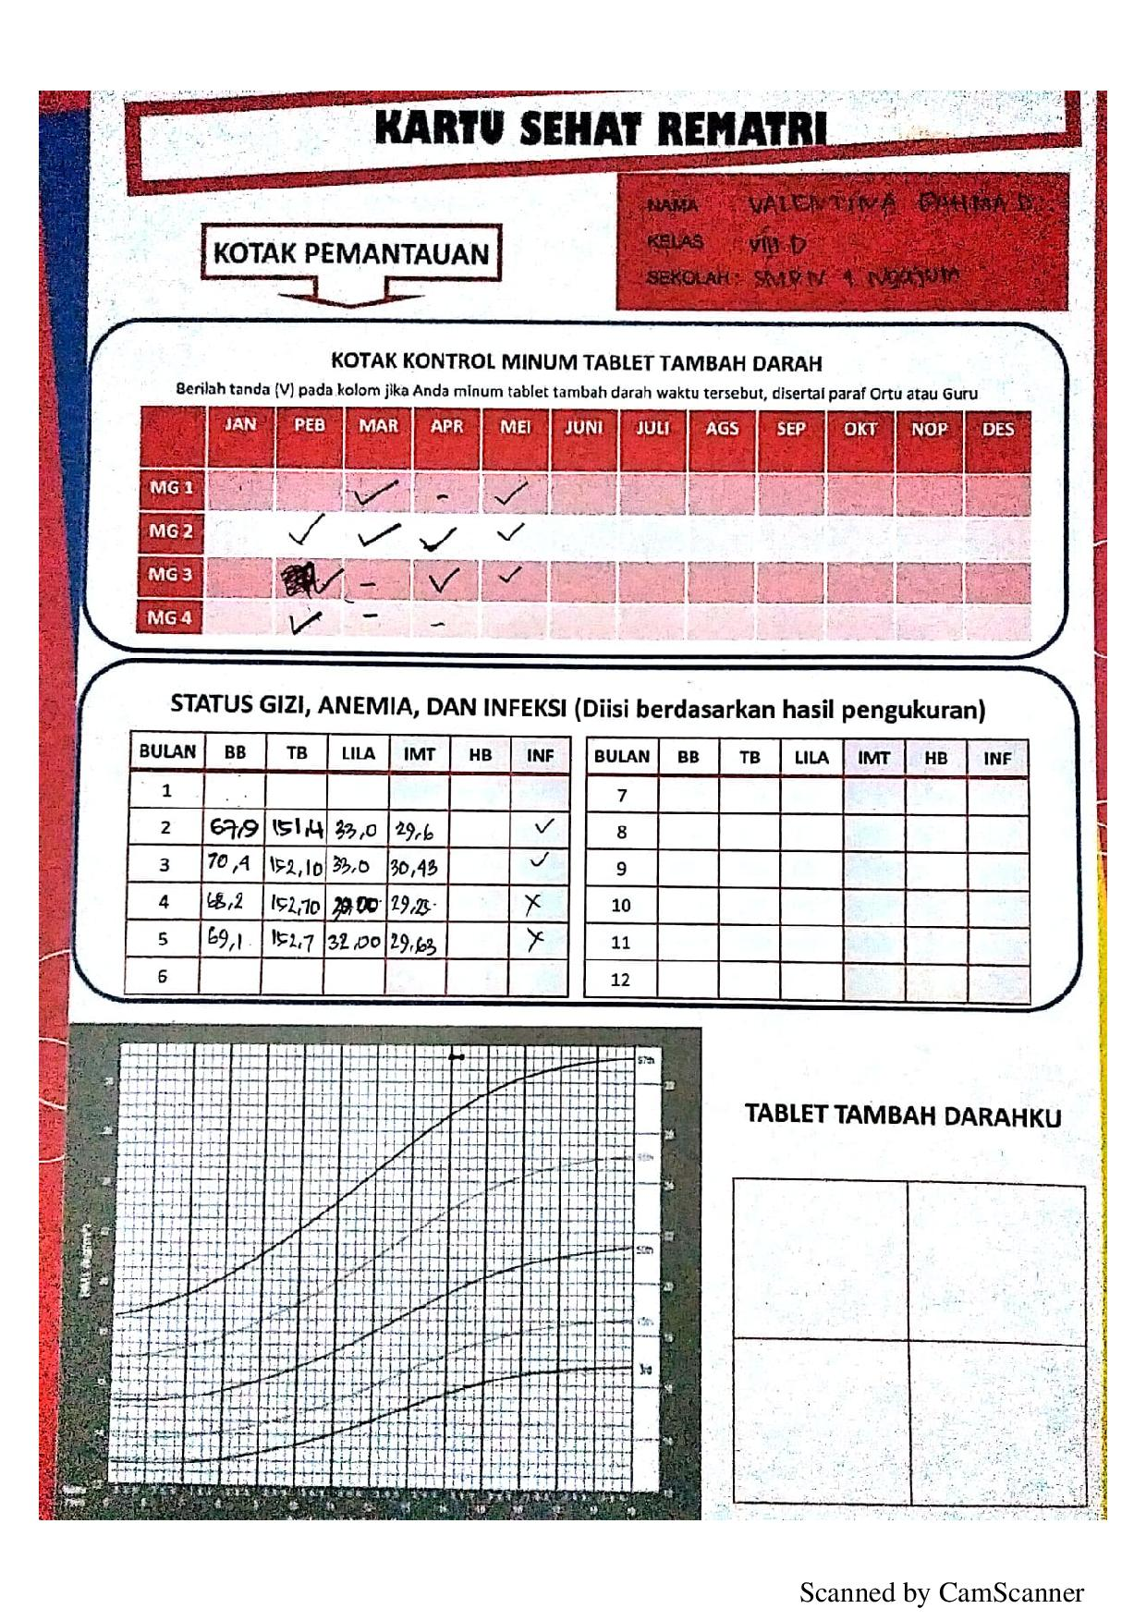

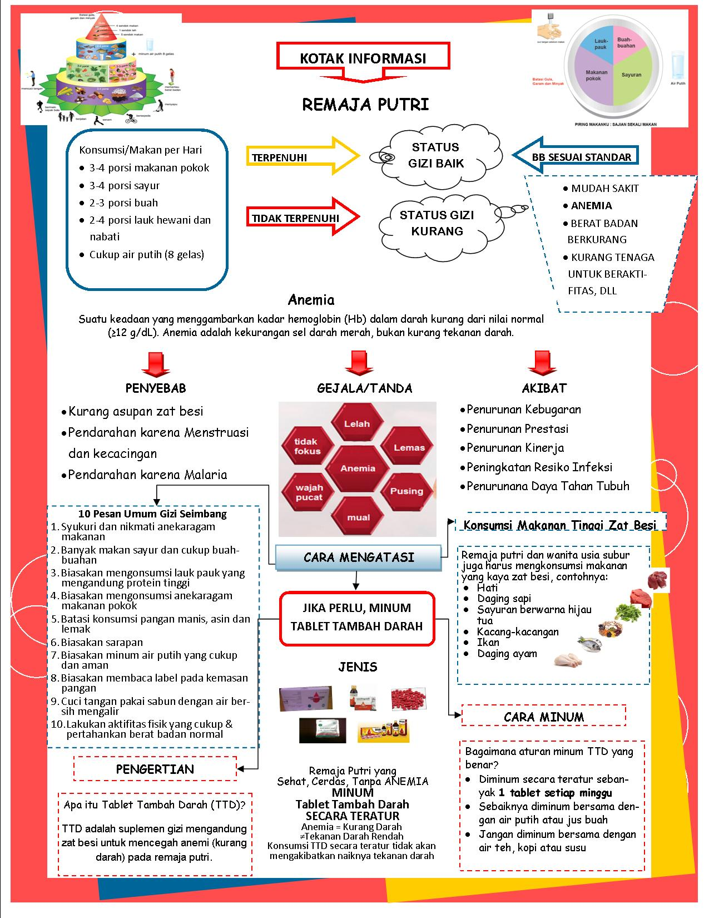

Lampiran 4. Lembar persetujuan responden

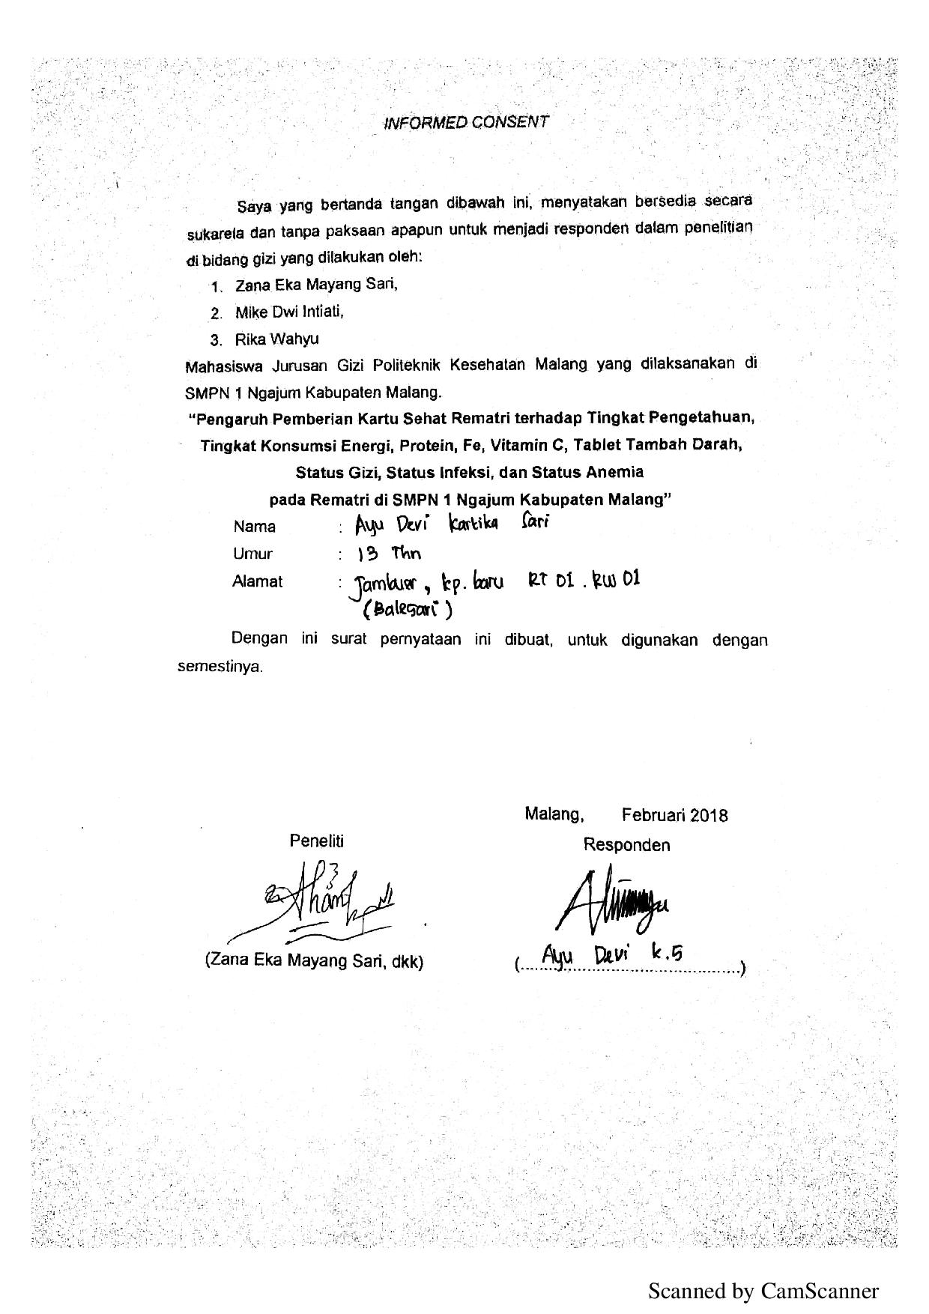

Lampiran 5. Kuesioner tingkat pengetahuan

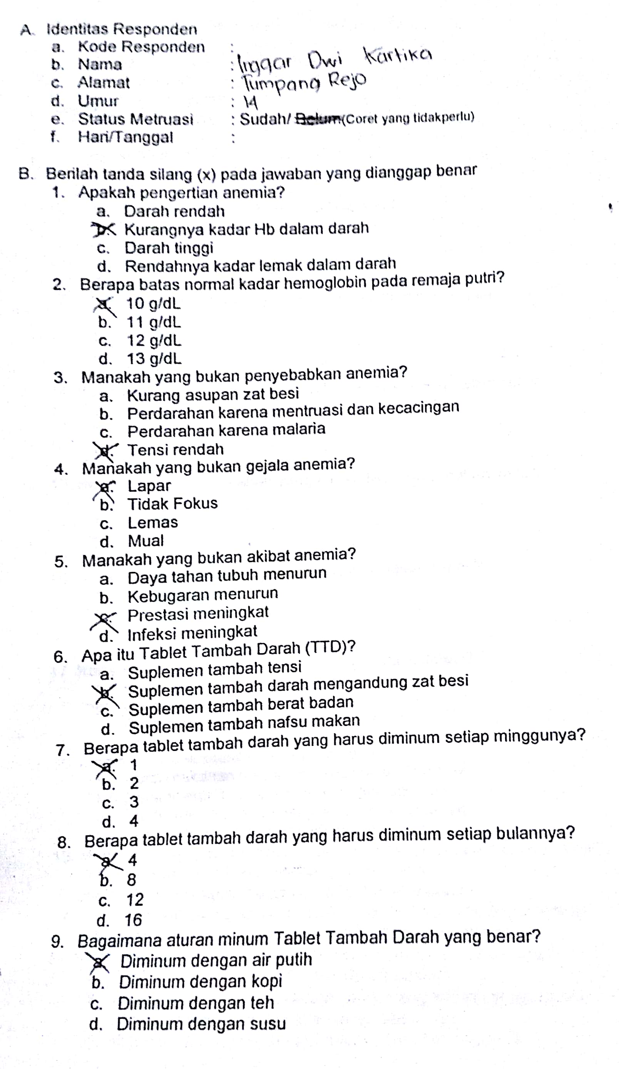

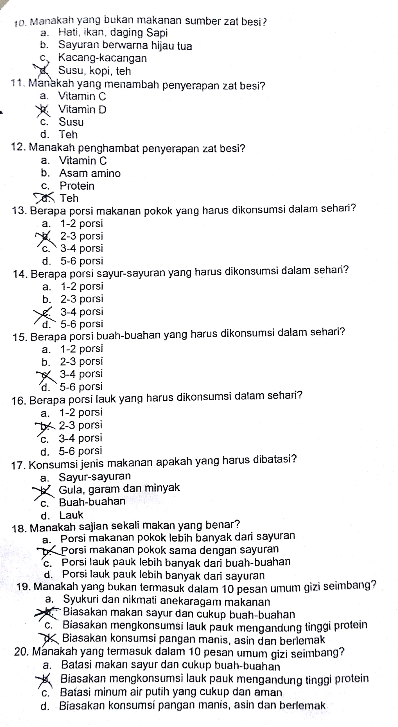

Lampiran 6. Form status infeksi

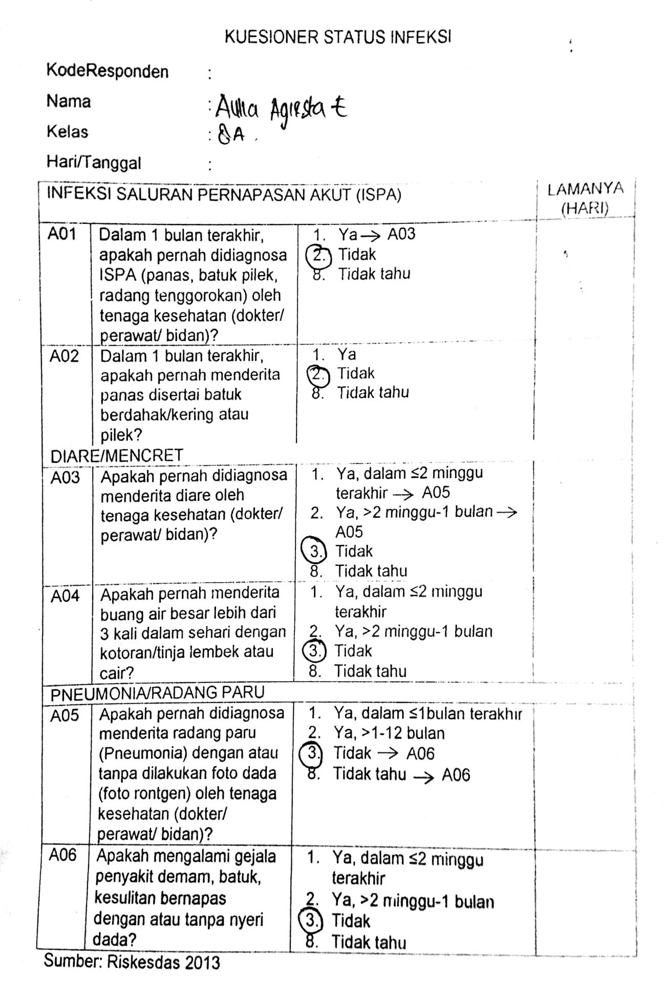

Lampiran 7. Form *Food Recall*

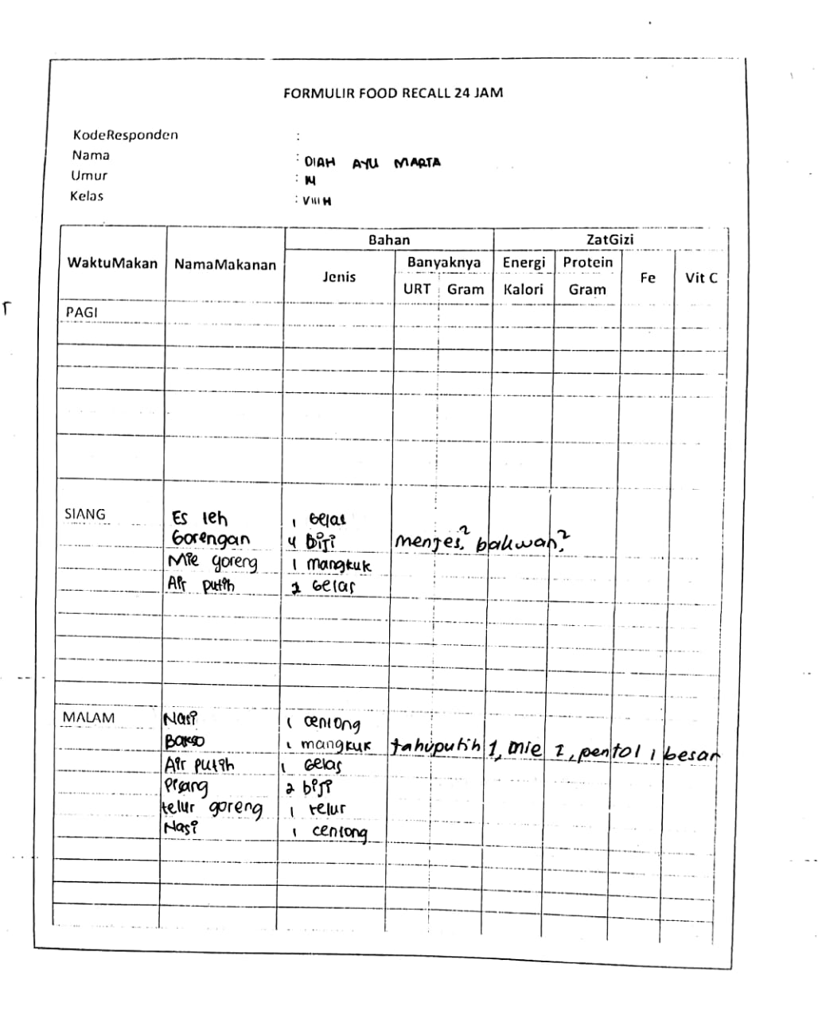

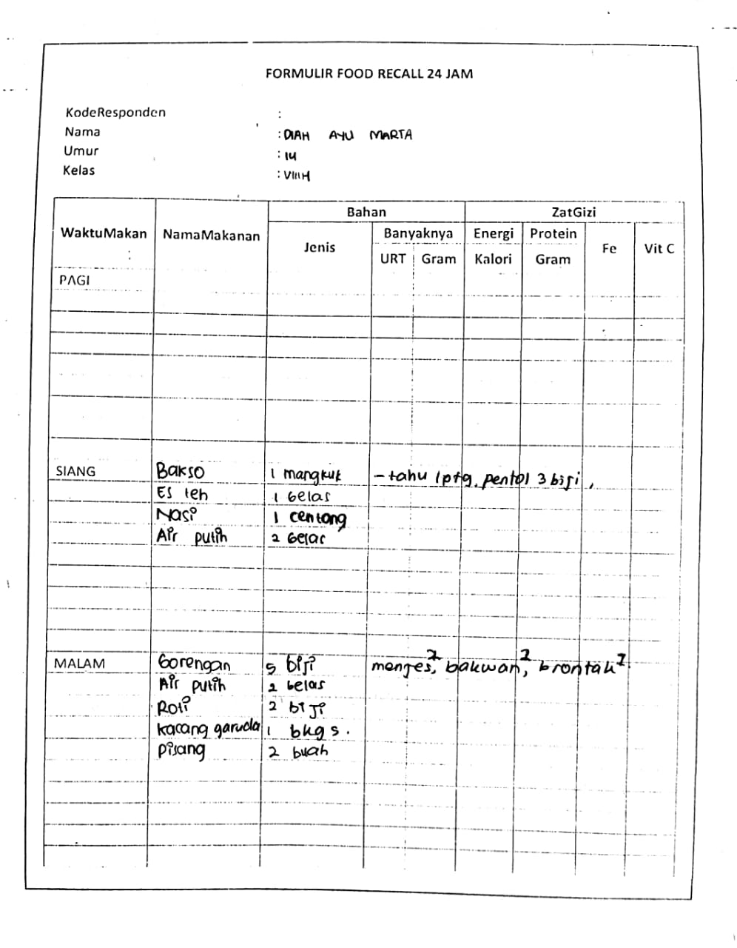

Lampiran 8. Master tabel hasil penelitian

|  |  |  |  |  |  |  |  |  |  |  |  |  |  |  |  |  |  |  |  |  |  |  |  |  |  |  |  |  |  |  |
| --- | --- | --- | --- | --- | --- | --- | --- | --- | --- | --- | --- | --- | --- | --- | --- | --- | --- | --- | --- | --- | --- | --- | --- | --- | --- | --- | --- | --- | --- | --- |
| NO | KODE RESP | U | Tingkat Pengetahuan | | | | Tingkat Konsumsi Energi | | | | Tingkat Konsumsi Protein | | | | Tingkat Konsumsi Fe | | | | Tingkat Konsumsi Vitamin C | | | | Tingkat Konsumsi TTD | | | | Status Infeksi | | | |
| B0 | B1 | B2 | B3 | B0 | B1 | B2 | B3 | B0 | B1 | B2 | B3 | B0 | B1 | B2 | B3 | B0 | B1 | B2 | B3 | B0 | B1 | B2 | B3 | B0 | B1 | B2 | B3 |
| 1 | G001 | 14 | 1 | 1 | 1 | 0 | 3 | 0 | 3 | 3 | 3 | 1 | 3 | 3 | 3 | 3 | 3 | 3 | 3 | 3 | 3 | 3 | 1 | 0 | 0 | 0 | 0 | 0 | 0 | 0 |
| 2 | G002 | 15 | 1 | 0 | 1 | 0 | 3 | 0 | 3 | 3 | 3 | 3 | 3 | 3 | 3 | 3 | 3 | 3 | 3 | 3 | 0 | 3 | 1 | 1 | 1 | 1 | 1 | 1 | 0 | 0 |
| 3 | G003 | 13 | 1 | 1 | 0 | 0 | 3 | 3 | 3 | 3 | 3 | 3 | 3 | 3 | 3 | 3 | 3 | 3 | 3 | 3 | 3 | 3 | 1 | 1 | 1 | 0 | 1 | 1 | 0 | 0 |
| 4 | G004 | 14 | 1 | 1 | 0 | 0 | 3 | 3 | 1 | 3 | 3 | 3 | 3 | 3 | 3 | 3 | 3 | 3 | 3 | 3 | 3 | 3 | 1 | 0 | 1 | 0 | 1 | 0 | 0 | 0 |
| 5 | G005 | 14 | 1 | 1 | 1 | 0 | 3 | 3 | 3 | 3 | 3 | 3 | 3 | 3 | 3 | 3 | 3 | 3 | 0 | 3 | 3 | 3 | 1 | 1 | 1 | 1 | 0 | 1 | 0 | 0 |
| 6 | G007 | 14 | 1 | 1 | 1 | 0 | 3 | 3 | 3 | 3 | 3 | 3 | 3 | 3 | 3 | 3 | 3 | 3 | 3 | 0 | 3 | 0 | 1 | 1 | 1 | 1 | 0 | 0 | 0 | 0 |
| 7 | G008 | 15 | 1 | 1 | 0 | 0 | 3 | 3 | 3 | 3 | 3 | 3 | 3 | 3 | 3 | 3 | 3 | 3 | 3 | 3 | 3 | 3 | 1 | 1 | 1 | 0 | 1 | 0 | 0 | 1 |
| 8 | G010 | 14 | 1 | 1 | 1 | 0 | 3 | 3 | 3 | 3 | 3 | 3 | 3 | 3 | 3 | 3 | 3 | 3 | 3 | 3 | 3 | 3 | 1 | 1 | 1 | 0 | 0 | 0 | 1 | 1 |
| 9 | G012 | 14 | 1 | 1 | 0 | 0 | 3 | 3 | 3 | 3 | 3 | 3 | 3 | 3 | 3 | 3 | 3 | 3 | 3 | 0 | 3 | 3 | 1 | 1 | 1 | 1 | 0 | 0 | 1 | 1 |
| 10 | G013 | 14 | 1 | 0 | 0 | 0 | 3 | 3 | 3 | 3 | 2 | 3 | 3 | 3 | 2 | 3 | 3 | 3 | 3 | 1 | 3 | 3 | 1 | 0 | 0 | 0 | 1 | 0 | 0 | 0 |
| 11 | G014 | 14 | 1 | 1 | 1 | 1 | 3 | 3 | 3 | 3 | 3 | 3 | 3 | 3 | 3 | 3 | 3 | 3 | 3 | 3 | 3 | 3 | 1 | 1 | 1 | 0 | 0 | 0 | 0 | 0 |
| 12 | G015 | 14 | 1 | 1 | 1 | 0 | 3 | 3 | 3 | 3 | 3 | 3 | 3 | 3 | 3 | 3 | 3 | 3 | 3 | 3 | 3 | 3 | 1 | 1 | 0 | 0 | 0 | 0 | 0 | 0 |
| 13 | G016 | 14 | 1 | 0 | 0 | 0 | 3 | 3 | 3 | 3 | 3 | 3 | 3 | 3 | 3 | 3 | 3 | 3 | 3 | 3 | 3 | 3 | 1 | 1 | 1 | 0 | 0 | 0 | 0 | 0 |
| 14 | G017 | 14 | 1 | 0 | 0 | 0 | 3 | 3 | 3 | 3 | 3 | 3 | 3 | 3 | 3 | 3 | 3 | 3 | 3 | 3 | 3 | 3 | 1 | 0 | 0 | 0 | 1 | 0 | 0 | 0 |
| 15 | G018 | 14 | 1 | 1 | 1 | 1 | 3 | 3 | 3 | 3 | 3 | 3 | 3 | 3 | 3 | 3 | 3 | 3 | 3 | 3 | 3 | 3 | 1 | 1 | 1 | 0 | 1 | 0 | 0 | 0 |
| 16 | G019 | 13 | 1 | 1 | 1 | 0 | 2 | 2 | 2 | 3 | 2 | 1 | 2 | 3 | 3 | 2 | 3 | 3 | 3 | 0 | 3 | 3 | 1 | 1 | 0 | 0 | 1 | 0 | 0 | 0 |
| 17 | G020 | 14 | 1 | 1 | 1 | 0 | 3 | 3 | 3 | 3 | 3 | 3 | 3 | 3 | 3 | 3 | 3 | 3 | 2 | 3 | 3 | 3 | 1 | 0 | 0 | 0 | 1 | 0 | 0 | 0 |
| 18 | G021 | 14 | 1 | 1 | 1 | 0 | 3 | 3 | 3 | 3 | 3 | 3 | 3 | 3 | 3 | 3 | 3 | 3 | 3 | 3 | 3 | 3 | 1 | 1 | 1 | 1 | 0 | 1 | 1 | 0 |
| 19 | G022 | 13 | 1 | 1 | 0 | 1 | 3 | 2 | 3 | 3 | 3 | 3 | 3 | 3 | 3 | 3 | 3 | 3 | 3 | 3 | 3 | 3 | 1 | 1 | 1 | 1 | 1 | 1 | 1 | 1 |
| 20 | G023 | 14 | 1 | 0 | 0 | 0 | 3 | 3 | 3 | 3 | 3 | 3 | 3 | 3 | 3 | 3 | 3 | 3 | 3 | 3 | 3 | 3 | 1 | 1 | 1 | 1 | 1 | 1 | 1 | 0 |
| NO | KODE RESP | U | Tingkat Pengetahuan | | | | Tingkat Konsumsi Energi | | | | Tingkat Konsumsi Protein | | | | Tingkat Konsumsi Fe | | | | Tingkat Konsumsi Vitamin C | | | | Tingkat Konsumsi TTD | | | | Status Infeksi | | | |
| B0 | B1 | B2 | B3 | B0 | B1 | B2 | B3 | B0 | B1 | B2 | B3 | B0 | B1 | B2 | B3 | B0 | B1 | B2 | B3 | B0 | B1 | B2 | B3 | B0 | B1 | B2 | B3 |
| 21 | G024 | 14 | 1 | 1 | 1 | 1 | 3 | 3 | 3 | 3 | 3 | 3 | 3 | 3 | 3 | 3 | 3 | 3 | 3 | 3 | 3 | 3 | 1 | 0 | 0 | 0 | 1 | 1 | 1 | 0 |
| 22 | G026 | 13 | 1 | 1 | 0 | 0 | 3 | 3 | 3 | 3 | 3 | 3 | 3 | 3 | 3 | 3 | 3 | 3 | 3 | 3 | 3 | 3 | 1 | 1 | 1 | 1 | 1 | 0 | 1 | 1 |
| 23 | G027 | 15 | 1 | 1 | 1 | 1 | 3 | 2 | 3 | 3 | 3 | 3 | 3 | 3 | 3 | 3 | 3 | 3 | 3 | 1 | 3 | 3 | 1 | 1 | 1 | 1 | 0 | 1 | 1 | 1 |
| 24 | G028 | 14 | 1 | 1 | 0 | 0 | 3 | 3 | 3 | 3 | 3 | 3 | 3 | 3 | 3 | 3 | 3 | 3 | 3 | 3 | 3 | 3 | 1 | 1 | 1 | 1 | 0 | 1 | 0 | 0 |
| 25 | G029 | 14 | 1 | 1 | 0 | 0 | 3 | 3 | 3 | 3 | 3 | 3 | 3 | 3 | 3 | 3 | 3 | 3 | 3 | 3 | 3 | 3 | 1 | 0 | 0 | 0 | 0 | 0 | 0 | 0 |
| 26 | G030 | 15 | 1 | 1 | 0 | 0 | 3 | 3 | 3 | 3 | 3 | 3 | 3 | 3 | 3 | 3 | 3 | 3 | 2 | 3 | 3 | 3 | 1 | 1 | 1 | 1 | 1 | 1 | 1 | 1 |
| 27 | G031 | 14 | 1 | 1 | 1 | 1 | 3 | 3 | 3 | 3 | 3 | 3 | 3 | 3 | 3 | 3 | 3 | 3 | 3 | 3 | 3 | 3 | 1 | 1 | 1 | 1 | 0 | 1 | 0 | 0 |
| 28 | G033 | 15 | 1 | 1 | 1 | 1 | 3 | 3 | 3 | 3 | 3 | 3 | 3 | 3 | 3 | 3 | 3 | 3 | 3 | 2 | 3 | 3 | 1 | 1 | 1 | 1 | 1 | 1 | 0 | 0 |
| 29 | G036 | 14 | 1 | 1 | 1 | 1 | 3 | 2 | 3 | 3 | 3 | 3 | 3 | 3 | 3 | 3 | 3 | 3 | 3 | 3 | 3 | 3 | 1 | 1 | 1 | 1 | 0 | 0 | 0 | 0 |
| 30 | G037 | 15 | 1 | 1 | 0 | 0 | 3 | 3 | 3 | 3 | 3 | 3 | 3 | 3 | 3 | 3 | 3 | 3 | 3 | 3 | 3 | 3 | 1 | 0 | 0 | 0 | 0 | 0 | 1 | 0 |
| 31 | G038 | 14 | 1 | 1 | 0 | 0 | 3 | 3 | 3 | 3 | 3 | 3 | 3 | 3 | 3 | 3 | 3 | 3 | 3 | 3 | 3 | 3 | 1 | 1 | 1 | 1 | 0 | 0 | 0 | 1 |
| 32 | G039 | 14 | 1 | 1 | 1 | 1 | 3 | 3 | 3 | 3 | 3 | 3 | 3 | 3 | 3 | 3 | 3 | 3 | 0 | 3 | 3 | 3 | 1 | 1 | 1 | 1 | 0 | 1 | 0 | 0 |
| 33 | G040 | 14 | 1 | 1 | 0 | 0 | 3 | 3 | 3 | 2 | 3 | 3 | 3 | 3 | 3 | 3 | 3 | 3 | 3 | 3 | 3 | 3 | 1 | 1 | 1 | 1 | 0 | 0 | 0 | 0 |
| 34 | G042 | 14 | 1 | 1 | 1 | 0 | 3 | 2 | 3 | 3 | 3 | 3 | 3 | 3 | 3 | 3 | 3 | 3 | 3 | 3 | 3 | 3 | 1 | 1 | 1 | 1 | 0 | 0 | 1 | 0 |
| 35 | G044 | 15 | 1 | 0 | 0 | 0 | 3 | 3 | 3 | 3 | 3 | 3 | 3 | 3 | 3 | 3 | 3 | 3 | 3 | 3 | 3 | 3 | 1 | 1 | 1 | 1 | 0 | 1 | 1 | 0 |
| 36 | G045 | 14 | 1 | 1 | 1 | 0 | 3 | 3 | 3 | 3 | 3 | 3 | 3 | 3 | 3 | 3 | 3 | 3 | 3 | 3 | 3 | 3 | 1 | 1 | 1 | 1 | 0 | 0 | 0 | 0 |
| 37 | G046 | 14 | 1 | 1 | 1 | 0 | 3 | 3 | 3 | 3 | 3 | 3 | 3 | 3 | 3 | 3 | 3 | 3 | 3 | 3 | 3 | 3 | 1 | 1 | 1 | 1 | 0 | 0 | 0 | 0 |
| 38 | G047 | 14 | 1 | 1 | 0 | 0 | 3 | 1 | 3 | 3 | 3 | 3 | 3 | 3 | 3 | 3 | 3 | 3 | 3 | 3 | 1 | 3 | 1 | 1 | 1 | 1 | 0 | 0 | 0 | 0 |
| 39 | G050 | 14 | 1 | 0 | 0 | 0 | 1 | 3 | 3 | 3 | 2 | 3 | 3 | 3 | 3 | 3 | 3 | 3 | 3 | 3 | 1 | 2 | 1 | 1 | 1 | 1 | 1 | 0 | 0 | 0 |
| 40 | G051 | 15 | 1 | 1 | 1 | 0 | 3 | 3 | 3 | 3 | 3 | 3 | 3 | 3 | 3 | 3 | 3 | 3 | 3 | 3 | 3 | 3 | 1 | 1 | 1 | 1 | 0 | 1 | 0 | 1 |
| NO | KODE RESP | U | Tingkat Pengetahuan | | | | Tingkat Konsumsi Energi | | | | Tingkat Konsumsi Protein | | | | Tingkat Konsumsi Fe | | | | Tingkat Konsumsi Vitamin C | | | | Tingkat Konsumsi TTD | | | | Status Infeksi | | | |
| B0 | B1 | B2 | B3 | B0 | B1 | B2 | B3 | B0 | B1 | B2 | B3 | B0 | B1 | B2 | B3 | B0 | B1 | B2 | B3 | B0 | B1 | B2 | B3 | B0 | B1 | B2 | B3 |
| 41 | G053 | 14 | 1 | 1 | 0 | 0 | 3 | 3 | 3 | 3 | 3 | 3 | 3 | 3 | 3 | 3 | 3 | 3 | 3 | 3 | 3 | 3 | 1 | 1 | 1 | 0 | 1 | 1 | 0 | 0 |
| 42 | G054 | 14 | 1 | 1 | 0 | 0 | 3 | 3 | 3 | 3 | 3 | 3 | 3 | 3 | 3 | 3 | 3 | 3 | 3 | 3 | 3 | 3 | 1 | 0 | 0 | 0 | 0 | 0 | 0 | 0 |
| 43 | G055 | 14 | 1 | 1 | 0 | 0 | 3 | 3 | 3 | 3 | 3 | 3 | 3 | 3 | 3 | 3 | 3 | 3 | 3 | 3 | 3 | 3 | 1 | 1 | 1 | 0 | 1 | 1 | 0 | 0 |
| 44 | G057 | 14 | 1 | 1 | 1 | 0 | 3 | 3 | 3 | 3 | 3 | 3 | 3 | 3 | 3 | 3 | 3 | 3 | 3 | 3 | 3 | 3 | 1 | 1 | 1 | 1 | 1 | 1 | 1 | 0 |
| 45 | G058 | 14 | 1 | 1 | 1 | 1 | 3 | 3 | 3 | 3 | 3 | 3 | 3 | 3 | 3 | 3 | 3 | 3 | 3 | 1 | 3 | 3 | 1 | 1 | 1 | 1 | 1 | 1 | 1 | 0 |
| 46 | G059 | 13 | 1 | 1 | 1 | 0 | 3 | 3 | 3 | 3 | 3 | 3 | 3 | 3 | 3 | 3 | 3 | 3 | 0 | 0 | 3 | 3 | 1 | 1 | 1 | 0 | 1 | 1 | 1 | 0 |
| 47 | G060 | 15 | 1 | 1 | 0 | 0 | 3 | 3 | 3 | 3 | 3 | 3 | 3 | 3 | 3 | 3 | 3 | 3 | 3 | 3 | 3 | 3 | 1 | 1 | 1 | 1 | 0 | 1 | 0 | 0 |
| 48 | G061 | 13 | 1 | 1 | 0 | 0 | 3 | 3 | 3 | 3 | 2 | 3 | 3 | 3 | 3 | 3 | 3 | 3 | 3 | 3 | 1 | 3 | 1 | 1 | 1 | 1 | 1 | 1 | 0 | 1 |
| 49 | G063 | 15 | 1 | 1 | 1 | 1 | 3 | 3 | 3 | 3 | 3 | 3 | 3 | 3 | 3 | 3 | 3 | 3 | 3 | 3 | 3 | 3 | 1 | 1 | 1 | 1 | 1 | 0 | 0 | 1 |
| 50 | G064 | 13 | 1 | 1 | 0 | 0 | 3 | 3 | 3 | 3 | 3 | 3 | 3 | 3 | 3 | 3 | 3 | 3 | 3 | 3 | 3 | 3 | 1 | 1 | 1 | 1 | 0 | 1 | 0 | 0 |
| 51 | G065 | 13 | 1 | 1 | 1 | 0 | 3 | 3 | 3 | 3 | 3 | 3 | 3 | 3 | 3 | 3 | 3 | 3 | 3 | 3 | 3 | 3 | 1 | 1 | 1 | 0 | 1 | 1 | 0 | 0 |
| 52 | G066 | 14 | 2 | 1 | 1 | 1 | 3 | 3 | 3 | 3 | 3 | 3 | 3 | 3 | 3 | 3 | 3 | 3 | 3 | 3 | 3 | 3 | 1 | 1 | 1 | 1 | 1 | 1 | 0 | 0 |
| 53 | G068 | 15 | 1 | 0 | 0 | 0 | 3 | 3 | 3 | 3 | 3 | 3 | 3 | 3 | 3 | 3 | 3 | 3 | 3 | 3 | 3 | 3 | 1 | 1 | 1 | 1 | 1 | 1 | 0 | 0 |
| 54 | G069 | 14 | 1 | 1 | 0 | 0 | 3 | 3 | 3 | 3 | 3 | 3 | 3 | 3 | 3 | 3 | 3 | 3 | 3 | 3 | 3 | 3 | 1 | 1 | 1 | 1 | 1 | 0 | 0 | 1 |
| 55 | G070 | 13 | 1 | 1 | 0 | 0 | 3 | 3 | 3 | 3 | 3 | 3 | 3 | 3 | 3 | 3 | 3 | 3 | 3 | 3 | 3 | 3 | 1 | 1 | 1 | 1 | 0 | 0 | 0 | 0 |
| 56 | G071 | 14 | 1 | 0 | 0 | 0 | 3 | 2 | 3 | 2 | 3 | 3 | 3 | 3 | 3 | 3 | 3 | 3 | 0 | 0 | 0 | 3 | 1 | 1 | 1 | 0 | 0 | 0 | 0 | 0 |
| 57 | G072 | 15 | 1 | 0 | 1 | 0 | 3 | 3 | 3 | 3 | 3 | 3 | 3 | 3 | 3 | 3 | 3 | 3 | 3 | 3 | 3 | 3 | 1 | 1 | 1 | 0 | 0 | 1 | 0 | 0 |
| 58 | G074 | 14 | 1 | 1 | 0 | 0 | 3 | 3 | 3 | 3 | 3 | 3 | 3 | 3 | 3 | 3 | 3 | 3 | 3 | 3 | 3 | 3 | 1 | 1 | 1 | 0 | 0 | 0 | 0 | 0 |
| 59 | G075 | 13 | 1 | 1 | 1 | 0 | 3 | 3 | 3 | 3 | 3 | 3 | 3 | 3 | 3 | 3 | 3 | 3 | 3 | 3 | 3 | 3 | 1 | 1 | 1 | 0 | 0 | 0 | 0 | 0 |
| 60 | G076 | 14 | 1 | 1 | 1 | 1 | 3 | 3 | 3 | 3 | 3 | 3 | 3 | 3 | 3 | 3 | 3 | 3 | 3 | 3 | 3 | 3 | 1 | 1 | 1 | 1 | 0 | 0 | 0 | 0 |
| NO | KODE RESP | U | Tingkat Pengetahuan | | | | Tingkat Konsumsi Energi | | | | Tingkat Konsumsi Protein | | | | Tingkat Konsumsi Fe | | | | Tingkat Konsumsi Vitamin C | | | | Tingkat Konsumsi TTD | | | | Status Infeksi | | | |
| B0 | B1 | B2 | B3 | B0 | B1 | B2 | B3 | B0 | B1 | B2 | B3 | B0 | B1 | B2 | B3 | B0 | B1 | B2 | B3 | B0 | B1 | B2 | B3 | B0 | B1 | B2 | B3 |
| 61 | G077 | 14 | 1 | 0 | 0 | 0 | 3 | 3 | 3 | 3 | 3 | 3 | 3 | 3 | 3 | 3 | 3 | 3 | 3 | 3 | 3 | 3 | 1 | 1 | 1 | 0 | 0 | 0 | 0 | 0 |
| 62 | G078 | 14 | 1 | 1 | 0 | 0 | 2 | 3 | 3 | 3 | 3 | 3 | 3 | 3 | 3 | 3 | 3 | 3 | 3 | 3 | 3 | 3 | 1 | 1 | 1 | 1 | 0 | 0 | 0 | 0 |
| 63 | G079 | 14 | 1 | 0 | 0 | 0 | 3 | 3 | 3 | 3 | 2 | 3 | 3 | 3 | 3 | 3 | 3 | 3 | 3 | 0 | 3 | 3 | 1 | 1 | 1 | 1 | 0 | 0 | 0 | 0 |
| 64 | G080 | 15 | 1 | 1 | 0 | 0 | 3 | 3 | 3 | 3 | 3 | 3 | 3 | 3 | 3 | 3 | 3 | 3 | 3 | 3 | 3 | 3 | 1 | 1 | 1 | 0 | 0 | 0 | 0 | 0 |
| 65 | G081 | 14 | 1 | 1 | 0 | 0 | 3 | 3 | 3 | 3 | 3 | 3 | 3 | 3 | 3 | 3 | 3 | 3 | 3 | 3 | 3 | 3 | 1 | 1 | 1 | 1 | 0 | 1 | 0 | 0 |
| 66 | G082 | 13 | 1 | 1 | 0 | 0 | 3 | 3 | 2 | 3 | 3 | 3 | 3 | 3 | 3 | 3 | 3 | 3 | 3 | 3 | 3 | 3 | 1 | 1 | 1 | 1 | 1 | 0 | 0 | 0 |
| 67 | G083 | 14 | 1 | 1 | 0 | 0 | 3 | 3 | 3 | 3 | 3 | 3 | 3 | 3 | 3 | 3 | 3 | 3 | 3 | 3 | 3 | 3 | 1 | 1 | 1 | 1 | 1 | 1 | 0 | 0 |
| 68 | G084 | 14 | 1 | 1 | 1 | 1 | 3 | 3 | 3 | 3 | 3 | 3 | 3 | 3 | 3 | 3 | 3 | 3 | 3 | 3 | 3 | 3 | 1 | 1 | 1 | 1 | 0 | 0 | 0 | 0 |
| 69 | G085 | 13 | 1 | 1 | 1 | 0 | 3 | 3 | 3 | 3 | 3 | 3 | 3 | 3 | 3 | 3 | 3 | 3 | 3 | 3 | 3 | 3 | 1 | 1 | 1 | 1 | 1 | 0 | 0 | 0 |
| 70 | G086 | 13 | 2 | 1 | 1 | 1 | 3 | 1 | 3 | 3 | 3 | 3 | 3 | 3 | 3 | 3 | 3 | 3 | 3 | 3 | 3 | 3 | 1 | 0 | 0 | 0 | 1 | 1 | 1 | 1 |
| 71 | G087 | 13 | 1 | 1 | 1 | 1 | 3 | 3 | 3 | 3 | 3 | 3 | 3 | 3 | 3 | 3 | 3 | 3 | 0 | 3 | 3 | 3 | 1 | 1 | 1 | 1 | 0 | 0 | 0 | 0 |
| 72 | G088 | 14 | 1 | 1 | 0 | 0 | 3 | 1 | 3 | 3 | 3 | 3 | 3 | 3 | 3 | 3 | 3 | 3 | 3 | 1 | 3 | 3 | 1 | 1 | 1 | 1 | 0 | 1 | 0 | 0 |
| 73 | G089 | 14 | 1 | 1 | 1 | 0 | 3 | 3 | 3 | 3 | 3 | 3 | 3 | 3 | 3 | 3 | 3 | 3 | 3 | 3 | 3 | 3 | 1 | 1 | 1 | 1 | 1 | 1 | 0 | 0 |
| 74 | G090 | 14 | 1 | 1 | 0 | 0 | 3 | 3 | 3 | 3 | 3 | 3 | 3 | 3 | 3 | 3 | 3 | 3 | 3 | 0 | 3 | 3 | 1 | 1 | 1 | 1 | 1 | 1 | 0 | 0 |
| 75 | G091 | 13 | 1 | 1 | 1 | 1 | 3 | 3 | 3 | 3 | 3 | 3 | 3 | 3 | 3 | 3 | 3 | 3 | 3 | 3 | 3 | 3 | 1 | 1 | 1 | 1 | 1 | 1 | 1 | 0 |
| 76 | G092 | 14 | 1 | 1 | 1 | 1 | 3 | 3 | 3 | 3 | 3 | 3 | 3 | 3 | 3 | 3 | 3 | 3 | 3 | 3 | 3 | 3 | 1 | 1 | 1 | 1 | 0 | 0 | 0 | 0 |
| 77 | G093 | 13 | 1 | 1 | 1 | 1 | 3 | 3 | 3 | 3 | 3 | 3 | 3 | 3 | 3 | 3 | 3 | 3 | 3 | 3 | 3 | 3 | 1 | 1 | 1 | 1 | 0 | 1 | 0 | 0 |
| 78 | G094 | 14 | 1 | 1 | 1 | 0 | 3 | 3 | 3 | 3 | 3 | 3 | 3 | 3 | 3 | 3 | 3 | 3 | 3 | 3 | 3 | 3 | 1 | 1 | 1 | 1 | 1 | 1 | 0 | 1 |
| 79 | G095 | 13 | 1 | 1 | 1 | 0 | 3 | 3 | 3 | 3 | 3 | 3 | 3 | 3 | 3 | 3 | 3 | 3 | 3 | 3 | 3 | 3 | 1 | 1 | 1 | 1 | 1 | 0 | 1 | 0 |
| 80 | G096 | 13 | 2 | 1 | 1 | 1 | 3 | 3 | 3 | 3 | 3 | 3 | 3 | 3 | 3 | 3 | 3 | 3 | 3 | 3 | 3 | 3 | 1 | 1 | 1 | 1 | 1 | 0 | 0 | 0 |
| NO | KODE RESP | U | Tingkat Pengetahuan | | | | Tingkat Konsumsi Energi | | | | Tingkat Konsumsi Protein | | | | Tingkat Konsumsi Fe | | | | Tingkat Konsumsi Vitamin C | | | | Tingkat Konsumsi TTD | | | | Status Infeksi | | | |
| B0 | B1 | B2 | B3 | B0 | B1 | B2 | B3 | B0 | B1 | B2 | B3 | B0 | B1 | B2 | B3 | B0 | B1 | B2 | B3 | B0 | B1 | B2 | B3 | B0 | B1 | B2 | B3 |
| 81 | G097 | 14 | 1 | 1 | 1 | 0 | 3 | 3 | 3 | 3 | 3 | 3 | 3 | 3 | 3 | 3 | 3 | 3 | 3 | 3 | 3 | 3 | 1 | 1 | 1 | 1 | 1 | 1 | 1 | 1 |
| 82 | G098 | 14 | 1 | 1 | 1 | 0 | 3 | 3 | 3 | 3 | 3 | 3 | 3 | 3 | 3 | 3 | 3 | 3 | 3 | 3 | 3 | 3 | 1 | 1 | 1 | 0 | 0 | 0 | 1 | 0 |
| 83 | G099 | 14 | 1 | 0 | 1 | 0 | 3 | 3 | 3 | 3 | 3 | 3 | 3 | 3 | 3 | 3 | 3 | 3 | 3 | 3 | 3 | 3 | 1 | 1 | 0 | 0 | 1 | 1 | 0 | 0 |
| 84 | G100 | 14 | 1 | 1 | 0 | 0 | 3 | 3 | 3 | 3 | 3 | 3 | 3 | 3 | 3 | 3 | 3 | 3 | 3 | 3 | 3 | 3 | 1 | 1 | 1 | 0 | 1 | 0 | 0 | 1 |
| 85 | G101 | 14 | 1 | 1 | 1 | 0 | 3 | 3 | 3 | 3 | 3 | 3 | 3 | 3 | 3 | 3 | 3 | 3 | 3 | 3 | 3 | 3 | 1 | 1 | 0 | 0 | 1 | 0 | 0 | 0 |
| 86 | G102 | 14 | 1 | 1 | 0 | 0 | 3 | 3 | 3 | 3 | 3 | 3 | 3 | 3 | 3 | 3 | 3 | 3 | 3 | 3 | 3 | 3 | 1 | 1 | 0 | 0 | 1 | 1 | 0 | 0 |
| 87 | G103 | 14 | 1 | 1 | 0 | 0 | 3 | 3 | 3 | 3 | 3 | 3 | 3 | 3 | 3 | 3 | 3 | 3 | 3 | 3 | 3 | 3 | 1 | 1 | 1 | 0 | 1 | 1 | 0 | 0 |
| 88 | G104 | 13 | 1 | 1 | 1 | 0 | 3 | 3 | 3 | 3 | 3 | 3 | 3 | 3 | 3 | 3 | 3 | 3 | 3 | 3 | 3 | 3 | 1 | 1 | 0 | 0 | 1 | 0 | 0 | 0 |
| 89 | G105 | 14 | 1 | 0 | 0 | 0 | 3 | 3 | 3 | 3 | 3 | 3 | 3 | 3 | 3 | 3 | 3 | 3 | 3 | 3 | 3 | 3 | 1 | 1 | 1 | 1 | 0 | 1 | 0 | 0 |
| 90 | G106 | 14 | 1 | 0 | 0 | 0 | 3 | 2 | 3 | 3 | 3 | 3 | 3 | 3 | 3 | 3 | 3 | 3 | 3 | 3 | 3 | 3 | 1 | 1 | 0 | 0 | 1 | 1 | 1 | 0 |
| 91 | G107 | 14 | 1 | 1 | 0 | 0 | 3 | 3 | 3 | 3 | 3 | 3 | 3 | 3 | 3 | 3 | 3 | 3 | 3 | 3 | 3 | 3 | 1 | 1 | 1 | 1 | 0 | 0 | 1 | 1 |
| 92 | G108 | 14 | 1 | 1 | 0 | 0 | 3 | 2 | 2 | 3 | 2 | 3 | 3 | 3 | 3 | 3 | 3 | 2 | 3 | 3 | 3 | 3 | 1 | 1 | 0 | 0 | 0 | 0 | 0 | 0 |
| 93 | G109 | 14 | 1 | 1 | 0 | 0 | 3 | 3 | 3 | 3 | 3 | 3 | 3 | 3 | 3 | 3 | 3 | 3 | 3 | 3 | 3 | 3 | 1 | 1 | 1 | 1 | 0 | 0 | 0 | 1 |
| 94 | G110 | 14 | 1 | 1 | 0 | 0 | 3 | 3 | 3 | 3 | 3 | 3 | 3 | 3 | 3 | 3 | 3 | 3 | 3 | 3 | 3 | 3 | 1 | 1 | 1 | 0 | 1 | 0 | 0 | 0 |
| 95 | G111 | 14 | 1 | 0 | 0 | 0 | 3 | 3 | 3 | 3 | 3 | 3 | 3 | 3 | 3 | 3 | 3 | 3 | 3 | 3 | 3 | 3 | 1 | 1 | 1 | 1 | 0 | 0 | 0 | 0 |
| 96 | G112 | 14 | 1 | 1 | 0 | 0 | 3 | 3 | 3 | 3 | 3 | 3 | 3 | 3 | 3 | 3 | 3 | 1 | 3 | 3 | 3 | 3 | 1 | 1 | 1 | 1 | 0 | 0 | 0 | 0 |
| 97 | G113 | 14 | 1 | 1 | 0 | 0 | 1 | 0 | 2 | 2 | 3 | 1 | 3 | 3 | 3 | 3 | 3 | 3 | 3 | 3 | 3 | 3 | 1 | 0 | 1 | 0 | 0 | 0 | 0 | 0 |
| 98 | G114 | 14 | 1 | 1 | 0 | 0 | 3 | 3 | 3 | 3 | 3 | 3 | 3 | 3 | 3 | 3 | 3 | 3 | 3 | 3 | 3 | 3 | 1 | 1 | 0 | 0 | 1 | 0 | 0 | 1 |
| 99 | G115 | 14 | 1 | 1 | 0 | 0 | 3 | 3 | 3 | 3 | 3 | 3 | 3 | 3 | 3 | 3 | 3 | 3 | 3 | 3 | 3 | 3 | 1 | 1 | 1 | 1 | 1 | 1 | 1 | 1 |
| 100 | G116 | 14 | 1 | 1 | 0 | 0 | 3 | 3 | 3 | 3 | 3 | 3 | 3 | 3 | 3 | 3 | 3 | 3 | 0 | 3 | 3 | 3 | 1 | 1 | 1 | 0 | 0 | 0 | 0 | 0 |
| NO | KODE RESP | U | Tingkat Pengetahuan | | | | Tingkat Konsumsi Energi | | | | Tingkat Konsumsi Protein | | | | Tingkat Konsumsi Fe | | | | Tingkat Konsumsi Vitamin C | | | | Tingkat Konsumsi TTD | | | | Status Infeksi | | | |
| B0 | B1 | B2 | B3 | B0 | B1 | B2 | B3 | B0 | B1 | B2 | B3 | B0 | B1 | B2 | B3 | B0 | B1 | B2 | B3 | B0 | B1 | B2 | B3 | B0 | B1 | B2 | B3 |
| 101 | G117 | 14 | 1 | 1 | 0 | 0 | 3 | 1 | 3 | 3 | 3 | 0 | 3 | 3 | 3 | 3 | 3 | 3 | 3 | 3 | 3 | 3 | 1 | 1 | 1 | 0 | 1 | 1 | 0 | 0 |
| 102 | G118 | 13 | 1 | 1 | 1 | 0 | 3 | 3 | 3 | 3 | 3 | 3 | 3 | 3 | 3 | 3 | 3 | 3 | 3 | 3 | 3 | 3 | 1 | 1 | 0 | 0 | 0 | 0 | 0 | 0 |
| 103 | G119 | 14 | 1 | 1 | 1 | 1 | 3 | 3 | 3 | 3 | 3 | 3 | 3 | 3 | 3 | 3 | 3 | 3 | 3 | 3 | 3 | 3 | 1 | 1 | 1 | 0 | 0 | 0 | 0 | 0 |
| 104 | G120 | 13 | 1 | 1 | 0 | 0 | 3 | 3 | 3 | 3 | 3 | 3 | 3 | 3 | 3 | 3 | 3 | 3 | 3 | 3 | 3 | 3 | 1 | 1 | 1 | 0 | 0 | 0 | 1 | 0 |
| 105 | G121 | 14 | 1 | 1 | 1 | 1 | 1 | 1 | 3 | 2 | 2 | 1 | 3 | 3 | 3 | 3 | 3 | 3 | 3 | 3 | 3 | 3 | 1 | 1 | 1 | 0 | 0 | 0 | 1 | 0 |
| 106 | G122 | 13 | 1 | 1 | 0 | 0 | 3 | 3 | 3 | 2 | 3 | 3 | 3 | 3 | 3 | 3 | 3 | 3 | 0 | 1 | 0 | 3 | 1 | 1 | 1 | 1 | 0 | 0 | 0 | 0 |
| 107 | G123 | 14 | 2 | 0 | 0 | 0 | 3 | 1 | 3 | 2 | 3 | 0 | 3 | 3 | 3 | 1 | 3 | 3 | 3 | 3 | 3 | 3 | 1 | 1 | 1 | 1 | 0 | 0 | 0 | 0 |
| 108 | G124 | 14 | 1 | 1 | 0 | 0 | 3 | 3 | 3 | 3 | 3 | 3 | 3 | 3 | 3 | 3 | 3 | 3 | 3 | 3 | 3 | 3 | 1 | 1 | 1 | 0 | 0 | 1 | 0 | 1 |
| 109 | G125 | 14 | 1 | 1 | 0 | 0 | 3 | 3 | 3 | 3 | 3 | 3 | 3 | 3 | 3 | 3 | 3 | 3 | 3 | 3 | 3 | 3 | 1 | 1 | 1 | 1 | 0 | 0 | 0 | 0 |
| 110 | G126 | 13 | 1 | 1 | 1 | 1 | 3 | 3 | 3 | 3 | 3 | 3 | 3 | 3 | 3 | 3 | 3 | 3 | 3 | 3 | 3 | 3 | 1 | 1 | 1 | 0 | 0 | 1 | 0 | 0 |
| 111 | G127 | 14 | 1 | 1 | 0 | 0 | 3 | 3 | 3 | 3 | 3 | 3 | 3 | 3 | 3 | 3 | 3 | 3 | 3 | 3 | 3 | 3 | 1 | 1 | 1 | 1 | 0 | 0 | 0 | 0 |
| 112 | G128 | 15 | 1 | 1 | 1 | 1 | 3 | 3 | 3 | 3 | 3 | 3 | 3 | 3 | 3 | 3 | 3 | 3 | 3 | 3 | 3 | 3 | 1 | 1 | 0 | 0 | 1 | 1 | 0 | 0 |
| 113 | G129 | 14 | 1 | 1 | 1 | 0 | 3 | 3 | 3 | 3 | 3 | 3 | 3 | 3 | 3 | 3 | 3 | 3 | 3 | 3 | 3 | 1 | 1 | 1 | 1 | 1 | 0 | 0 | 0 | 0 |
| 114 | G131 | 14 | 1 | 1 | 0 | 0 | 1 | 1 | 1 | 0 | 2 | 2 | 3 | 3 | 1 | 3 | 3 | 3 | 3 | 0 | 0 | 2 | 1 | 1 | 1 | 1 | 1 | 1 | 1 | 0 |
| 115 | G132 | 14 | 2 | 1 | 1 | 0 | 3 | 3 | 3 | 3 | 3 | 2 | 3 | 3 | 3 | 3 | 3 | 3 | 3 | 3 | 3 | 3 | 1 | 1 | 1 | 1 | 0 | 1 | 1 | 0 |
| 116 | G133 | 14 | 1 | 1 | 0 | 0 | 3 | 3 | 3 | 1 | 3 | 2 | 3 | 3 | 3 | 3 | 3 | 3 | 3 | 3 | 3 | 3 | 1 | 1 | 1 | 1 | 1 | 0 | 0 | 0 |
| 117 | G134 | 14 | 1 | 1 | 1 | 0 | 3 | 2 | 3 | 2 | 3 | 2 | 3 | 3 | 3 | 3 | 3 | 3 | 3 | 3 | 3 | 3 | 1 | 1 | 1 | 1 | 1 | 1 | 1 | 0 |

Lampiran 9. Rata-rata nilai pengetahuan berdasarkan materi kuesioner

Rata-rata nilai pengetahuan berdasarkan materi kuesioner

|  |  |  |  |  |  |  |
| --- | --- | --- | --- | --- | --- | --- |
| No | Materi | Jumlah Jawaban Benar | | | | % Peningkatan |
| Pre Test | | Post Test | |
| n | % | n | % |
| 1 | Pengertian Anemia | 81 | 69.23 | 95 | 81.20 | 11.97 |
| 2 | Kadar Hb Normal | 50 | 42.74 | 111 | 94.87 | 52.14 |
| 3 | Penyebab Anemia | 39 | 33.33 | 112 | 95.73 | 62.39 |
| 4 | Gejala Anemia | 93 | 79.49 | 112 | 95.73 | 16.24 |
| 5 | Akibat Anemia | 104 | 88.89 | 115 | 98.29 | 9.40 |
| 6 | Pengertian TTD | 108 | 92.31 | 115 | 98.29 | 5.98 |
| 7 | Anjuran Jumlah Konsumsi TTD/Minggu | 102 | 87.18 | 115 | 98.29 | 11.11 |
| 8 | Anjuran Jumlah Konsumsi TTD/Bulan | 106 | 90.60 | 115 | 98.29 | 7.69 |
| 9 | Aturan Minum TTD | 117 | 100.00 | 117 | **100.00** | 0.00 |
| 10 | Sumber Zat Besi | 91 | 77.78 | 111 | 94.87 | 17.09 |
| 11 | Zat Pendukung Penyerapan Zat Besi | 17 | 14.53 | 31 | **26.50** | 11.97 |
| 12 | Zat Penghambat Penyerapan Zat Besi | 66 | 56.41 | 92 | 78.63 | 22.22 |
| 13 | Anjuran Porsi Makanan Pokok/hari | 7 | 5.98 | 108 | 92.31 | **86.32** |
| 14 | Anjuran Porsi Sayur-sayuran/hari | 7 | 5.98 | 109 | 93.16 | **87.18** |
| 15 | Anjuran Porsi Buah-buahan/hari | 47 | 40.17 | 107 | 91.45 | 51.28 |
| 16 | Anjuran Porsi Lauk Pauk/hari | 53 | 45.30 | 81 | 69.23 | 23.93 |
| 17 | Jenis Makanan yang Harus Dibatasi | 113 | 96.58 | 115 | 98.29 | 1.71 |
| 18 | Anjuran Sajian Sekali Makan | 92 | 78.63 | 109 | 93.16 | 14.53 |
| 19 | Isi PUGS | 72 | 61.54 | 110 | 94.02 | 32.48 |
| 20 | Tidak Termasuk Isi 10 PUGS | 88 | 75.21 | 109 | 93.16 | 17.95 |

Lampiran 10. Uji SPSS tingkat pengetahuan

**T-Test**

|  |  |  |  |  |  |
| --- | --- | --- | --- | --- | --- |
| **Paired Samples Statistics** | | | | | |
|  | | Mean | N | Std. Deviation | Std. Error Mean |
| Pair 1 | Pre Test | 62.09 | 117 | 11.638 | 1.076 |
| Post Test 1 | 71.75 | 117 | 13.428 | 1.241 |
| Pair 2 | Pre Test | 62.09 | 117 | 11.638 | 1.076 |
| Post Test 2 | 86.11 | 117 | 10.507 | .971 |
| Pair 3 | Pre Test | 62.09 | 117 | 11.638 | 1.076 |
| Post Test 3 | 91.75 | 117 | 6.342 | .586 |
| Pair 4 | Post Test 1 | 71.75 | 117 | 13.428 | 1.241 |
| Post Test 2 | 86.11 | 117 | 10.507 | .971 |
| Pair 5 | Post Test 2 | 86.11 | 117 | 10.507 | .971 |
| Post Test 3 | 91.75 | 117 | 6.342 | .586 |

|  |  |  |  |  |
| --- | --- | --- | --- | --- |
| **Paired Samples Correlations** | | | | |
|  | | N | Correlation | Sig. |
| Pair 1 | Pre Test & Post Test 1 | 117 | .303 | .001 |
| Pair 2 | Pre Test & Post Test 2 | 117 | .250 | .006 |
| Pair 3 | Pre Test & Post Test 3 | 117 | .181 | .051 |
| Pair 4 | Post Test 1 & Post Test 2 | 117 | .285 | .002 |
| Pair 5 | Post Test 2 & Post Test 3 | 117 | .592 | .000 |

|  |  |  |  |  |  |  |  |  |  |  |  |  |  |  |  |
| --- | --- | --- | --- | --- | --- | --- | --- | --- | --- | --- | --- | --- | --- | --- | --- |
| **Paired Samples Test** | | | | | | | | | | | | | | | |
|  | | | Paired Differences | | | | | | | | | t | df | | Sig. (2-tailed) |
| Mean | Std. Deviation | | Std. Error Mean | | 95% Confidence Interval of the Difference | | | |
| Lower | | Upper | |
| Pair 1 | Pre Test – Post Test 1 | | -9.658 | 14.866 | | 1.374 | | -12.380 | | -6.936 | | -7.027 | 116 | | .000 |
| Pair 2 | Pre Test – Post Test 2 | | -24.017 | 13.586 | | 1.256 | | -26.505 | | -21.529 | | -19.121 | 116 | | .000 |
| Pair 3 | Pre Test - Post Test 3 | | -29.658 | 12.207 | | 1.129 | | -31.893 | | -27.423 | | -26.279 | 116 | | .000 |
| Pair 4 | Post Test 1 - Post Test 2 | | -14.359 | 14.496 | | 1.340 | | -17.013 | | -11.705 | | -10.714 | 116 | | .000 |
| Pair 5 | Post Test 2 - Post Test 3 | | -5.641 | 8.473 | | .783 | | -7.192 | | -4.090 | | -7.202 | 116 | | .000 |
| **Descriptive Statistics** | | | | | | | | | | | | | |
|  | | N | | | Minimum | | Maximum | | Mean | | Std. Deviation | | |
| Pre Test | | 117 | | | 25 | | 85 | | 62.09 | | 11.638 | | |
| Post Test 1 | | 117 | | | 40 | | 95 | | 71.75 | | 13.428 | | |
| Post Test 2 | | 117 | | | 40 | | 100 | | 86.11 | | 10.507 | | |
| Post Test 3 | | 117 | | | 70 | | 100 | | 91.75 | | 6.342 | | |
| Valid N (listwise) | | 117 | | |  | |  | |  | |  | | |

Lampiran 11. Uji SPSS tingkat konsumsi energi

**T-Test**

|  |  |  |  |  |  |  |
| --- | --- | --- | --- | --- | --- | --- |
| **Paired Samples Statistics** | | | | | | |
|  | | | Mean | N | Std. Deviation | Std. Error Mean | |
| Pair 1 | Pre Test | 50.969 | | 117 | 13.4519 | 1.2436 | |
| Post Test 1 | 51.212 | | 117 | 20.4421 | 1.8899 | |
| Pair 2 | Pre Test | 50.969 | | 117 | 13.4519 | 1.2436 | |
| Post Test 2 | 40.304 | | 117 | 16.3603 | 1.5125 | |
| Pair 3 | Pre Test | 50.969 | | 117 | 13.4519 | 1.2436 | |
| Post Test 3 | 47.463 | | 117 | 15.3222 | 1.4165 | |
| Pair 4 | Post Test 1 | 51.212 | | 117 | 20.4421 | 1.8899 | |
| Post Test 2 | 40.304 | | 117 | 16.3603 | 1.5125 | |
| Pair 5 | Post Test 2 | 40.304 | | 117 | 16.3603 | 1.5125 | |
| Post Test 3 | 47.463 | | 117 | 15.3222 | 1.4165 | |

|  |  |  |  |  |
| --- | --- | --- | --- | --- |
| **Paired Samples Correlations** | | | | |
|  | | N | Correlation | Sig. | |
| Pair 1 | Pre Test & Post Test 1 | 117 | .544 | .000 | |
| Pair 2 | Pre Test & Post Test 2 | 117 | .570 | .000 | |
| Pair 3 | Pre Test & Post Test 3 | 117 | .517 | .000 | |
| Pair 4 | Post Test 1 & Post Test 2 | 117 | .614 | .000 | |
| Pair 5 | Post Test 2 & Post Test 3 | 117 | .594 | .000 | |

|  |  |  |  |  |  |  |  |  |  |  |  |  |  |  |  |
| --- | --- | --- | --- | --- | --- | --- | --- | --- | --- | --- | --- | --- | --- | --- | --- |
| **Paired Samples Test** | | | | | | | | | | | | | | | |
|  | | | Paired Differences | | | | | | | | | t | df | | Sig. (2-tailed) |
| Mean | Std. Deviation | | Std. Error Mean | | 95% Confidence Interval of the Difference | | | |
| Lower | | Upper | |
| Pair 1 | Pre Test – Post Test 1 | | -.2427 | 17.3166 | | 1.6009 | | -3.4136 | | 2.9281 | | -.152 | 116 | | .880 |
| Pair 2 | Pre Test – Post Test 2 | | 10.6650 | 14.0586 | | 1.2997 | | 8.0907 | | 13.2392 | | 8.206 | 116 | | .000 |
| Pair 3 | Pre Test - Post Test 3 | | 3.5060 | 14.2299 | | 1.3156 | | .9004 | | 6.1116 | | 2.665 | 116 | | .009 |
| Pair 4 | Post Test 1 - Post Test 2 | | 10.9077 | 16.5836 | | 1.5332 | | 7.8711 | | 13.9443 | | 7.115 | 116 | | .000 |
| Pair 5 | Post Test 2 - Post Test 3 | | -7.1590 | 14.3056 | | 1.3226 | | -9.7785 | | -4.5395 | | -5.413 | 116 | | .000 |
| **Descriptive Statistics** | | | | | | | | | | | | | |
|  | | N | | | Minimum | | Maximum | | Mean | | Std. Deviation | | |
| Pre Test | | 117 | | | 10.3 | | 87.1 | | 50.969 | | 13.4519 | | |
| Post Test 1 | | 117 | | | 16.5 | | 127.1 | | 51.212 | | 20.4421 | | |
| Post Test 2 | | 117 | | | 8.7 | | 95.9 | | 40.304 | | 16.3603 | | |
| Post Test 3 | | 117 | | | 9.9 | | 112.4 | | 47.463 | | 15.3222 | | |
| Valid N (listwise) | | 117 | | |  | |  | |  | |  | | |

Lampiran 12. Uji SPSS tingkat konsumsi protein

**T-Test**

|  |  |  |  |  |  |  |
| --- | --- | --- | --- | --- | --- | --- |
| **Paired Samples Statistics** | | | | | | |
|  | | Mean | | N | Std. Deviation | Std. Error Mean |
| Pair 1 | Pre Test | | 44.575 | 117 | 14.5705 | 1.3470 |
| Post Test 1 | | 39.765 | 117 | 20.4851 | 1.8939 |
| Pair 2 | Pre Test | | 44.575 | 117 | 14.5705 | 1.3470 |
| Post Test 2 | | 33.052 | 117 | 14.0432 | 1.2983 |
| Pair 3 | Pre Test | | 44.575 | 117 | 14.5705 | 1.3470 |
| Post Test 3 | | 33.830 | 117 | 12.2373 | 1.1313 |
| Pair 4 | Post Test 1 | | 39.765 | 117 | 20.4851 | 1.8939 |
| Post Test 2 | | 33.052 | 117 | 14.0432 | 1.2983 |
| Pair 5 | Post Test 2 | | 33.052 | 117 | 14.0432 | 1.2983 |
| Post Test 3 | | 33.830 | 117 | 12.2373 | 1.1313 |

|  |  |  |  |  |  |  |  |
| --- | --- | --- | --- | --- | --- | --- | --- |
| **Paired Samples Correlations** | | | | | | | |
|  | | N | | Correlation | | Sig. | |
| Pair 1 | Pre Test & Post Test 1 | | 117 | | .360 | | .000 | |
| Pair 2 | Pre Test & Post Test 2 | | 117 | | .466 | | .000 | |
| Pair 3 | Pre Test & Post Test 3 | | 117 | | .340 | | .000 | |
| Pair 4 | Post Test 1 & Post Test 2 | | 117 | | .491 | | .000 | |
| Pair 5 | Post Test 2 & Post Test 3 | | 117 | | .546 | | .000 | |

|  |  |  |  |  |  |  |  |  |  |  |  |  |  |  |  |
| --- | --- | --- | --- | --- | --- | --- | --- | --- | --- | --- | --- | --- | --- | --- | --- |
| **Paired Samples Test** | | | | | | | | | | | | | | | |
|  | | | Paired Differences | | | | | | | | | t | df | Sig. (2-tailed) | | |
| Mean | Std. Deviation | | Std. Error Mean | | 95% Confidence Interval of the Difference | | | |
| Lower | | Upper | |
| Pair 1 | Pre Test – Post Test 1 | | 4.8101 | 20.4282 | | 1.8886 | | 1.0695 | | 8.5507 | | 2.547 | 116 | .012 | | |
| Pair 2 | Pre Test – Post Test 2 | | 11.5230 | 14.7924 | | 1.3676 | | 8.8144 | | 14.2316 | | 8.426 | 116 | .000 | | |
| Pair 3 | Pre Test - Post Test 3 | | 10.7450 | 15.5170 | | 1.4345 | | 7.9037 | | 13.5863 | | 7.490 | 116 | .000 | | |
| Pair 4 | Post Test 1 - Post Test 2 | | 6.7129 | 18.2813 | | 1.6901 | | 3.3654 | | 10.0604 | | 3.972 | 116 | .000 | | |
| Pair 5 | Post Test 2 - Post Test 3 | | -.7780 | 12.6276 | | 1.1674 | | -3.0903 | | 1.5342 | | -.666 | 116 | .506 | | |
| **Descriptive Statistics** | | | | | | | | | | | | | | |
|  | | N | | | Minimum | | Maximum | | Mean | | Std. Deviation | | | |
| Pre Test | | 117 | | | 3.8 | | 79.3 | | 44.575 | | 14.5705 | | | |
| Post Test 1 | | 117 | | | 11.3 | | 111.3 | | 39.765 | | 20.4851 | | | |
| Post Test 2 | | 117 | | | 4.2 | | 79.4 | | 33.052 | | 14.0432 | | | |
| Post Test 3 | | 117 | | | 5.9 | | 68.8 | | 33.830 | | 12.2373 | | | |
| Valid N (listwise) | | 117 | | |  | |  | |  | |  | | | |

Lampiran 13. Uji SPSS tingkat konsumsi Fe

**T-Test**

|  |  |  |  |  |  |
| --- | --- | --- | --- | --- | --- |
| **Paired Samples Statistics** | | | | | |
|  | | Mean | N | Std. Deviation | Std. Error Mean |
| Pair 1 | Pre Test | 35.553 | 117 | 14.7290 | 1.3617 |
| Post Test 1 | 29.887 | 117 | 16.3468 | 1.5113 |
| Pair 2 | Pre Test | 35.553 | 117 | 14.7290 | 1.3617 |
| Post Test 2 | 23.230 | 117 | 11.2431 | 1.0394 |
| Pair 3 | Pre Test | 35.553 | 117 | 14.7290 | 1.3617 |
| Post Test 3 | 30.890 | 117 | 14.9551 | 1.3826 |
| Pair 4 | Post Test 1 | 29.887 | 117 | 16.3468 | 1.5113 |
| Post Test 2 | 23.230 | 117 | 11.2431 | 1.0394 |
| Pair 5 | Post Test 2 | 23.230 | 117 | 11.2431 | 1.0394 |
| Post Test 3 | 30.890 | 117 | 14.9551 | 1.3826 |

|  |  |  |  |  |  |  |  |  |  |  |  |  |  |  |
| --- | --- | --- | --- | --- | --- | --- | --- | --- | --- | --- | --- | --- | --- | --- |
| **Paired Samples Correlations** | | | | | | | | | | | | | | |
|  | | | | | | | N | | | Correlation | | | | Sig. | | | |
| Pair 1 | | Pre Test & Post Test 1 | | | | | 117 | | | .165 | | | | .075 | | | |
| Pair 2 | | Pre Test & Post Test 2 | | | | | 117 | | | .431 | | | | .000 | | | |
| Pair 3 | | Pre Test & Post Test 3 | | | | | 117 | | | .156 | | | | .092 | | | |
| Pair 4 | | Post Test 1 & Post Test 2 | | | | | 117 | | | .367 | | | | .000 | | | |
| Pair 5 | | Post Test 2 & Post Test 3 | | | | | 117 | | | .219 | | | | .018 | | | |
| **Paired Samples Test** | | | | | | | | | | | | | | | | | | | | | |
|  | | | | Paired Differences | | | | | | | | | | | | | t | | df | Sig. (2-tailed) | | |
| Mean | Std. Deviation | | | Std. Error Mean | | | 95% Confidence Interval of the Difference | | | | | |
| Lower | | Upper | | | |
| Pair 1 | Pre Test – Post Test 1 | | | 5.6659 | 20.1131 | | | 1.8595 | | | 1.9830 | | 9.3488 | | | | 3.047 | | 116 | .003 | | |
| Pair 2 | Pre Test – Post Test 2 | | | 12.3233 | 14.1692 | | | 1.3099 | | | 9.7288 | | 14.9178 | | | | 9.408 | | 116 | .000 | | |
| Pair 3 | Pre Test - Post Test 3 | | | 4.6629 | 19.2806 | | | 1.7825 | | | 1.1324 | | 8.1934 | | | | 2.616 | | 116 | .010 | | |
| Pair 4 | Post Test 1 - Post Test 2 | | | 6.6574 | 16.0873 | | | 1.4873 | | | 3.7117 | | 9.6032 | | | | 4.476 | | 116 | .000 | | |
| Pair 5 | Post Test 2 - Post Test 3 | | | -7.6604 | 16.6265 | | | 1.5371 | | | -10.7049 | | -4.6160 | | | | -4.984 | | 116 | .000 | | |
| **Descriptive Statistics** | | | | | | | | | | | | | | | | | | | | |
|  | | | N | | | Minimum | | | Maximum | | | Mean | | | | Std. Deviation | | | | |
| Pre Test | | | 117 | | | 7.3 | | | 84.7 | | | 35.553 | | | | 14.7290 | | | | |
| Post Test 1 | | | 117 | | | 5.9 | | | 98.6 | | | 29.887 | | | | 16.3468 | | | | |
| Post Test 2 | | | 117 | | | 2.8 | | | 66.0 | | | 23.230 | | | | 11.2431 | | | | |
| Post Test 3 | | | 117 | | | 4.1 | | | 83.5 | | | 30.890 | | | | 14.9551 | | | | |
| Valid N (listwise) | | | 117 | | |  | | |  | | |  | | | |  | | | | |

Lampiran 14. Uji SPSS tingkat konsumsi vitamin C

**T-Test**

|  |  |  |  |  |  |
| --- | --- | --- | --- | --- | --- |
| **Paired Samples Statistics** | | | | | |
|  | | Mean | N | Std. Deviation | Std. Error Mean |
| Pair 1 | Pre Test | 28.502 | 117 | 35.1216 | 3.2470 |
| Post Test 1 | 34.282 | 117 | 36.0724 | 3.3349 |
| Pair 2 | Pre Test | 28.521 | 116 | 35.2734 | 3.2750 |
| Post Test 2 | 22.318 | 116 | 41.7489 | 3.8763 |
| Pair 3 | Pre Test | 28.502 | 117 | 35.1216 | 3.2470 |
| Post Test 3 | 30.361 | 117 | 48.3658 | 4.4714 |
| Pair 4 | Post Test 1 | 34.572 | 116 | 36.0919 | 3.3511 |
| Post Test 2 | 22.318 | 116 | 41.7489 | 3.8763 |
| Pair 5 | Post Test 2 | 22.318 | 116 | 41.7489 | 3.8763 |
| Post Test 3 | 30.618 | 116 | 48.4955 | 4.5027 |

|  |  |  |  |  |
| --- | --- | --- | --- | --- |
| **Paired Samples Correlations** | | | | |
|  | | N | Correlation | Sig. | |
| Pair 1 | Pre Test & Post Test 1 | 117 | .264 | .004 | |
| Pair 2 | Pre Test & Post Test 2 | 116 | .259 | .005 | |
| Pair 3 | Pre Test & Post Test 3 | 117 | -.010 | .916 | |
| Pair 4 | Post Test 1 & Post Test 2 | 116 | .261 | .005 | |
| Pair 5 | Post Test 2 & Post Test 3 | 116 | .017 | .854 | |

|  |  |  |  |  |  |  |  |  |  |  |  |  |  |  |  |
| --- | --- | --- | --- | --- | --- | --- | --- | --- | --- | --- | --- | --- | --- | --- | --- |
| **Paired Samples Test** | | | | | | | | | | | | | | | |
|  | | | Paired Differences | | | | | | | | | t | df | | Sig. (2-tailed) | |
| Mean | Std. Deviation | | Std. Error Mean | | 95% Confidence Interval of the Difference | | | |
| Lower | | Upper | |
| Pair 1 | Pre Test – Post Test 1 | | -5.7803 | 43.1844 | | 3.9924 | | -13.6878 | | 2.1271 | | -1.448 | 116 | | .150 | |
| Pair 2 | Pre Test – Post Test 2 | | 6.2031 | 47.1515 | | 4.3779 | | -2.4687 | | 14.8749 | | 1.417 | 115 | | .159 | |
| Pair 3 | Pre Test - Post Test 3 | | -1.8595 | 60.0521 | | 5.5518 | | -12.8556 | | 9.1366 | | -.335 | 116 | | .738 | |
| Pair 4 | Post Test 1 - Post Test 2 | | 12.2539 | 47.5184 | | 4.4120 | | 3.5146 | | 20.9931 | | 2.777 | 115 | | .006 | |
| Pair 5 | Post Test 2 - Post Test 3 | | -8.3000 | 63.4400 | | 5.8903 | | -19.9675 | | 3.3675 | | -1.409 | 115 | | .162 | |
| **Descriptive Statistics** | | | | | | | | | | | | | |
|  | | N | | | Minimum | | Maximum | | Mean | | Std. Deviation | | |
| Pre Test | | 117 | | | .0 | | 188.2 | | 28.502 | | 35.1216 | | |
| Post Test 1 | | 117 | | | .1 | | 197.7 | | 34.282 | | 36.0724 | | |
| Post Test 2 | | 116 | | | .0 | | 331.5 | | 22.318 | | 41.7489 | | |
| Post Test 3 | | 117 | | | .1 | | 513.6 | | 30.361 | | 48.3658 | | |
| Valid N (listwise) | | 116 | | |  | |  | |  | |  | | |

Lampiran 15. Uji SPSS tingkat konsumsi tablet tambah darah

**T-Test**

|  |  |  |  |  |  |
| --- | --- | --- | --- | --- | --- |
| **Paired Samples Statistics** | | | | | |
|  | | Mean | N | Std. Deviation | Std. Error Mean |
| Pair 1 | Pre Test | .24 | 117 | .567 | .052 |
| Post Test 1 | 1.36 | 117 | 1.367 | .126 |
| Pair 2 | Pre Test | .24 | 117 | .567 | .052 |
| Post Test 2 | 2.03 | 117 | 1.323 | .122 |
| Pair 3 | Pre Test | .24 | 117 | .567 | .052 |
| Post Test 3 | 3.18 | 117 | .795 | .073 |
| Pair 4 | Post Test 1 | 1.36 | 117 | 1.367 | .126 |
| Post Test 2 | 2.03 | 117 | 1.323 | .122 |
| Pair 5 | Post Test 2 | 2.03 | 117 | 1.323 | .122 |
| Post Test 3 | 3.18 | 117 | .795 | .073 |

|  |  |  |  |  |
| --- | --- | --- | --- | --- |
| **Paired Samples Correlations** | | | | |
|  | | N | Correlation | Sig. | |
| Pair 1 | Pre Test & Post Test 1 | 117 | .311 | .001 | |
| Pair 2 | Pre Test & Post Test 2 | 117 | .199 | .032 | |
| Pair 3 | Pre Test & Post Test 3 | 117 | .210 | .023 | |
| Pair 4 | Post Test 1 & Post Test 2 | 117 | .614 | .000 | |
| Pair 5 | Post Test 2 & Post Test 3 | 117 | .898 | .000 | |

|  |  |  |  |  |  |  |  |  |  |  |  |  |  |  |  |
| --- | --- | --- | --- | --- | --- | --- | --- | --- | --- | --- | --- | --- | --- | --- | --- |
| **Paired Samples Test** | | | | | | | | | | | | | | | |
|  | | | Paired Differences | | | | | | | | t | | df | Sig. (2-tailed) | | |
| Mean | Std. Deviation | | Std. Error Mean | | 95% Confidence Interval of the Difference | | |
| Lower | | Upper |
| Pair 1 | Pre Test – Post Test 1 | | -1.120 | 1.308 | | .121 | | -1.359 | | -.880 | -9.262 | | 116 | .000 | | |
| Pair 2 | Pre Test – Post Test 2 | | -1.786 | 1.332 | | .123 | | -2.030 | | -1.543 | -14.511 | | 116 | .000 | | |
| Pair 3 | Pre Test - Post Test 3 | | -2.940 | .874 | | .081 | | -3.100 | | -2.780 | -36.393 | | 116 | .000 | | |
| Pair 4 | Post Test 1 - Post Test 2 | | -.667 | 1.182 | | .109 | | -.883 | | -.450 | -6.102 | | 116 | .000 | | |
| Pair 5 | Post Test 2 - Post Test 3 | | -1.154 | .702 | | .065 | | -1.282 | | -1.025 | -17.769 | | 116 | .000 | | |
| **Descriptive Statistics** | | | | | | | | | | | | | | |
|  | | N | | | Minimum | | Maximum | | Mean | | | Std. Deviation | | |
| Pre Test | | 117 | | | 0 | | 3 | | .24 | | | .567 | | |
| Post Test 1 | | 117 | | | 0 | | 4 | | 1.36 | | | 1.367 | | |
| Post Test 2 | | 117 | | | 0 | | 4 | | 2.03 | | | 1.323 | | |
| Post Test 3 | | 117 | | | 2 | | 4 | | 3.18 | | | .795 | | |
| Valid N (listwise) | | 117 | | |  | |  | |  | | |  | | |

Lampiran 16. Uji SPSS status infeksi

**Wilcoxon Signed Ranks Test Status Infeksi**

|  |  |  |  |  |
| --- | --- | --- | --- | --- |
| **Ranks** | | | | |
|  | | N | Mean Rank | Sum of Ranks |
| Post Test 1 - Pre Test | Negative Ranks | 21a | 20.00 | 420.00 |
| Positive Ranks | 18b | 20.00 | 360.00 |
| Ties | 78c |  |  |
| Total | 117 |  |  |
| Post Test 2 - Pre Test | Negative Ranks | 37d | 25.00 | 925.00 |
| Positive Ranks | 12e | 25.00 | 300.00 |
| Ties | 68f |  |  |
| Total | 117 |  |  |
| Post Test 3 - Pre Test | Negative Ranks | 40g | 24.50 | 980.00 |
| Positive Ranks | 8h | 24.50 | 196.00 |
| Ties | 69i |  |  |
| Total | 117 |  |  |
| Post Test 2 - Post Test 1 | Negative Ranks | 32j | 21.50 | 688.00 |
| Positive Ranks | 10k | 21.50 | 215.00 |
| Ties | 75l |  |  |
| Total | 117 |  |  |
| Post Test 3 - Post Test 2 | Negative Ranks | 18m | 15.00 | 270.00 |
| Positive Ranks | 11n | 15.00 | 165.00 |
| Ties | 88o |  |  |
| Total | 117 |  |  |
| a. Post Test 1 < Pre Test | | | | |
| b. Post Test 1 > Pre Test | | | | |
| c. Post Test 1 = Pre Test | | | | |
| d. Post Test 2 < Pre Test | | | | |
| e. Post Test 2 > Pre Test | | | | |
| f. Post Test 2 = Pre Test | | | | |
| g. Post Test 3 < Pre Test | | | | |
| h. Post Test 3 > Pre Test | | | | |
| i. Post Test 3 = Pre Test | | | | |
| j. Post Test 2 < Post Test 1 | | | | |
| k. Post Test 2 > Post Test 1 | | | | |
| l. Post Test 2 = Post Test 1 | | | | |
| m. Post Test 3 < Post Test 2 | | | | |
| n. Post Test 3 > Post Test 2 | | | | |
| o. Post Test 3 = Post Test 2 | | | | |

|  |  |  |  |  |  |
| --- | --- | --- | --- | --- | --- |
| **Test Statisticsa** | | | | | |
|  | Post Test 1 - Pre Test | Post Test 2 - Pre Test | Post Test 3 - Pre Test | Post Test 2 - Post Test 1 | Post Test 3 - Post Test 2 |
| Z | -.480b | -3.571b | -4.619b | -3.395b | -1.300b |
| Asymp. Sig. (2-tailed) | .631 | .000 | .000 | .001 | .194 |
| a. Wilcoxon Signed Ranks Test | | | | | |
| b. Based on positive ranks. | | | | | |

Lampiran 17. Uji SPSS lama infeksi

|  |  |  |  |  |  |
| --- | --- | --- | --- | --- | --- |
| **Descriptive Statistics** | | | | | |
|  | N | Minimum | Maximum | Mean | Std. Deviation |
| Lama Infeksi 0 | 53 | 1 | 12 | 4.06 | 2.538 |
| Lama Infeksi 1 | 50 | 1 | 14 | 3.68 | 2.494 |
| Lama Infeksi 2 | 28 | 1 | 7 | 3.25 | 1.798 |
| Lama Infeksi 3 | 21 | 1 | 12 | 3.76 | 2.879 |
| Valid N (listwise) | 5 |  |  |  |  |

**T-Test Lama Infeksi**

|  |  |  |  |  |  |
| --- | --- | --- | --- | --- | --- |
| **Paired Samples Statistics** | | | | | |
|  | | Mean | N | Std. Deviation | Std. Error Mean |
| Pair 1 | Pre Test | 3.88 | 32 | 2.406 | .425 |
| Post Test 1 | 3.47 | 32 | 2.032 | .359 |
| Pair 2 | Pre Test | 3.44 | 16 | 1.711 | .428 |
| Post Test 2 | 2.94 | 16 | 1.769 | .442 |
| Pair 3 | Pre Test | 4.92 | 13 | 3.121 | .866 |
| Post Test 3 | 4.62 | 13 | 3.355 | .931 |
| Pair 4 | Post Test 1 | 3.61 | 18 | 3.109 | .733 |
| Post Test 2 | 3.06 | 18 | 1.731 | .408 |
| Pair 5 | Post Test 2 | 2.80 | 10 | 1.687 | .533 |
| Post Test 3 | 3.10 | 10 | 1.969 | .623 |

|  |  |  |  |  |
| --- | --- | --- | --- | --- |
| **Paired Samples Correlations** | | | | |
|  | | N | Correlation | Sig. | |
| Pair 1 | Pre Test & Post Test 1 | 32 | -.014 | .939 | |
| Pair 2 | Pre Test & Post Test 2 | 16 | .384 | .142 | |
| Pair 3 | Pre Test & Post Test 3 | 13 | .602 | .030 | |
| Pair 4 | Post Test 1 & Post Test 2 | 18 | .267 | .285 | |
| Pair 5 | Post Test 2 & Post Test 3 | 10 | .207 | .565 | |

|  |  |  |  |  |  |  |  |  |  |
| --- | --- | --- | --- | --- | --- | --- | --- | --- | --- |
| **Paired Samples Test** | | | | | | | | | |
|  | | Paired Differences | | | | | t | df | Sig. (2-tailed) | |
| Mean | Std. Deviation | Std. Error Mean | 95% Confidence Interval of the Difference | |
| Lower | Upper |
| Pair 1 | Pre Test – Post Test 1 | .406 | 3.171 | .561 | -.737 | 1.550 | .725 | 31 | .474 | |
| Pair 2 | Pre Test – Post Test 2 | .500 | 1.932 | .483 | -.530 | 1.530 | 1.035 | 15 | .317 | |
| Pair 3 | Pre Test - Post Test 3 | .308 | 2.898 | .804 | -1.443 | 2.059 | .383 | 12 | .709 | |
| Pair 4 | Post Test 1 - Post Test 2 | .556 | 3.129 | .738 | -1.000 | 2.112 | .753 | 17 | .462 | |
| Pair 5 | Post Test 2 - Post Test 3 | -.300 | 2.312 | .731 | -1.954 | 1.354 | -.410 | 9 | .691 | |

Lampiran 18. Foto-foto penelitian

PENELITIAN PENDAHULUAN

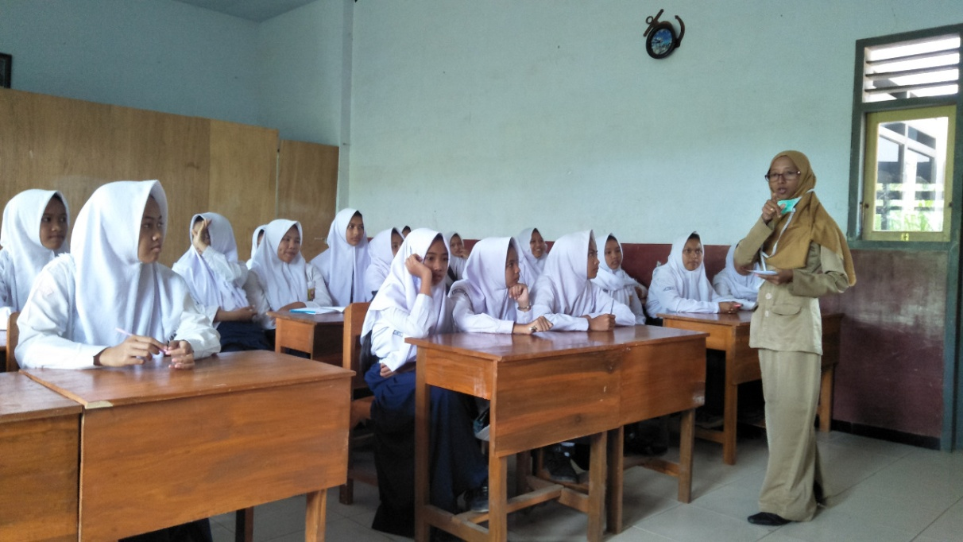

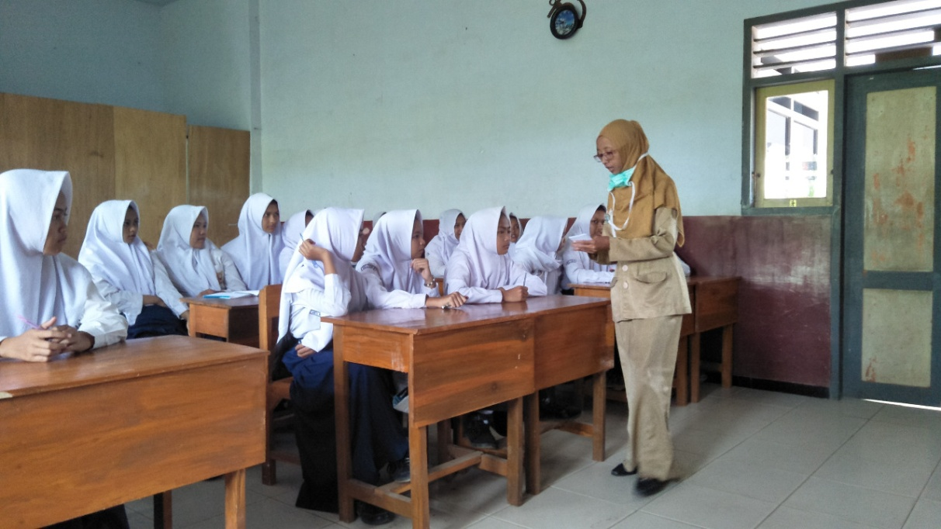

PENGUKURAN ANTROPOMETRI

|  |  |
| --- | --- |
| IMG-20180910-WA0046.jpg | IMG-20180910-WA0041.jpg |

PENGAMBILAN DATA RECALL DAN STATUS INFEKSI

OLEH ENUMERATOR

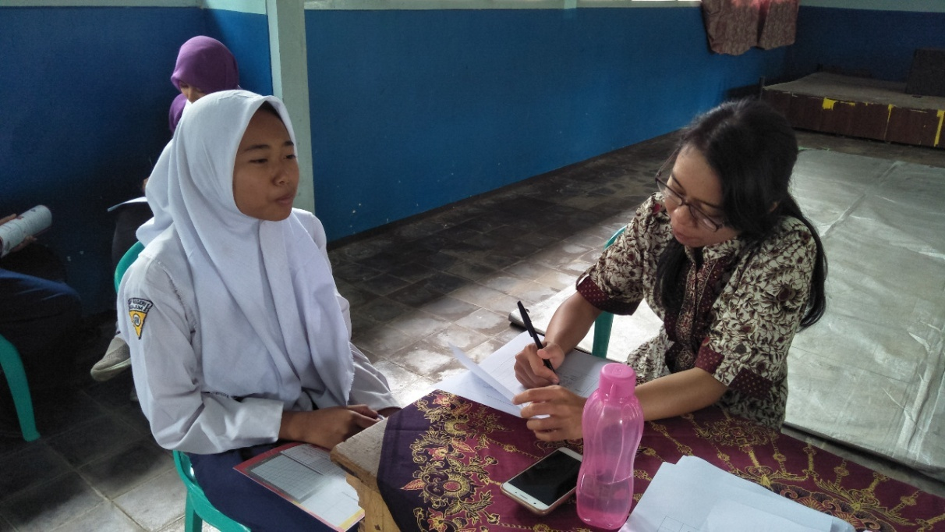

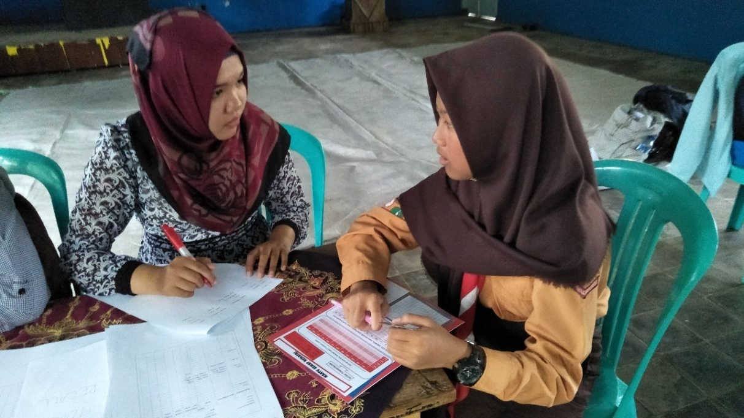

PEMERIKSAAN KADAR HB

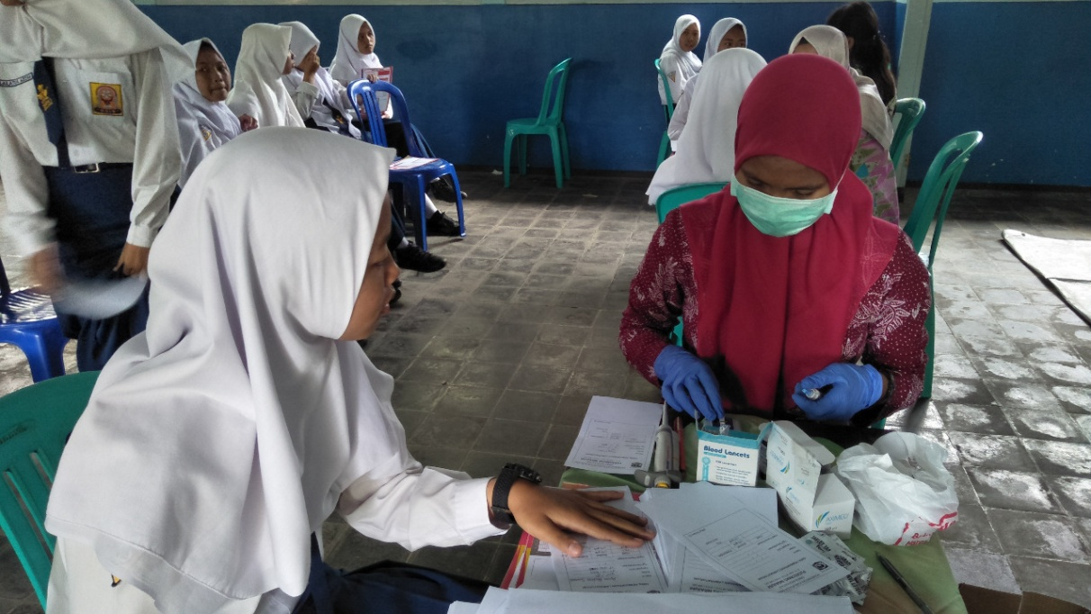

PEMBERIAN KENANG-KENANGAN

