# LAMPIRAN

Lampiran 1 Lembar Informasi

# LEMBAR INFORMASI

Kepada

Yth. Bapak/Ibu Calon Responden Di Tempat

Dengan Hormat,

Saya yang bertanda tangan dibawah ini, Mahasiswa Politeknik Kesehatan Kemenkes Malang, Jurusan Keperawatan, Program Studi Sarjana Terapan Keperawatan Malang:

Nama : Aditya Mauludin Afkar Nur Arij Arifaen NIM : P17211201006

Saat ini saya sedang melakukan kegiatan menyusun skripsi sebagai tugas akhir. Sehubungan dengan hal tersebut, saya mohon untuk kesediaan Bapak/Ibu untuk bersedia menjadi responden dalam penelitian tentang “Analisis Faktor yang Mempengaruhi Waktu Pulih Sadar Pasien Post Operasi Dengan *General Anesthesia* di *Recovery Room* Rumah Sakit IHC Lavalette Kota Malang”.

Saya akan menjamin kerahasiaan identitas dan hasil yang didapatkan dari responden. Hasil penelitian ini diharapkan dapat bermanfaat, untuk itu pengisian observasi ini sesuai dengan apa yang dirasakan Bapak/Ibu. Jawaban yang demikian hanya akan digunakan untuk keperluan penelitian saja. Demikian permohonan saya, atas kesediaan dan bantuan Bapak/Ibu saya ucapkan terimakasih

Malang,……………………..

Peneliti

Aditya Mauludin Afkar N. A. A Nim. P17211201006

70

Lampiran 2 Lembar *Informed Consent*

**LEMBAR PERSETUJUAN (*INFORMED CONSENT*)**

Saya yang bertanda tangan di bawah ini: Nama (Inisial) :

Jenis Kelamin : L / P

Usia : Tahun

Dengan ini menyatakan bahwa saya telah memahami tentang penjelasan segala sesuatu mengenai penelitian yang berjudul “Analisis Faktor yang Mempengaruhi Waktu Pulih Sadar Pasien Post Operasi Dengan *General Anesthesia* di *Recovery Room* Rumah Sakit IHC Lavalette” dan saya bersedia untuk menjadi responden dalam penelitian ini dengan penuh kesadaran dan tanpa paksaan dari siapa pun.

Malang, 2024

Responden

Lampiran 3. Lembar Observasi

# LEMBAR OBSERVASI

1. **Karaktersitik Responden**

Nama (Inisial) :

**Usia** : tahun Jenis Kelamin : L / P

# Indeks Massa Tubuh (IMT)

Berat badan sebelum operasi : kg

Tinggi badan saat ini : cm

Penghitungan IMT : *𝑘𝑔 =*

*𝑚2*

# Status Fisik Klasifikasi ASA

|  |  |
| --- | --- |
| **Klasifikasi ASA** | **Beri tanda centang (🗸)** |
| ASA 1 |  |
| ASA 2 |  |

Keterangan:

* 1. ASA 1, seorang pasien yang normal dan sehat.
  2. ASA 2, seorang pasien dengan penyakit sistemik ringan.

# Lama Operasi

|  |  |
| --- | --- |
| **Operasi dimulai pukul** | **:** |
| **Operasi selesai pukul** | **:** |
| **Total waktu lama operasi**  **(menit)** | **:** |

1. **Waktu Pulih Sadar**

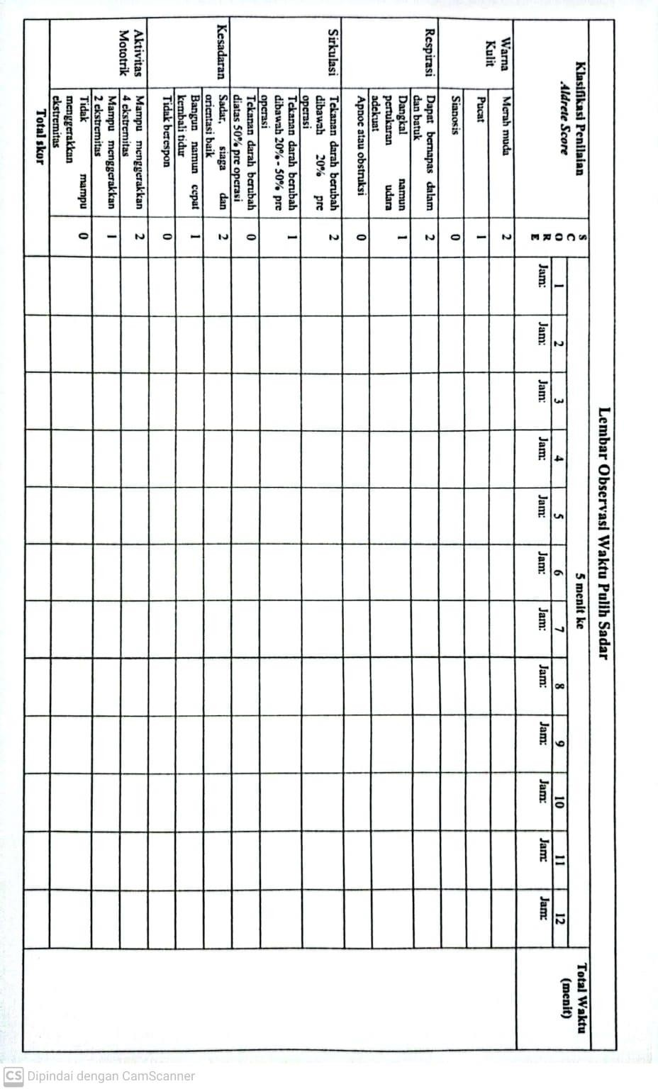

Lampiran 4. Tabulasi Data Penelitian

|  |  |  |  |  |  |  |
| --- | --- | --- | --- | --- | --- | --- |
| **Responden** | **Usia (tahun)** | **IMT**  **(kg/m2)** | **Status ASA** | **Lama Operasi (menit)** | **Waktu Pulih Sadar**  **(Menit)** | **Keterangan Jenis Operasi** |
| **1** | 54 | 24,2 | 2 | 125 | 25 | TAH BSO |
| **2** | 42 | 20,8 | 1 | 110 | 15 | RH |
| **3** | 45 | 22,2 | 1 | 55 | 15 | Pro incisi |
| **4** | 27 | 19,9 | 1 | 100 | 15 | Pro laparotomy |
| **5** | 55 | 23,7 | 1 | 115 | 15 | MRM |
| **6** | 37 | 22,4 | 1 | 55 | 10 | Odontectomy |
| **7** | 30 | 19,9 | 1 | 35 | 10 | Reposisi dislokasi |
| **8** | 27 | 21,2 | 1 | 55 | 10 | Debridement |
| **9** | 34 | 20,1 | 1 | 60 | 15 | Odontectomy |
| **10** | 65 | 33,5 | 2 | 170 | 25 | MRM |
| **11** | 30 | 21,3 | 1 | 60 | 10 | Pro eksisi |
| **12** | 62 | 31,9 | 2 | 135 | 35 | Pro laparascopy |
| **13** | 30 | 21,3 | 1 | 135 | 15 | Tiroidektomy |
| **14** | 43 | 25,6 | 1 | 30 | 15 | Biopsi mammae |
| **15** | 56 | 21,3 | 1 | 115 | 20 | RH |
| **16** | 65 | 19,1 | 2 | 180 | 45 | Hemicolectomy |
| **17** | 58 | 20,8 | 1 | 120 | 20 | MRM |
| **18** | 51 | 27,3 | 1 | 75 | 40 | Pro eksisi |
| **19** | 44 | 23,5 | 1 | 60 | 15 | Biopsi mammae |
| **20** | 52 | 20,1 | 2 | 105 | 40 | TAH BSO |
| **21** | 47 | 20,4 | 2 | 135 | 30 | TAH BSO |
| **22** | 43 | 24,1 | 1 | 120 | 20 | TAH BSO |
| **23** | 54 | 30,6 | 2 | 170 | 35 | MRM |
| **24** | 55 | 28,7 | 1 | 50 | 20 | Biopsi mammae |
| **25** | 65 | 24,8 | 1 | 75 | 25 | Open biopsi |
| **26** | 44 | 28,2 | 1 | 150 | 25 | MRM |
| **27** | 45 | 23,7 | 1 | 80 | 15 | Cholesistectomy |
| **28** | 50 | 23,5 | 1 | 60 | 15 | Biopsi mammae |
| **29** | 50 | 28,5 | 2 | 140 | 35 | TAH BSO |
| **30** | 42 | 24,4 | 1 | 145 | 15 | TAH BSO |
| **31** | 65 | 24,1 | 2 | 50 | 20 | Pro eksisi |
| **32** | 61 | 24,9 | 2 | 135 | 25 | Pro laparascopy |
| **33** | 57 | 21,9 | 1 | 90 | 15 | Miringoplasty |
| **34** | 57 | 25,5 | 2 | 130 | 25 | MRM |
| **35** | 65 | 25,6 | 2 | 125 | 25 | MRM |
| **36** | 39 | 35,5 | 2 | 135 | 20 | Tonsilectomy+Odontectomy |
| **37** | 61 | 25,2 | 1 | 185 | 25 | Pro Laparascopy |
| **38** | 48 | 20,7 | 1 | 55 | 15 | Orif |
| **39** | 49 | 22,3 | 1 | 60 | 15 | Pro eksisi |
| **40** | 65 | 24,1 | 1 | 105 | 20 | Apendiktomy |
| **41** | 56 | 25,2 | 1 | 125 | 20 | MRM |
| **42** | 52 | 23,5 | 1 | 135 | 25 | TAH BSO |

|  |  |  |  |  |  |  |
| --- | --- | --- | --- | --- | --- | --- |
| **43** | 36 | 30,1 | 1 | 60 | 15 | Biopsi mammae |
| **44** | 58 | 21,3 | 1 | 115 | 15 | MRM |
| **45** | 41 | 21,3 | 1 | 65 | 15 | Curettage |
| **46** | 43 | 24,4 | 1 | 110 | 15 | TAH BSO |
| **47** | 26 | 21,6 | 1 | 65 | 10 | CF Radius ulna |
| **48** | 57 | 21,8 | 1 | 100 | 15 | Pro unroofing cyst |
| **49** | 62 | 21,5 | 1 | 120 | 15 | MRM |
| **50** | 64 | 25,3 | 2 | 130 | 25 | MRM |
| **51** | 60 | 21,7 | 2 | 125 | 25 | Pro Laparatomy |
| **52** | 36 | 21,1 | 1 | 80 | 10 | Appendiktomy |
| **53** | 55 | 23,5 | 1 | 120 | 15 | MRM |
| **54** | 45 | 20,1 | 1 | 115 | 15 | TAH BSO |
| **55** | 56 | 22,8 | 2 | 130 | 20 | TAH BSO |
| **56** | 61 | 22,6 | 1 | 125 | 20 | MRM |
| **57** | 51 | 25,1 | 1 | 110 | 15 | Pro unroofing cyst |
| **58** | 26 | 22,2 | 1 | 55 | 10 | Pro eksisi |
| **59** | 32 | 24,0 | 1 | 70 | 10 | Open wound lidah |

Lampiran 5. Hasil Uji Statistik Deskriptif

**Statistics**

|  |  |  |  |  |  |
| --- | --- | --- | --- | --- | --- |
|  | | Usia | Lama Operasi (menit) | Waktu Pulih Sadar (menit) | IMT |
| N | Valid | 59 | 59 | 59 | 59 |
|  | Missing | 0 | 0 | 0 | 0 |
| Mean | | 48.92 | 102.46 | 19.66 | 23.829 |
| Median | | 51.00 | 110.00 | 15.00 | 23.500 |
| Mode | | 65 | 60a | 15 | 21.3 |
| Std. Deviation | | 11.683 | 38.185 | 8.140 | 3.4570 |
| Minimum | | 26 | 30 | 10 | 19.1 |
| Maximum | | 65 | 185 | 45 | 35.5 |

* 1. Multiple modes exist. The smallest value is shown Status ASA

|  |  |  |  |  |  |
| --- | --- | --- | --- | --- | --- |
|  | | Frequency | Percent | Valid Percent | Cumulative Percent |
| Valid | Status ASA 1 | 43 | 72.9 | 72.9 | 72.9 |
|  | Status ASA 2 | 16 | 27.1 | 27.1 | 100.0 |
|  | Total | 59 | 100.0 | 100.0 |  |

Lampiran 6. Hasil Uji Normalitas

# Variabel Usia

**One-Sample Kolmogorov-Smirnov Test**

|  |  |  |
| --- | --- | --- |
|  | | Unstandardized  Residual |
| N |  | 59 |
| Normal Parametersa,b | Mean | .0000000 |
|  | Std. Deviation | 9.62235007 |
| Most Extreme Differences | Absolute | .100 |
|  | Positive | .098 |
|  | Negative | -.100 |
| Kolmogorov-Smirnov Z |  | .767 |
| Asymp. Sig. (2-tailed) |  | .599 |

1. Test distribution is Normal.
2. Calculated from data.

# Variabel IMT

**One-Sample Kolmogorov-Smirnov Test**

|  |  |  |
| --- | --- | --- |
|  | | Unstandardized Residual |
| N |  | 59 |
| Normal Parametersa,b | Mean | .0000000 |
|  | Std. Deviation | 3.26781320 |
| Most Extreme Differences | Absolute | .156 |
|  | Positive | .156 |
|  | Negative | -.107 |
| Kolmogorov-Smirnov Z |  | 1.200 |
| Asymp. Sig. (2-tailed) |  | .112 |

1. Test distribution is Normal.
2. Calculated from data.

# Variabel Lama Operasi

**One-Sample Kolmogorov-Smirnov Test**

|  |  |  |
| --- | --- | --- |
|  | | Unstandardized Residual |
| N |  | 59 |
| Normal Parametersa,b | Mean | .0000000 |
|  | Std. Deviation | 31.04123917 |
| Most Extreme Differences | Absolute | .127 |
|  | Positive | .076 |
|  | Negative | -.127 |
| Kolmogorov-Smirnov Z |  | .972 |
| Asymp. Sig. (2-tailed) |  | .301 |

1. Test distribution is Normal.
2. Calculated from data.

Lampiran 7. Hasil Uji Bivariat

# Korelasi Pearson

|  |  |  |  |
| --- | --- | --- | --- |
| **Correlations** | | | |
|  | | Usia | Waktu Pulih  Sadar (menit) |
| Usia | Pearson Correlation | 1 | .567** |
|  | Sig. (2-tailed) |  | .000 |
|  | N | 59 | 59 |
| Waktu Pulih Sadar (menit) | Pearson Correlation | .567** | 1 |
|  | Sig. (2-tailed) | .000 |  |
|  | N | 59 | 59 |
| **. Correlation is significant at the 0.01 level (2-tailed). | | | |

|  |  |  |  |
| --- | --- | --- | --- |
| **Correlations** | | | |
|  | | IMT | Waktu Pulih Sadar (menit) |
| IMT | Pearson Correlation | 1 | .326* |
|  | Sig. (2-tailed) |  | .012 |
|  | N | 59 | 59 |
| Waktu Pulih Sadar (menit) | Pearson Correlation | .326* | 1 |
|  | Sig. (2-tailed) | .012 |  |
|  | N | 59 | 59 |
| *. Correlation is significant at the 0.05 level (2-tailed). | | | |

|  |  |  |  |
| --- | --- | --- | --- |
| **Correlations** | | | |
|  | | Lama Operasi (menit) | Waktu Pulih Sadar (menit) |
| Lama Operasi (menit) | Pearson Correlation | 1 | .582** |
|  | Sig. (2-tailed) |  | .000 |
|  | N | 59 | 59 |
| Waktu Pulih Sadar (menit) | Pearson Correlation | .582** | 1 |
|  | Sig. (2-tailed) | .000 |  |
|  | N | 59 | 59 |
| **. Correlation is significant at the 0.01 level (2-tailed). | | | |

* 1. **Korelasi Spearman Rank**

|  |  |  |  |
| --- | --- | --- | --- |
| **Correlations** | | | |
|  | | Status ASA | Waktu Pulih Sadar (menit) |
|  | Correlation Coefficient | 1.000 | .681** |
| Status ASA | Sig. (2-tailed) | . | .000 |
|  | N | 59 | 59 |
| Spearman's rho |  |  |  |
|  | Correlation Coefficient | .681** | 1.000 |
| Waktu Pulih Sadar  (menit) | Sig. (2-tailed) | .000 | . |
|  | N | 59 | 59 |
| **. Correlation is significant at the 0.01 level (2-tailed). | | | |

Lampiran 8. Surat Izin Studi Pendahuluan

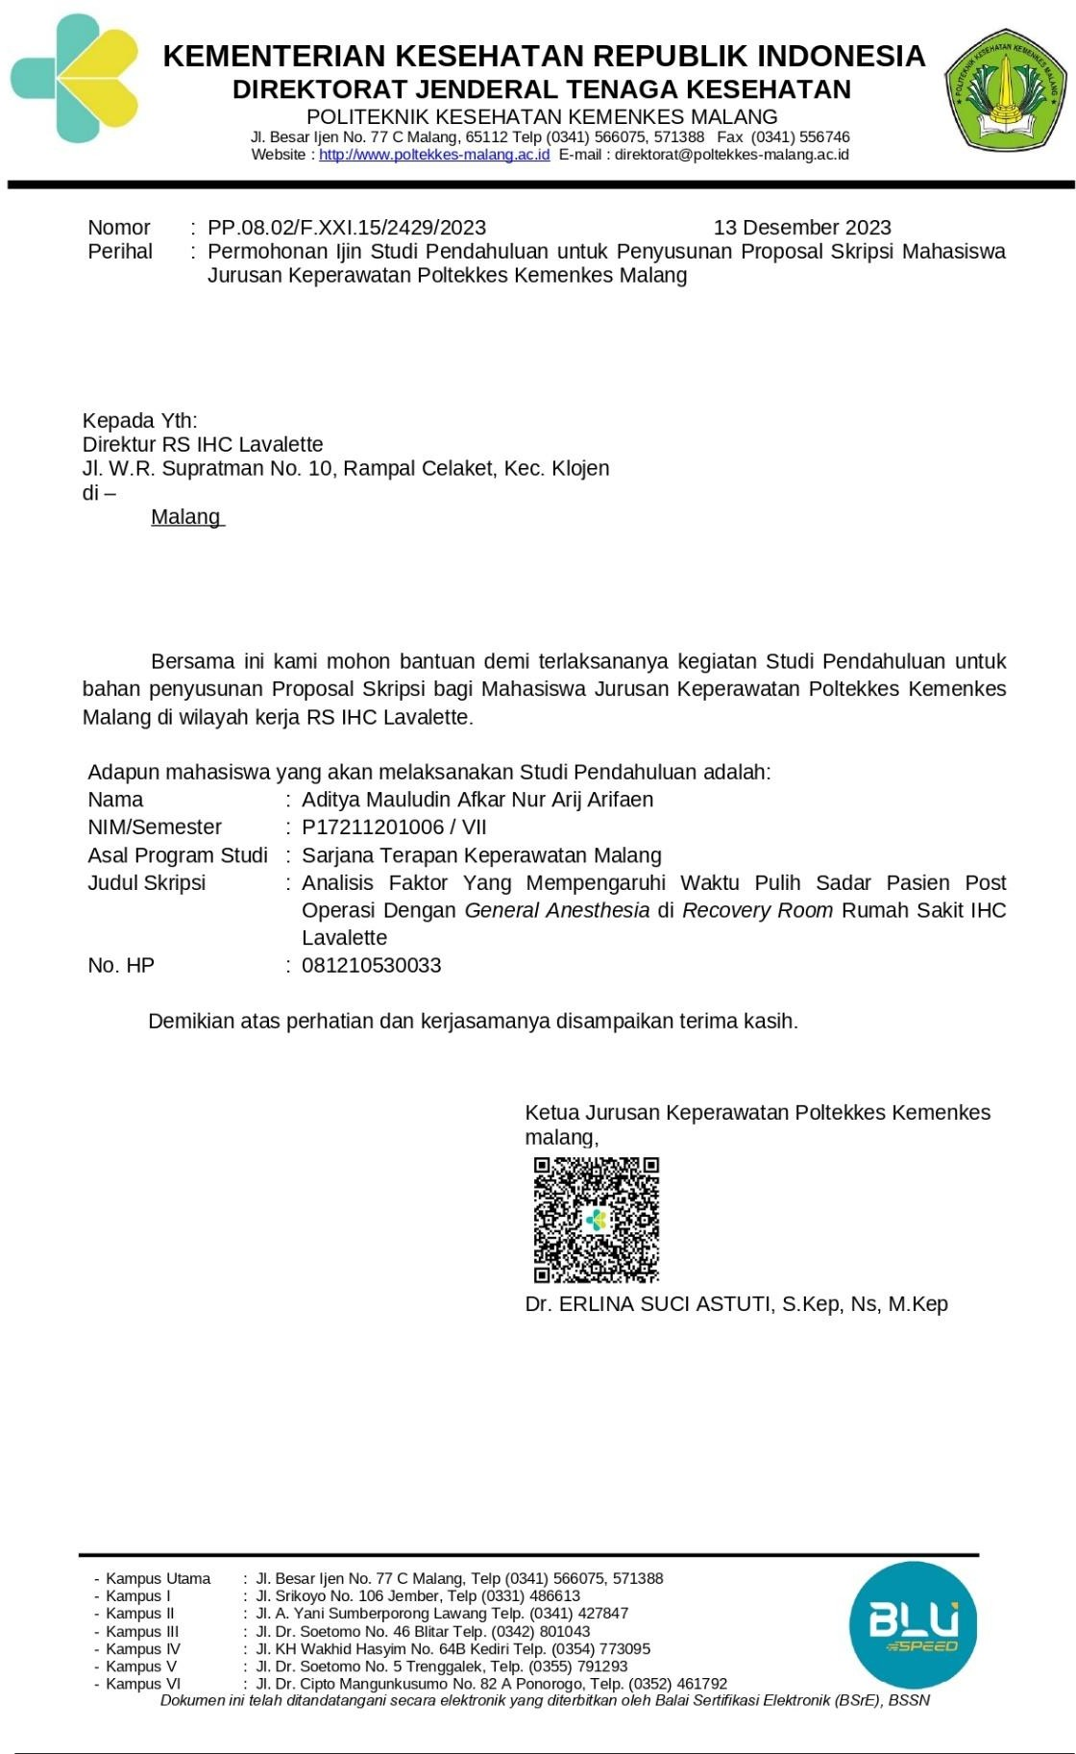

Lampiran 9. Surat Keterangan Layak Etik

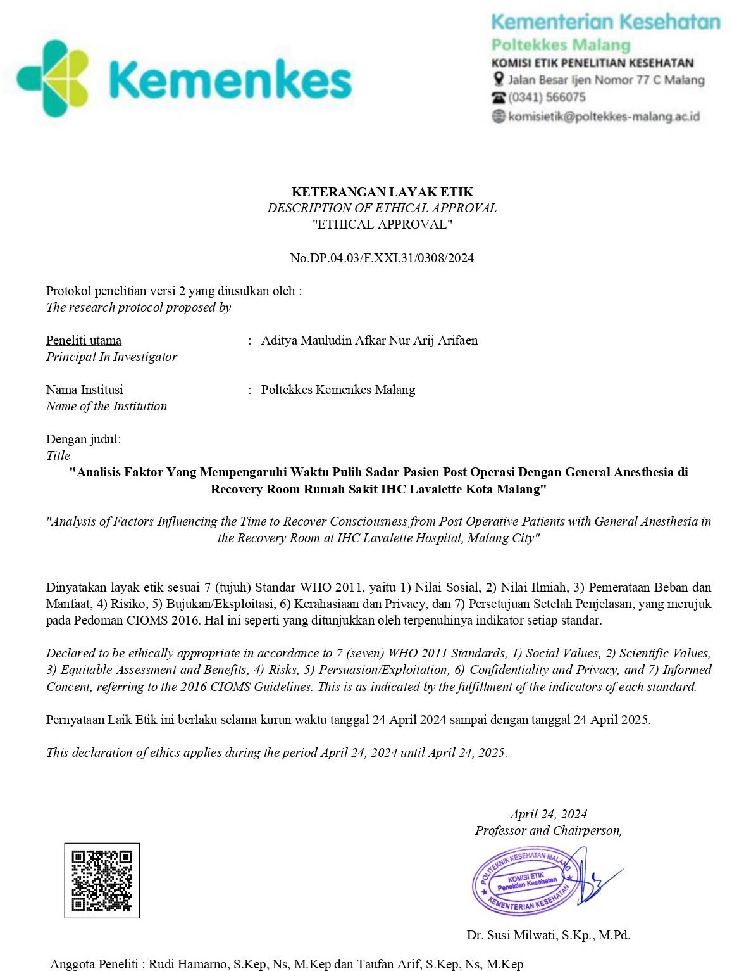

Lampiran 10. Surat Izin Pengambilan Data

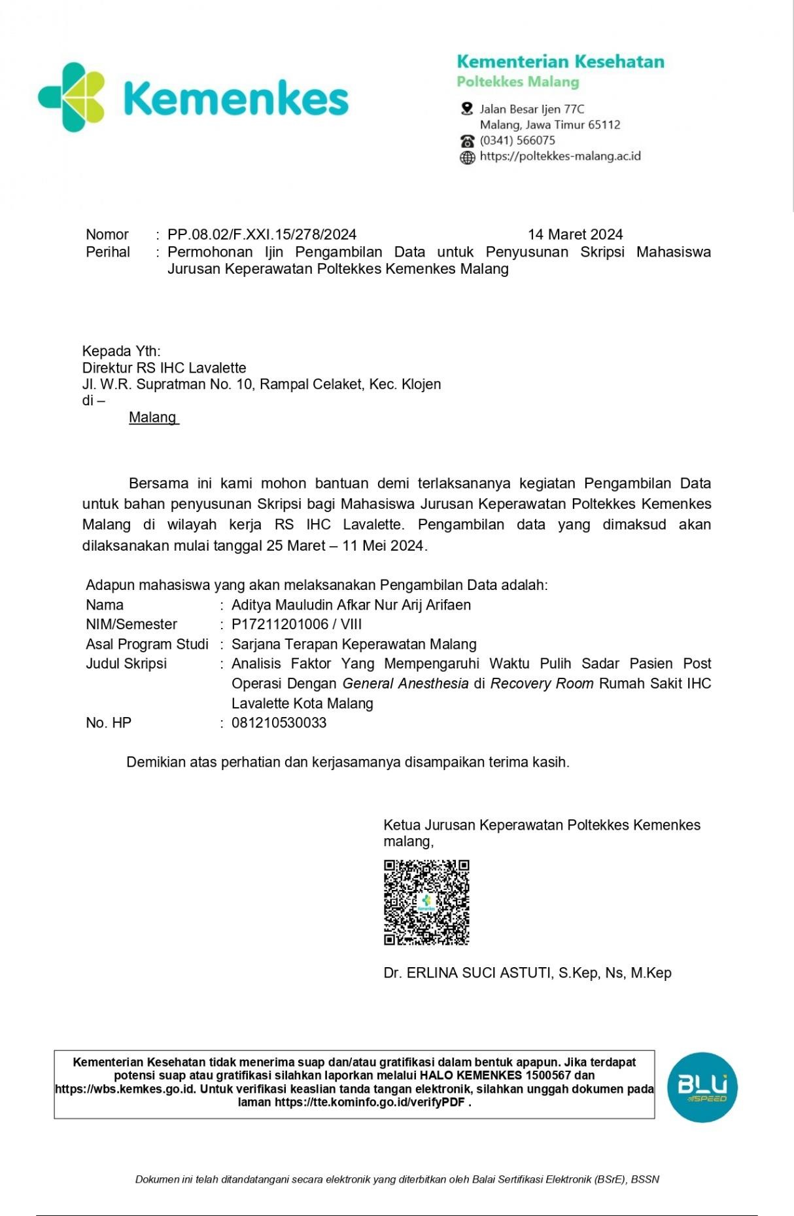

Lampiran 11. Surat Persetujuan Pengambilan Data

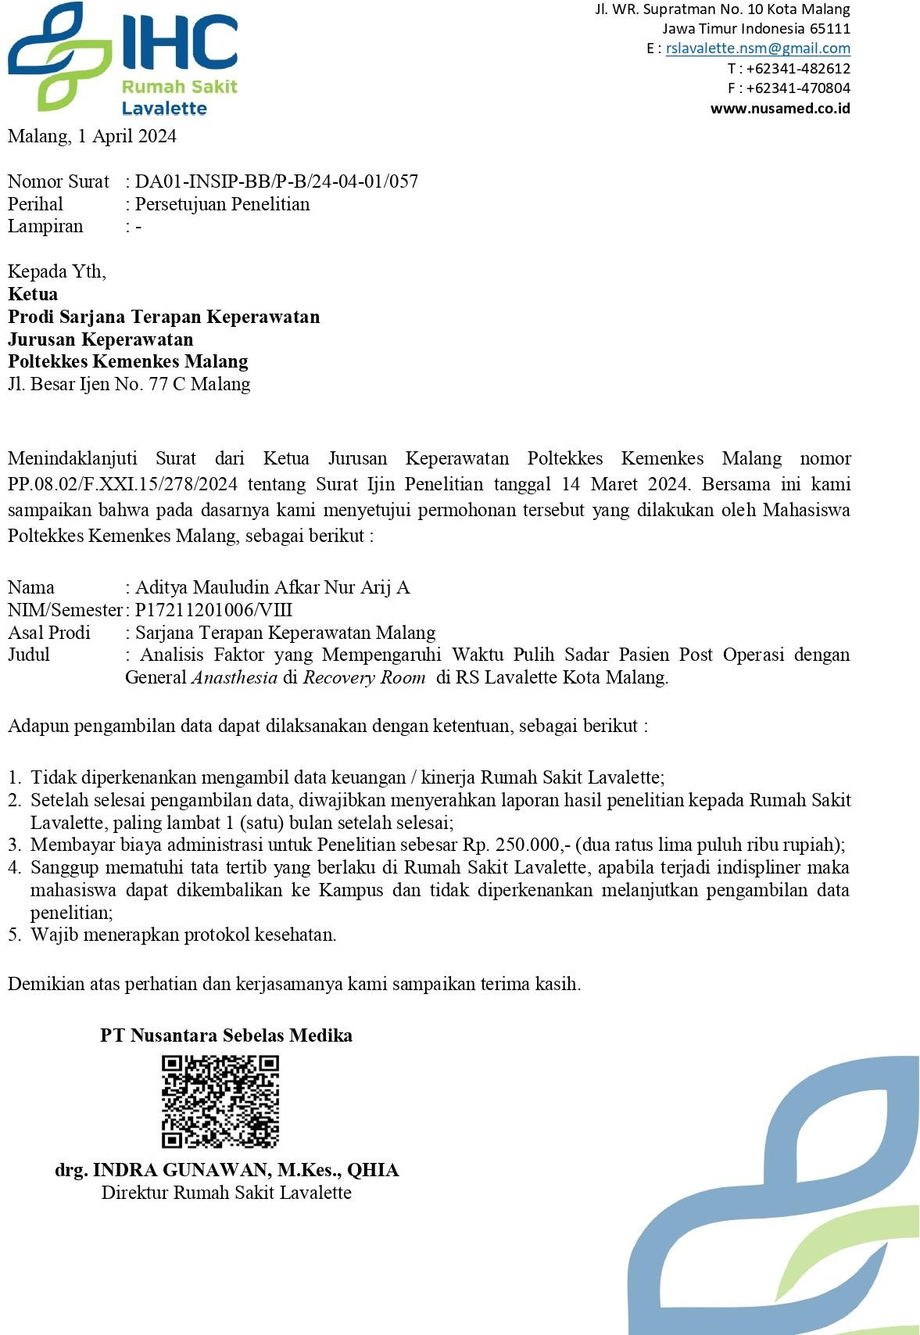

Lampiran 12. Surat Telah Selesai Pengambilan Data

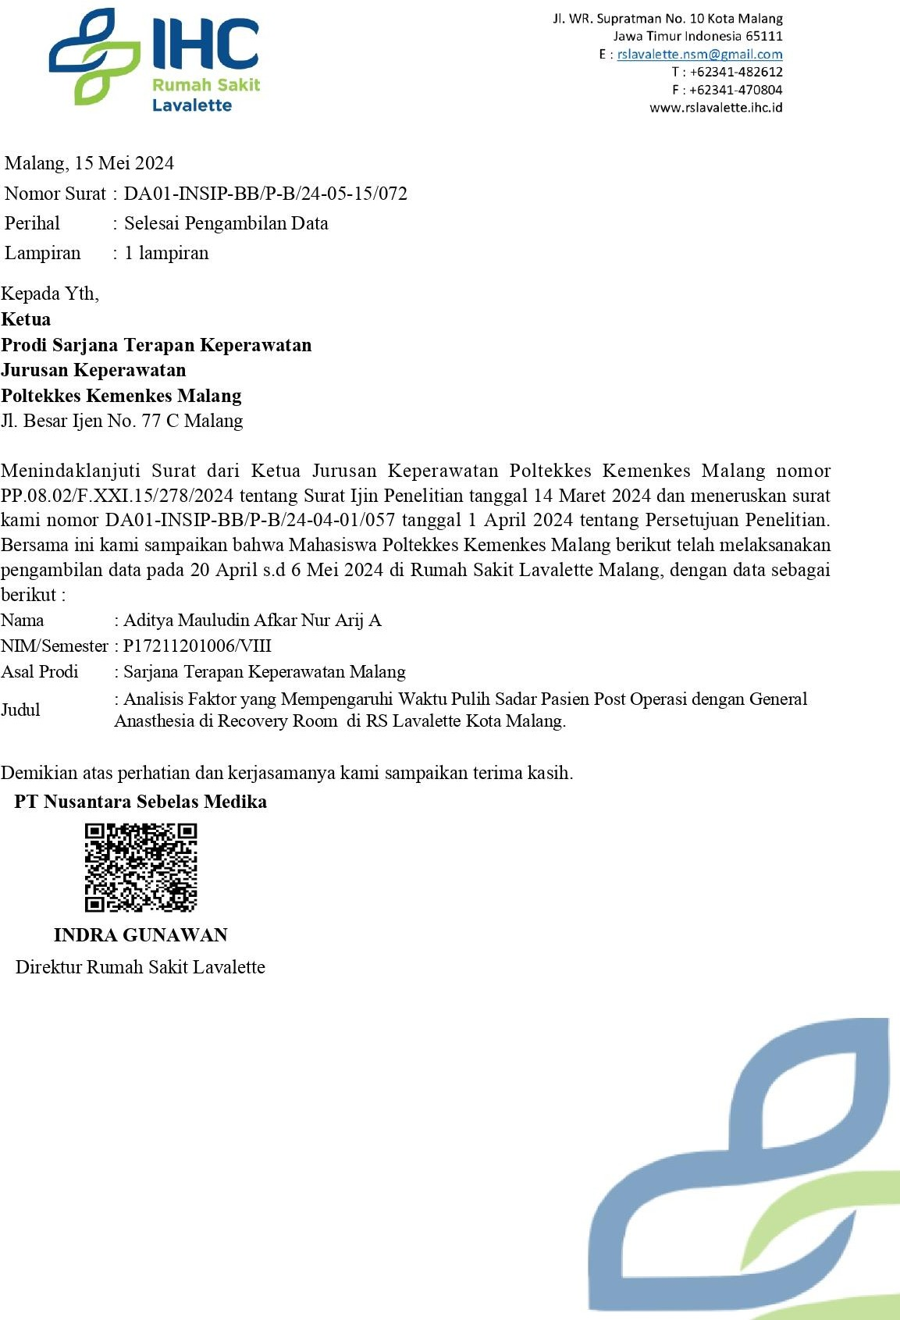

Lampiran 13. Formulir Pengajuan Judul Skripsi

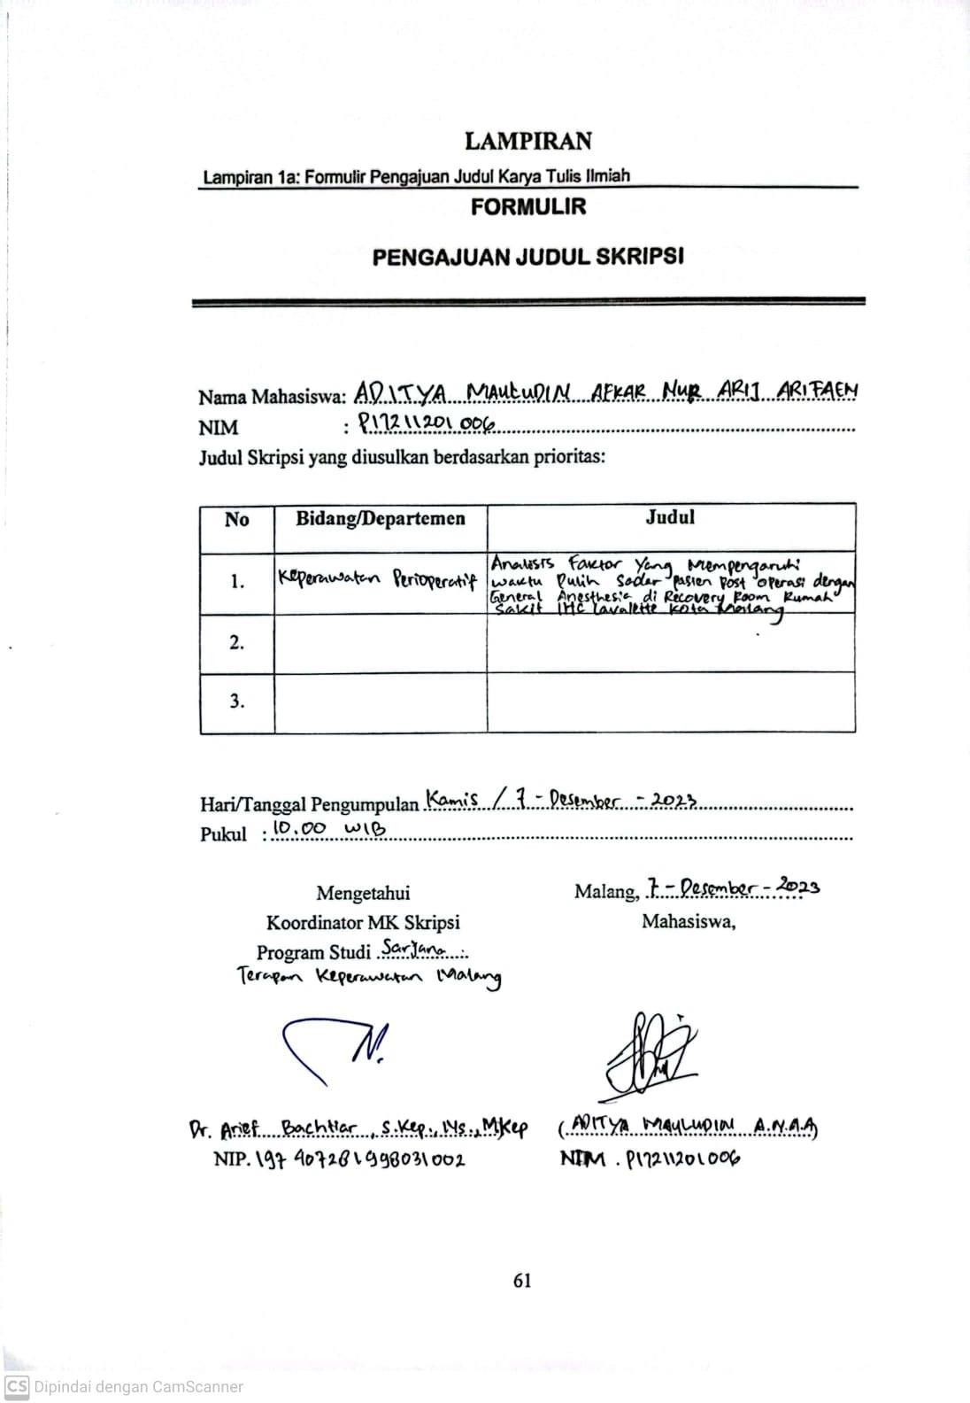

Lampiran 14. Formulir Kesediaan Pembimbing

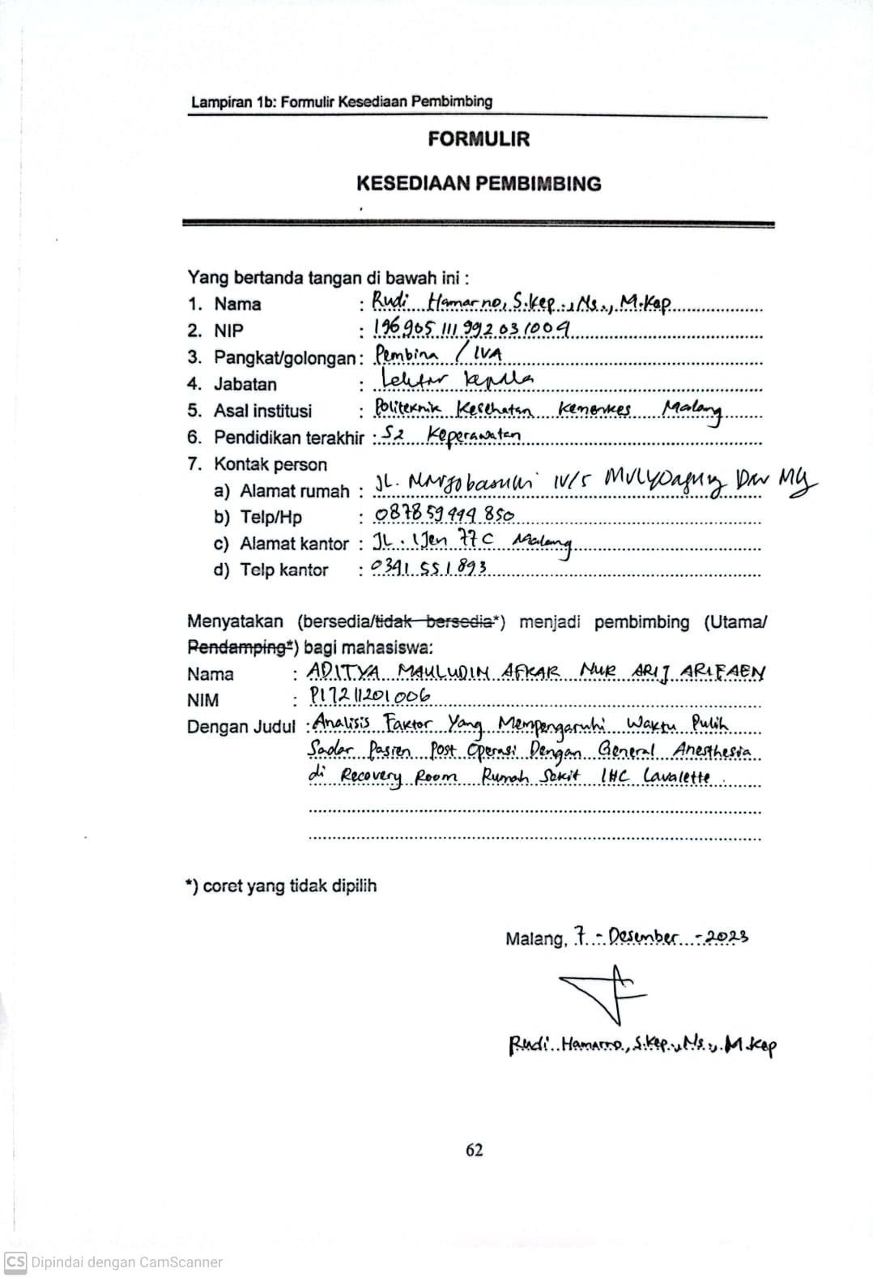

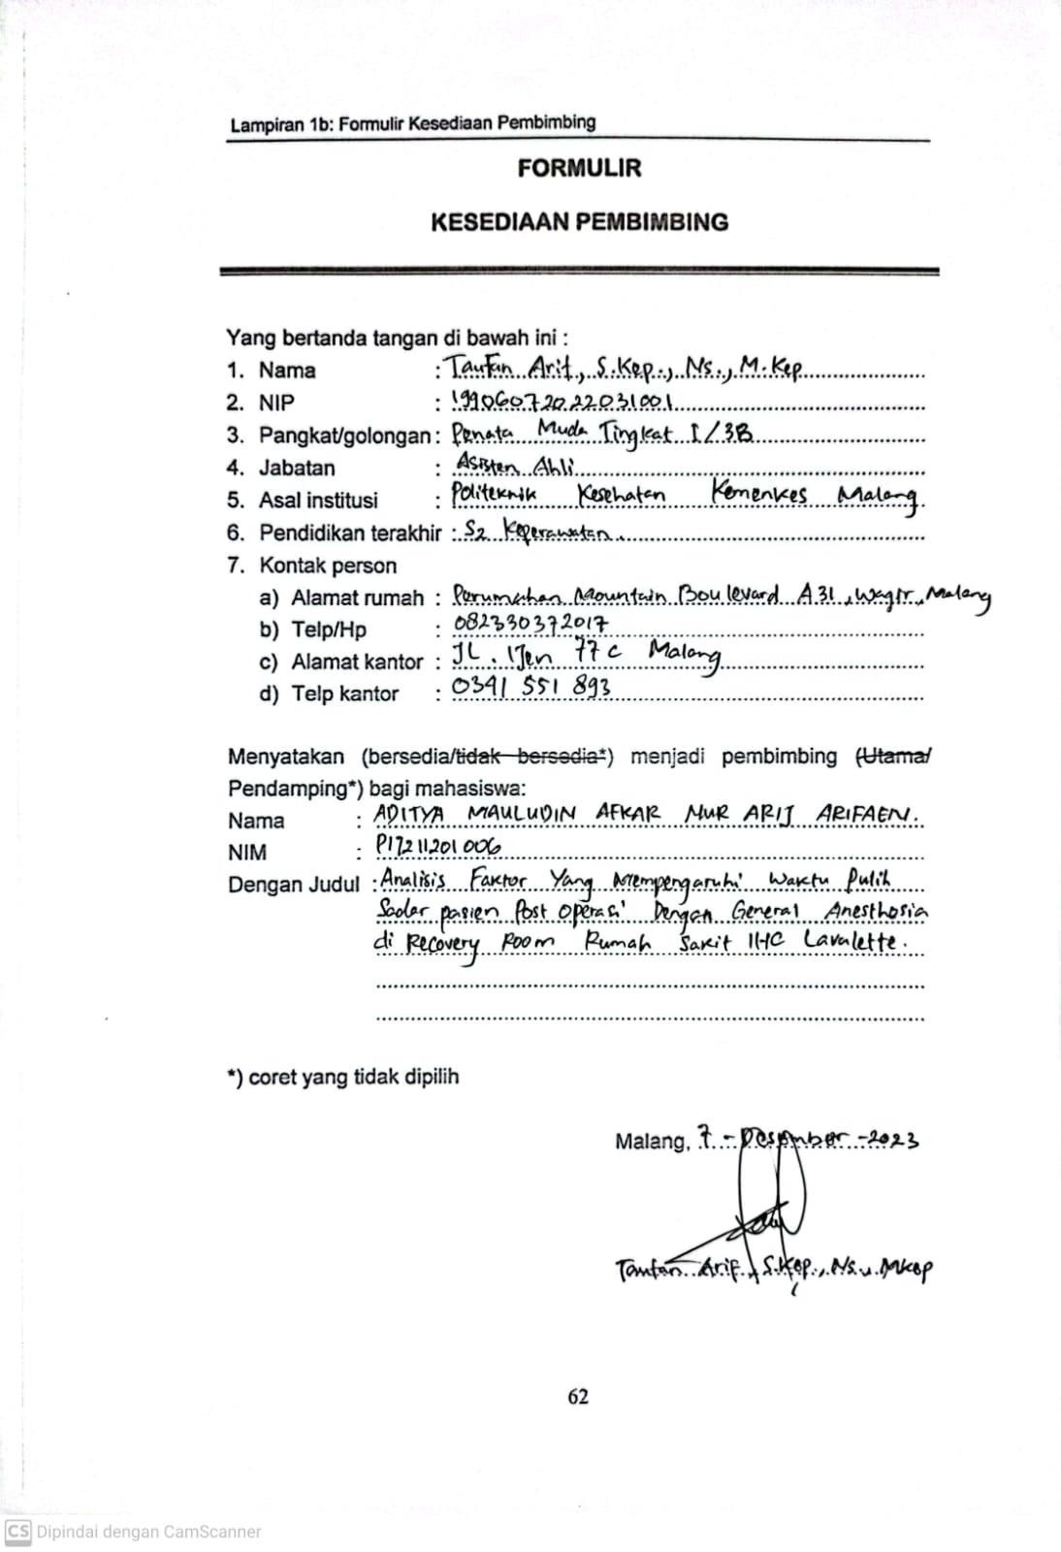

Lampiran 15. Lembar Bimbingan Skripsi

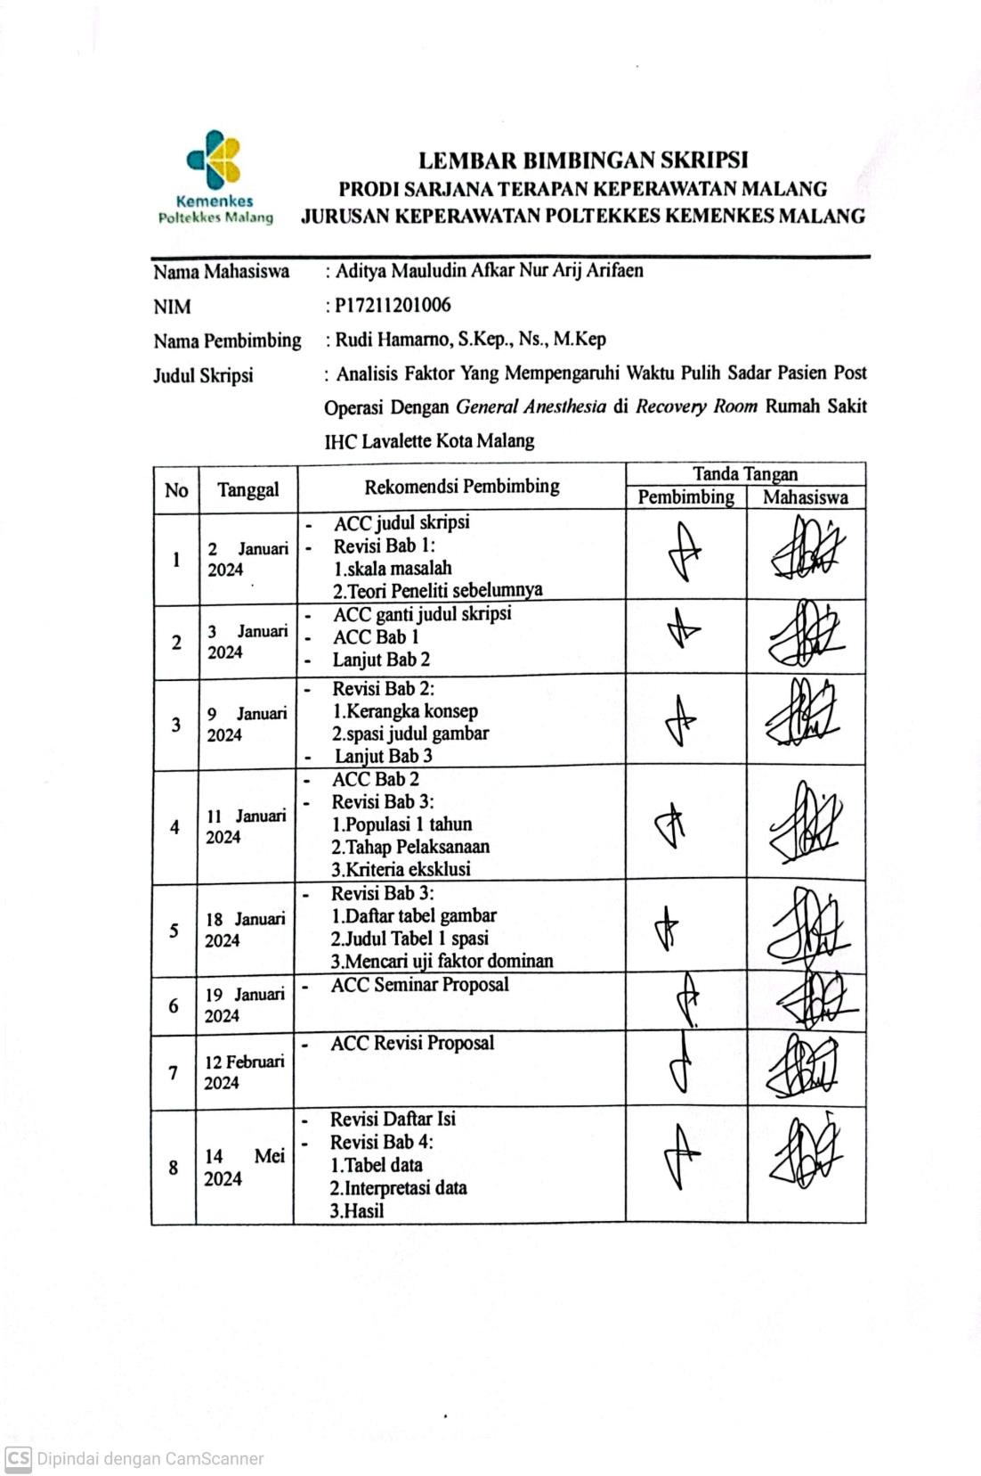

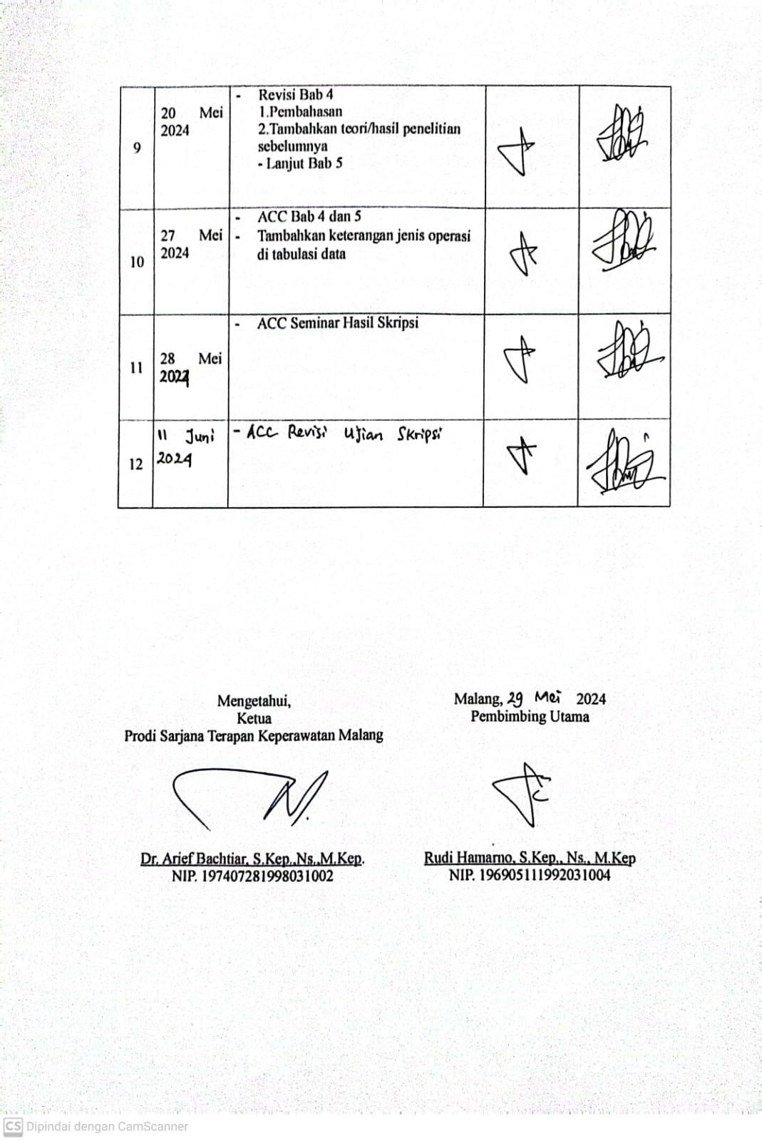

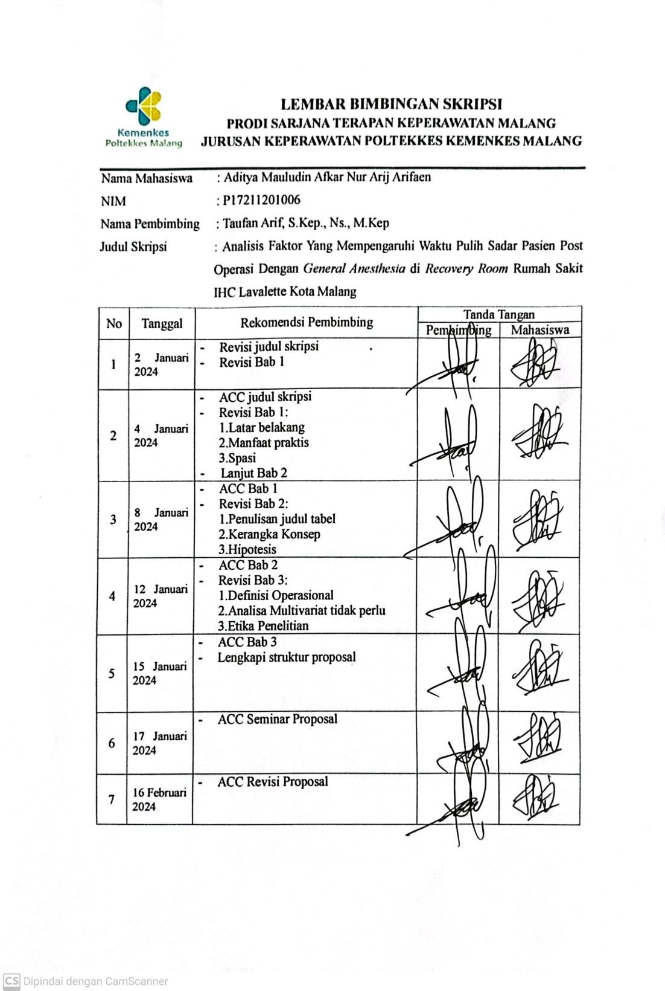

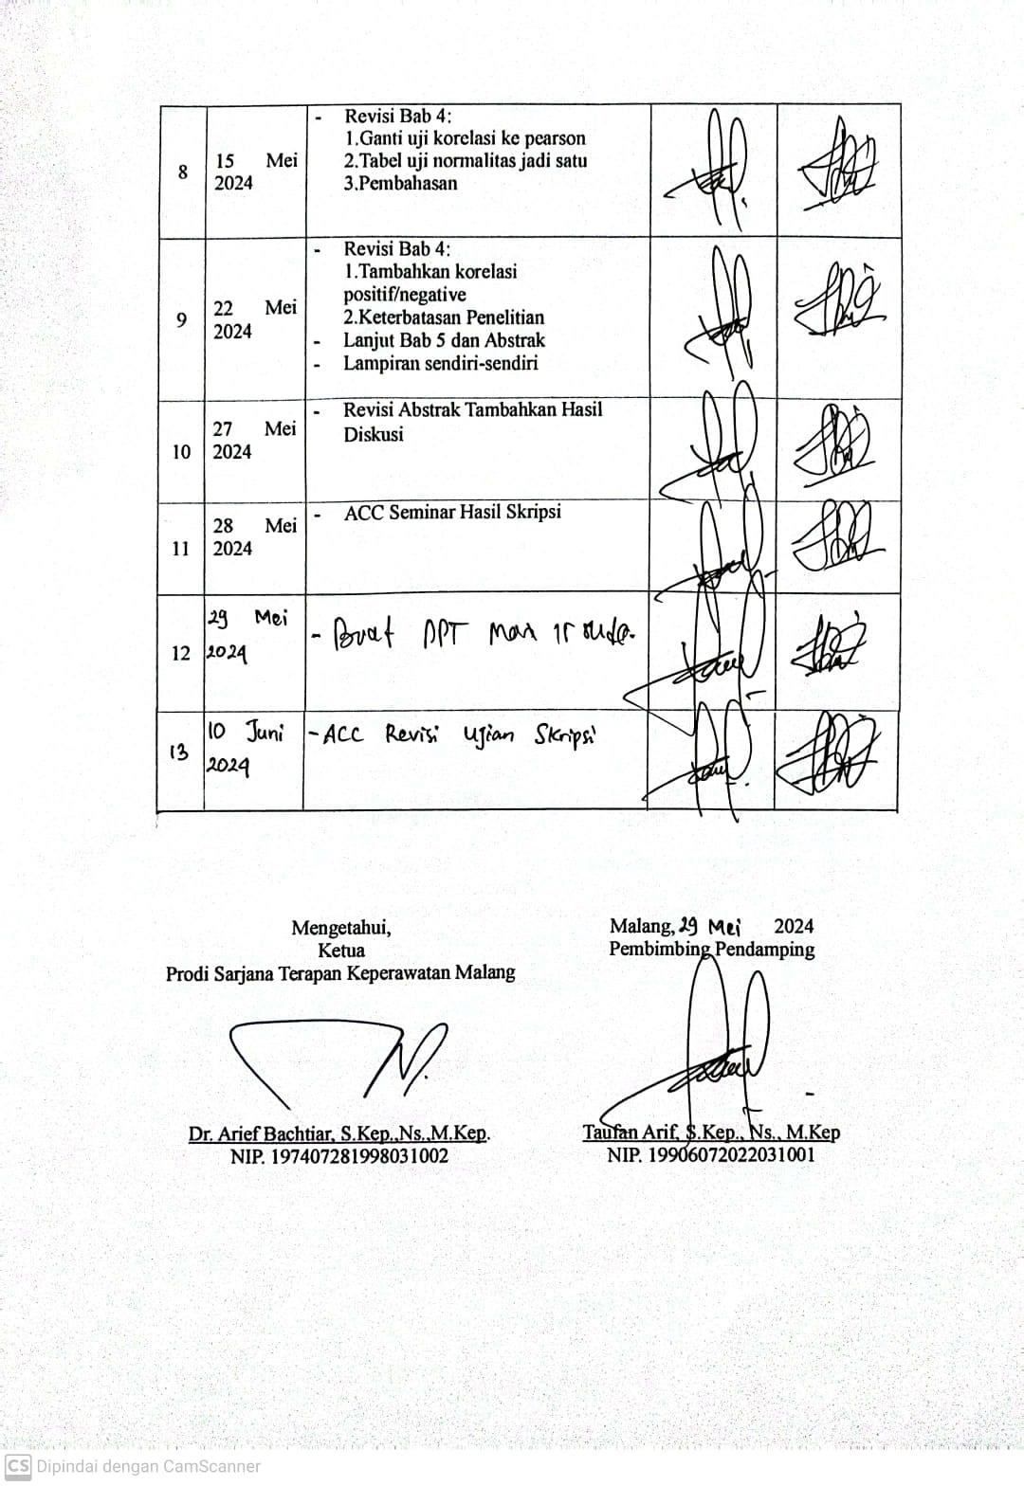

Lampiran 16. Lembar Revisi Ujian Skripsi

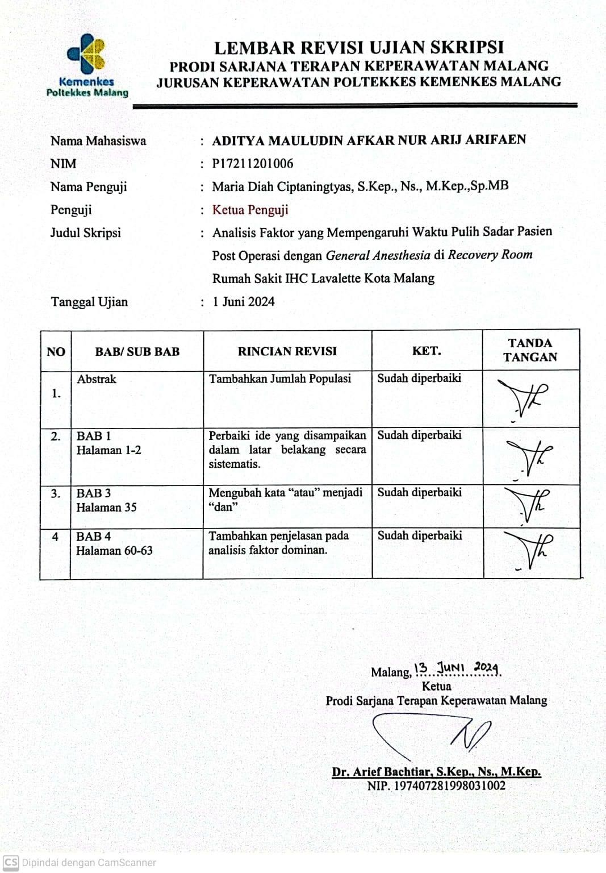

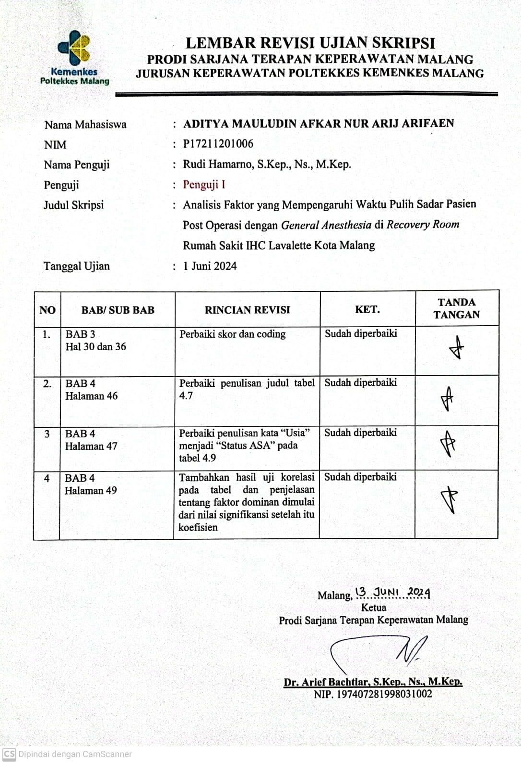

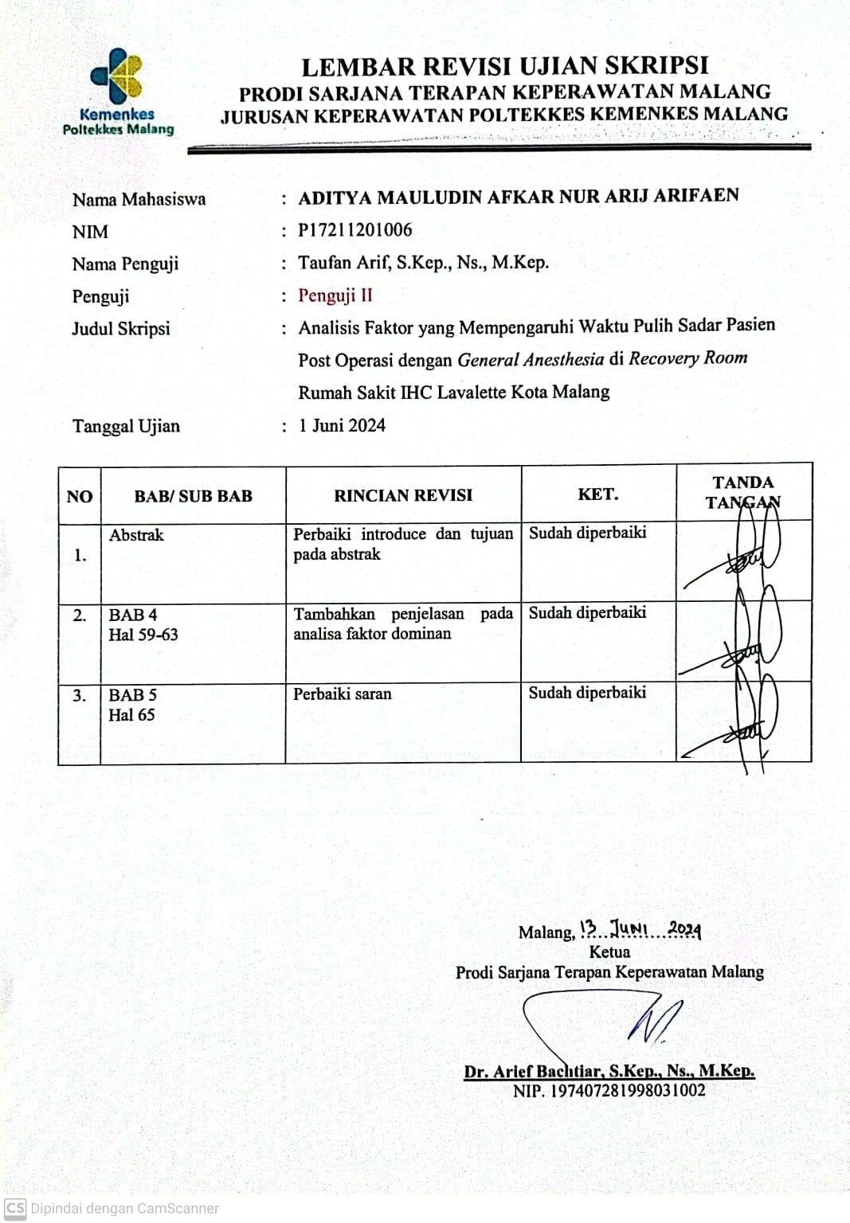

Lampiran 17. Hasil Uji Turnitin

