**LAMPIRAN**

*Lampiran 1*

**JADWAL PENELITIAN**

|  |  |  |  |  |  |  |  |  |  |  |  |  |
| --- | --- | --- | --- | --- | --- | --- | --- | --- | --- | --- | --- | --- |
| **JADWAL PENYUSUNAN SKRIPSI TAHUN 2023/2024** | | | | | | | | | | | | |
| **No.** | **Kegiatan** | **Sept 2023** | **Okt 2023** | **Nov 2023** | **Des 2023** | **Jan 2024** | **Feb 2024** | **Maret 2024** | **April 2024** | **Mei 2024** | **Juni 2024** | **Juli**  **2024** |
| 1 | Pengajuan Judul |  |  |  |  |  |  |  |  |  |  |  |
| 2 | Verifikasi Judul |  |  |  |  |  |  |  |  |  |  |  |
| 3 | Proses Bimbingan Dan Penyusunan Proposal |  |  |  |  |  |  |  |  |  |  |  |
| 4 | Pendaftaran Seminar Proposal |  |  |  |  |  |  |  |  |  |  |  |
| 5 | Seminar Proposal |  |  |  |  |  |  |  |  |  |  |  |
| 6 | Revisi Dan Persetujuan Proposal Oleh Penguji |  |  |  |  |  |  |  |  |  |  |  |
| 7 | *Ethical Clearance* |  |  |  |  |  |  |  |  |  |  |  |
| 8 | Pengambilan Data Penelitian |  |  |  |  |  |  |  |  |  |  |  |
| 9 | Pengolahan Data Hasil Penelitian |  |  |  |  |  |  |  |  |  |  |  |
| 10 | Proses Bimbingan Dan Penyusunan Skripsi |  |  |  |  |  |  |  |  |  |  |  |
| 11 | Pendaftaran Seminar Hasil |  |  |  |  |  |  |  |  |  |  |  |
| 12 | Seminar Hasil |  |  |  |  |  |  |  |  |  |  |  |
| 13 | Revisi dan Persetujuan Skripsi |  |  |  |  |  |  |  |  |  |  |  |
| 14 | Pengumpulan Skripsi |  |  |  |  |  |  |  |  |  |  |  |

*Lampiran 2*

**Surat Izin Studi Pendahuluan Dinas Kesehatan Kota Malang**

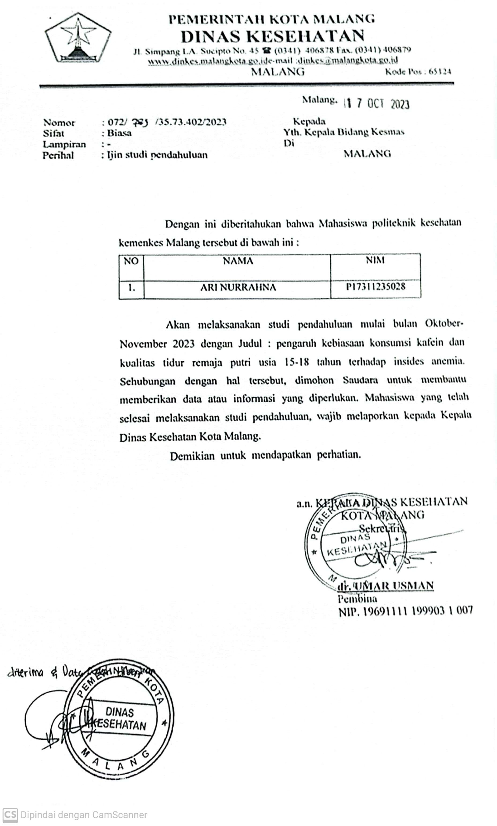

*Lampiran 3*

**Surat Rekomendasi Izin Penelitian Dinas Pendidikan Kota Malang**

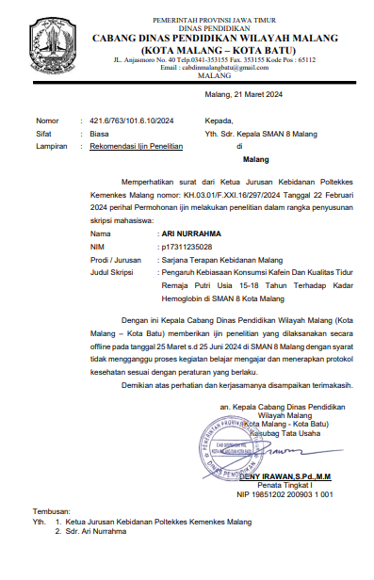

*Lampiran 4*

*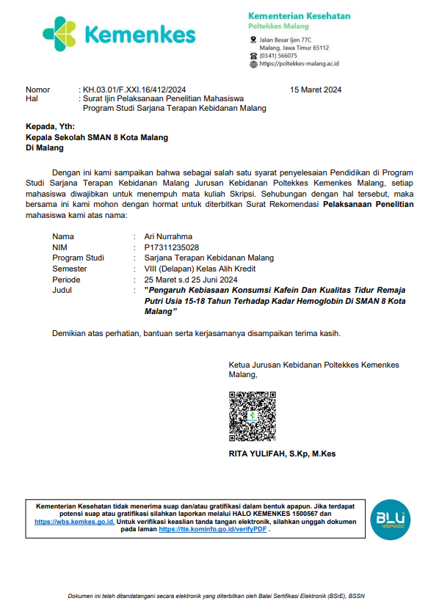***Surat Pengantar Izin Penelitian Ke Kepala Sekolah**

*Lampiran 5*

**Surat Keterangan Layak Etik**

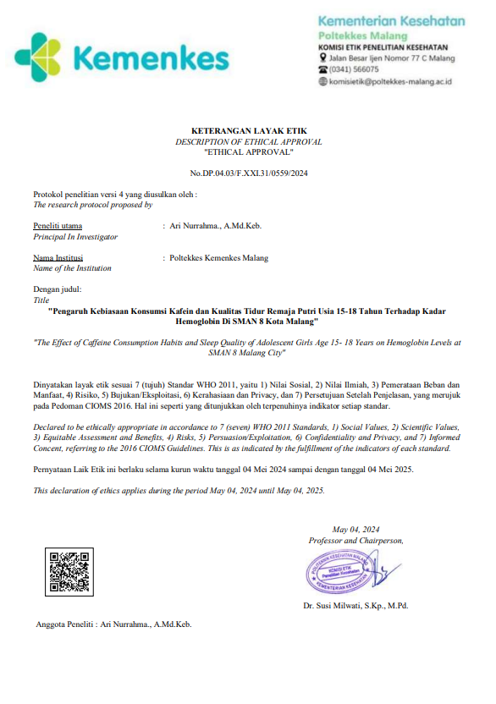

*Lampiran 6*

**INFORMED CONSENT**

Saya yang bertanda tangan di bawah ini menyatakan bahwa saya telah mendapatkan penjelasan secara rinci dan telah mengerti mengenai penelitian yang akan dilakukan oleh Ari Nurrahma, mahasiswi Sarjana Terapan Kebidanan Jurusan Kebidanan Politeknik Kesehatan Kemenkes Malang yang berjudul “Pengaruh Kebiasaan Konsumsi Kafein dan Kualitas tidur Remaja Putri Usia 15-18 Tahun Terhadap Kadar Hemoglobin di SMAN 8 Kota Malang”

Saya yakin bahwa penelitian ini tidak menimbulkan kerugian apapun pada saya dan keluarga. Dan saya telah mempertimbangkan serta memutuskan untuk berpartisipasi dalam penelitian ini dengan kesadaran sendiri dan tanpa paksaan siapapun.

|  |  |
| --- | --- |
|  | Malang, ……………………….2023 |
| Saksi | Yang Memberi Persetujuan |
|  |  |
| (………………………………..) | (………………………………..) |

|  |
| --- |
| Malang, ……………………….2023 |
| Mengetahui, |
| Ketua Pelaksana Penelitian |
|  |
| (Ari Nurrahma) |
| NIM. P17311235028 |

**LEMBAR PERSETUJUAN MENJADI RESPONDEN**

Saya yang bertanda tangan dibawah ini:

Nama : ………………………………………….

Umur : ………………………………………….

Pendidikan : ………………………………………….

Alamat : ………………………………………….

Menyatakan bersedia/tidak bersedia ⃰ ) untuk menjadi responden dalam penelitian yang dilakukan oleh:

Nama : Ari Nurrahma

NIM : P17311235028

Institusi : Politeknik Kesehatan Kemenkes Malang Jurusan Kebidanan

Program Studi Sarjana Terapan Kebidanan Malang

Dengan judul “Pengaruh Kebiasaan Konsumsi Kafein dan Kualitas tidur Remaja Putri Usia 15-18 Tahun Terhadap Kadar Hemoglobin di SMAN 8 Kota Malang”.

Adapun tujuan dari penelitian ini telah dijelaskan oleh peneliti.

Dengan surat persetujuan ini saya buat dengan sejujurnya dan tanpa ada unsur paksaan dari pihak manapun.

Malang, ……………2023

Responden

(…………………….)

⃰ ) Coret salah satu

*Lampiran 7*

**Master Data**

|  |  |  |  |  |  |  |  |  |  |
| --- | --- | --- | --- | --- | --- | --- | --- | --- | --- |
| **No**  **Resp** | **Usia** | **Konsumsi TTD** | **Sedang Menstruasi** | **Konsumsi Kadar Kafein (mg)** | **Kategori Asupan Kafein** | **Skor PSQI** | **Kategori PSQI** | **Kadar Hb**  **(g/dL)** | **Kategori Kadar Hb** |
| 1 | 17 | Kadang | Tidak | 43.00 | SBA | 5 | Baik | 13.30 | TA |
| 2 | 17 | Jarang | Tidak | 94.00 | SBA | 5 | Baik | 12.60 | TA |
| 3 | 16 | Jarang | Tidak | 43.00 | SBA | 4 | Baik | 12.20 | TA |
| 4 | 17 | Jarang | Tidak | 37.00 | SBA | 4 | Baik | 13.70 | TA |
| 5 | 17 | Jarang | Tidak | 67.00 | SBA | 1 | Baik | 13.50 | TA |
| 6 | 17 | Jarang | Tidak | 84.00 | SBA | 2 | Baik | 13.20 | TA |
| 7 | 17 | Jarang | Tidak | 12.00 | SBA | 5 | Baik | 14.90 | TA |
| 8 | 17 | Jarang | Tidak | 18.00 | SBA | 8 | Buruk | 12.10 | TA |
| 9 | 16 | Jarang | Tidak | 23.00 | SBA | 10 | Buruk | 12.60 | TA |
| 10 | 17 | Jarang | Tidak | 34.00 | SBA | 12 | Buruk | 13.40 | TA |
| 11 | 17 | Kadang | Tidak | 11.00 | SBA | 12 | Buruk | 12.80 | TA |
| 12 | 17 | Rutin | Tidak | 34.00 | SBA | 15 | Buruk | 12.00 | TA |
| 13 | 16 | Jarang | Tidak | 77.00 | SBA | 8 | Buruk | 12.60 | TA |
| 14 | 16 | Jarang | Tidak | 36.00 | SBA | 15 | Buruk | 12.60 | TA |
| 15 | 17 | Jarang | Tidak | 60.00 | SBA | 12 | Buruk | 13.40 | TA |
| 16 | 18 | Jarang | Tidak | 97.00 | SBA | 10 | Buruk | 15.50 | TA |
| 17 | 16 | Kadang | Tidak | 65.00 | SBA | 8 | Buruk | 13.20 | TA |
| 18 | 17 | Kadang | Tidak | 75.00 | SBA | 7 | Buruk | 13.50 | TA |
| 19 | 17 | Rutin | Tidak | 22.00 | SBA | 8 | Buruk | 13.30 | TA |
| 20 | 17 | Kadang | Tidak | 21.00 | SBA | 8 | Buruk | 15.50 | TA |
| 21 | 17 | Kadang | Tidak | 84.00 | SBA | 12 | Buruk | 13.10 | TA |
| 22 | 17 | Kadang | Tidak | 14.00 | SBA | 15 | Buruk | 13.50 | TA |
| 23 | 17 | Kadang | Tidak | 23.00 | SBA | 10 | Buruk | 14.30 | TA |
| 24 | 16 | Jarang | Tidak | 25.00 | SBA | 11 | Buruk | 13.50 | TA |
| 25 | 16 | Jarang | Tidak | 50.00 | SBA | 16 | Buruk | 12.40 | TA |
| 26 | 17 | Jarang | Tidak | 33.00 | SBA | 12 | Buruk | 12.80 | TA |
| 27 | 17 | Jarang | Tidak | 51.00 | SBA | 7 | Buruk | 12.00 | TA |
| 28 | 17 | Jarang | Tidak | 30.00 | SBA | 10 | Buruk | 12.90 | TA |
| 29 | 17 | Jarang | Tidak | 20.00 | SBA | 15 | Buruk | 13.70 | TA |
| 30 | 17 | Jarang | Tidak | 31.00 | SBA | 13 | Buruk | 14.00 | TA |
| 31 | 16 | Jarang | Tidak | 57.00 | SBA | 11 | Buruk | 12.50 | TA |
| 32 | 16 | Jarang | Tidak | 42.00 | SBA | 12 | Buruk | 14.50 | TA |
| 33 | 17 | Jarang | Tidak | 15.00 | SBA | 16 | Buruk | 13.00 | TA |
| 34 | 17 | Rutin | Tidak | 70.00 | SBA | 8 | Buruk | 13.10 | TA |
| 35 | 17 | Kadang | Tidak | 50.00 | SBA | 9 | Buruk | 8.60 | A |
| 36 | 17 | Kadang | Tidak | 112.00 | DBA | 15 | Buruk | 11.00 | A |
| 37 | 17 | Jarang | Tidak | 40.00 | SBA | 7 | Buruk | 10.80 | A |
| 38 | 16 | Jarang | Tidak | 77.00 | SBA | 18 | Buruk | 10.30 | A |
| 39 | 16 | Jarang | Tidak | 65.00 | SBA | 10 | Buruk | 11.60 | A |
| 40 | 17 | Jarang | Tidak | 85.00 | SBA | 10 | Buruk | 10.00 | A |
| 41 | 17 | Jarang | Tidak | 221.00 | DBA | 15 | Buruk | 10.20 | A |
| 42 | 17 | Kadang | Tidak | 60.00 | SBA | 8 | Buruk | 10.20 | A |
| 43 | 17 | Kadang | Tidak | 19.00 | SBA | 12 | Buruk | 8.40 | A |
| 44 | 17 | Kadang | Tidak | 135.00 | DBA | 11 | Buruk | 11.60 | A |
| 45 | 17 | Jarang | Tidak | 57.00 | SBA | 10 | Buruk | 9.90 | A |
| 46 | 16 | Jarang | Tidak | 77.00 | SBA | 9 | Buruk | 10.20 | A |
| 47 | 16 | Jarang | Tidak | 63.00 | DBA | 9 | Buruk | 10.00 | A |
| 48 | 16 | Jarang | Tidak | 175.00 | DBA | 10 | Buruk | 9.50 | A |
| 49 | 17 | Jarang | Tidak | 75.00 | SBA | 18 | Buruk | 10.60 | A |
| 50 | 17 | Jarang | Tidak | 212.00 | DBA | 15 | Buruk | 10.10 | A |
| 51 | 17 | Kadang | Tidak | 80.00 | SBA | 8 | Buruk | 9.80 | A |
| 52 | 17 | Jarang | Tidak | 88.00 | SBA | 9 | Buruk | 9.60 | A |
| 53 | 16 | Kadang | Tidak | 120.00 | DBA | 9 | Buruk | 8.70 | A |
| 54 | 17 | Kadang | Tidak | 75.00 | SBA | 6 | Buruk | 10.00 | A |
| 55 | 16 | Kadang | Tidak | 90.00 | SBA | 8 | Buruk | 9.70 | A |
| 56 | 17 | Jarang | Tidak | 86.00 | SBA | 10 | Buruk | 8.50 | A |
| 57 | 16 | Jarang | Tidak | 132.00 | DBA | 9 | Buruk | 8.50 | A |
| 58 | 17 | Jarang | Tidak | 65.00 | SBA | 9 | Buruk | 10.20 | A |
| 59 | 16 | Jarang | Tidak | 45.00 | SBA | 8 | Buruk | 9.50 | A |
| 60 | 16 | Jarang | Tidak | 30.00 | SBA | 6 | Buruk | 11.60 | A |
| 61 | 17 | Kadang | Tidak | 45.00 | SBA | 8 | Buruk | 10.40 | A |
| 62 | 17 | Jarang | Tidak | 59.00 | SBA | 12 | Buruk | 11.00 | A |
| 63 | 17 | Jarang | Tidak | 69.00 | SBA | 9 | Buruk | 10.90 | A |
| 64 | 16 | Jarang | Tidak | 73.00 | SBA | 10 | Buruk | 10.10 | A |
| 65 | 17 | Jarang | Tidak | 147.00 | DBA | 9 | Buruk | 9.50 | A |
| 66 | 16 | Jarang | Tidak | 75.00 | SBA | 11 | Buruk | 10.30 | A |
| 67 | 17 | Jarang | Tidak | 145.00 | DBA | 10 | Buruk | 9.20 | A |
| 68 | 17 | Jarang | Tidak | 70.00 | SBA | 6 | Buruk | 11.60 | A |

**Keterangan:**

|  |  |  |
| --- | --- | --- |
| SBA | : | Sesuai Batas Anjuran |
| DBA | : | Diatas Batas anjuran |
| TA | : | Tidak Anemia |
| A | : | Anemia |

*Lampiran 8*

***Output* SPSS**

**Frequency Table**

|  |  |  |  |  |  |
| --- | --- | --- | --- | --- | --- |
| **Umur** | | | | | |
|  | | Frequency | Percent | Valid Percent | Cumulative Percent |
| Valid | 16 | 21 | 30.9 | 30.9 | 30.9 |
| 17 | 46 | 67.6 | 67.6 | 98.5 |
| 18 | 1 | 1.5 | 1.5 | 100.0 |
| Total | 68 | 100.0 | 100.0 |  |

|  |  |  |  |  |  |
| --- | --- | --- | --- | --- | --- |
| **Konsumsi Tablet Tambah Darah** | | | | | |
|  | | Frequency | Percent | Valid Percent | Cumulative Percent |
| Valid | Rutin | 3 | 4.4 | 4.4 | 4.4 |
| Kadang | 18 | 26.5 | 26.5 | 30.9 |
| Jarang | 47 | 69.1 | 69.1 | 100.0 |
| Total | 68 | 100.0 | 100.0 |  |

|  |  |  |  |  |  |  |  |  |  |
| --- | --- | --- | --- | --- | --- | --- | --- | --- | --- |
| **Menstruasi** | | | | | | | | | |
|  | | Frequency | | Percent | | Valid Percent | | Cumulative Percent | |
| Valid | Tidak | 57 | | 83.8 | | 83.8 | | 83.8 | |
| Ya | 11 | | 16.2 | | 16.2 | | 100.0 | |
| Total | 68 | | 100.0 | | 100.0 | |  | |
| **Kategori Kadar Hemoglobin** | | | | | | | | | | |
|  | | | Frequency | | Percent | | Valid Percent | | Cumulative Percent | |
| Valid | Tidak Anemia | | 34 | | 50.0 | | 50.0 | | 50.0 | |
| Anemia | | 34 | | 50.0 | | 50.0 | | 100.0 | |
| Total | | 68 | | 100.0 | | 100.0 | |  | |

|  |  |  |  |  |  |
| --- | --- | --- | --- | --- | --- |
| **Kategori Kadar Konsumsi Kafein** | | | | | |
|  | | Frequency | Percent | Valid Percent | Cumulative Percent |
| Valid | Sesuai Batas Anjuran | 58 | 85.3 | 85.3 | 85.3 |
| Diatas Batas Anjuran | 10 | 14.7 | 14.7 | 100.0 |
| Total | 68 | 100.0 | 100.0 |  |

|  |  |  |  |  |  |
| --- | --- | --- | --- | --- | --- |
| **Kategori Kualitas Tidur** | | | | | |
|  | | Frequency | Percent | Valid Percent | Cumulative Percent |
| Valid | Baik | 7 | 10.3 | 10.3 | 10.3 |
| Buruk | 61 | 89.7 | 89.7 | 100.0 |
| Total | 68 | 100.0 | 100.0 |  |

**Descriptives**

|  |  |  |  |  |  |  |  |
| --- | --- | --- | --- | --- | --- | --- | --- |
| **Descriptive Statistics** | | | | | | | |
|  | N | Minimum | Maximum | Mean | | Std. Deviation |
| Statistic | Statistic | Statistic | Statistic | Std. Error | Statistic |
| Umur | 68 | 16 | 18 | 16.71 | .059 | .490 |
| SQFFQ | 68 | 11.00 | 221.00 | 66.3971 | 5.33110 | 43.96136 |
| PSQI | 68 | 1 | 18 | 9.85 | .429 | 3.538 |
| Kadar hemoglobin | 68 | 8.40 | 15.50 | 11.6662 | .22361 | 1.84396 |
| Valid N (listwise) | 68 |  |  |  |  |  |

**NPar Tests (Uji Normalitas Data Konsumsi Kafein, Kualitas Tidur dan Kadar Hemoglobin)**

|  |  |  |  |  |
| --- | --- | --- | --- | --- |
| **One-Sample Kolmogorov-Smirnov Test** | | | | |
|  | | SQFFQ | Kategori Kualitas Tidur | Kategori Kadar Hemoglobin |
| N | | 68 | 68 | 68 |
| Normal Parametersa,b | Mean | 66.3971 | 1.90 | .5000 |
| Std. Deviation | 43.96136 | .306 | .50372 |
| Most Extreme Differences | Absolute | .140 | .529 | .340 |
| Positive | .140 | .368 | .340 |
| Negative | -.104 | -.529 | -.340 |
| Test Statistic | | .140 | .529 | .340 |
| Asymp. Sig. (2-tailed) | | .002c | .000c | .000c |
| a. Test distribution is Normal. | | | | |
| b. Calculated from data. | | | | |
| c. Lilliefors Significance Correction. | | | | |

**Nonparametric Correlations (Uji Korelasi Spearman Rank antara Konsumsi Kafein dan Kualitas Tidur)**

|  |  |  |  |  |  |  |
| --- | --- | --- | --- | --- | --- | --- |
| **Correlations** | | | | | | |
|  | | | SQFFQ | | Kategori Kualitas Tidur | |
| Spearman's rho | SQFFQ | Correlation Coefficient | | 1.000 | | .057 |
| Sig. (2-tailed) | | . | | .646 |
| N | | 68 | | 68 |
| Kategori Kualitas Tidur | Correlation Coefficient | | .057 | | 1.000 |
| Sig. (2-tailed) | | .646 | | . |
| N | | 68 | | 68 |

**Nonparametric Correlations (Uji Korelasi Spearman Rank antara Kualitas Tidur dan Kadar Hemoglobin)**

|  |  |  |  |  |
| --- | --- | --- | --- | --- |
| **Correlations** | | | | |
|  | | | Kategori Kadar Hemoglobin | Kategori Kualitas Tidur |
| Spearman's rho | Kategori Kadar Hemoglobin | Correlation Coefficient | 1.000 | .339** |
| Sig. (2-tailed) | . | .005 |
| N | 68 | 68 |
| Kategori Kualitas Tidur | Correlation Coefficient | .339** | 1.000 |
| Sig. (2-tailed) | .005 | . |
| N | 68 | 68 |
| **. Correlation is significant at the 0.01 level (2-tailed). | | | | |

**Nonparametric Correlations (Uji Korelasi Spearman Rank antara Konsumsi Kafein dan Kadar Hemoglobin)**

|  |  |  |  |  |
| --- | --- | --- | --- | --- |
| **Correlations** | | | | |
|  | | | Kategori Kadar Hemoglobin | SQFFQ |
| Spearman's rho | Kategori Kadar Hemoglobin | Correlation Coefficient | 1.000 | .538** |
| Sig. (2-tailed) | . | .000 |
| N | 68 | 68 |
| SQFFQ | Correlation Coefficient | .538** | 1.000 |
| Sig. (2-tailed) | .000 | . |
| N | 68 | 68 |
| **. Correlation is significant at the 0.01 level (2-tailed). | | | | |

**Logistic Regression**

|  |  |  |  |  |  |
| --- | --- | --- | --- | --- | --- |
| **Iteration Historya,b,c,d** | | | | | |
| Iteration | | -2 Log likelihood | Coefficients | | |
| Constant | SQFFQ | PSQI |
| Step 1 | 1 | 73.618 | -1.684 | .023 | .013 |
| 2 | 69.936 | -2.811 | .038 | .048 |
| 3 | 69.559 | -3.296 | .044 | .062 |
| 4 | 69.555 | -3.357 | .045 | .064 |
| 5 | 69.555 | -3.357 | .045 | .064 |
| a. Method: Enter | | | | | |
| b. Constant is included in the model. | | | | | |
| c. Initial -2 Log Likelihood: 94,268 | | | | | |
| d. Estimation terminated at iteration number 5 because parameter estimates changed by less than ,001. | | | | | |

|  |  |  |  |
| --- | --- | --- | --- |
| **Hosmer and Lemeshow Test** | | | |
| Chi-square | df | Sig. |
| 1.316 | 8 | .995 |

|  |  |  |  |
| --- | --- | --- | --- |
| **Model Summary** | | | |
| Step | -2 Log likelihood | Cox & Snell R Square | Nagelkerke R Square |
| 1 | 69.555a | .305 | .406 |
| a. Estimation terminated at iteration number 5 because parameter estimates changed by less than ,001. | | | |

|  |  |  |  |  |  |  |  |
| --- | --- | --- | --- | --- | --- | --- | --- |
| **Classification Tablea** | | | | | | | |
|  | Observed | | Predicted | | | |
|  | Kategori Kadar Hemoglobin | | Percentage Correct |
|  | Tidak Anemia | Anemia |
| Step 1 | Kategori Kadar Hemoglobin | Tidak Anemia | 25 | 9 | 73.5 |
| Anemia | 8 | 26 | 76.5 |
| Overall Percentage | |  |  | 75.0 |
| a. The cut value is ,500 | | | | | | | |

|  |  |  |  |  |
| --- | --- | --- | --- | --- |
| **Omnibus Tests of Model Coefficients** | | | | |
|  | | Chi-square | df | Sig. |
| Step 1 | Step | 24.713 | 2 | .000 |
| Block | 24.713 | 2 | .000 |
| Model | 24.713 | 2 | .000 |

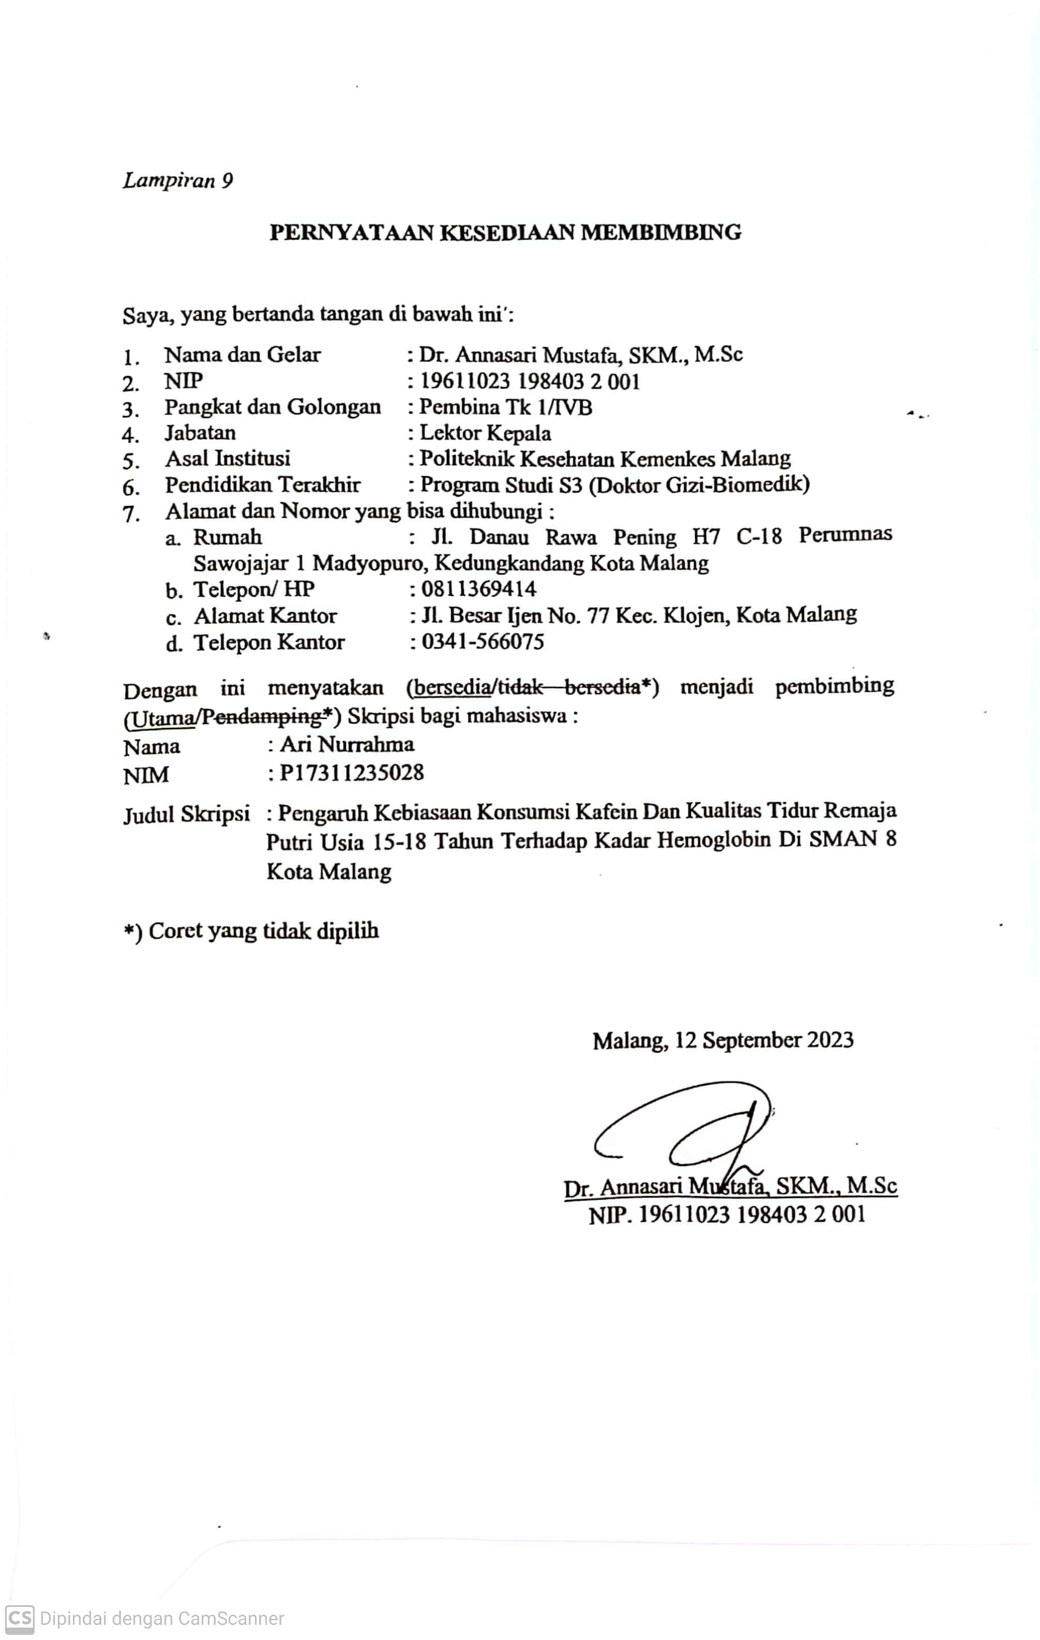

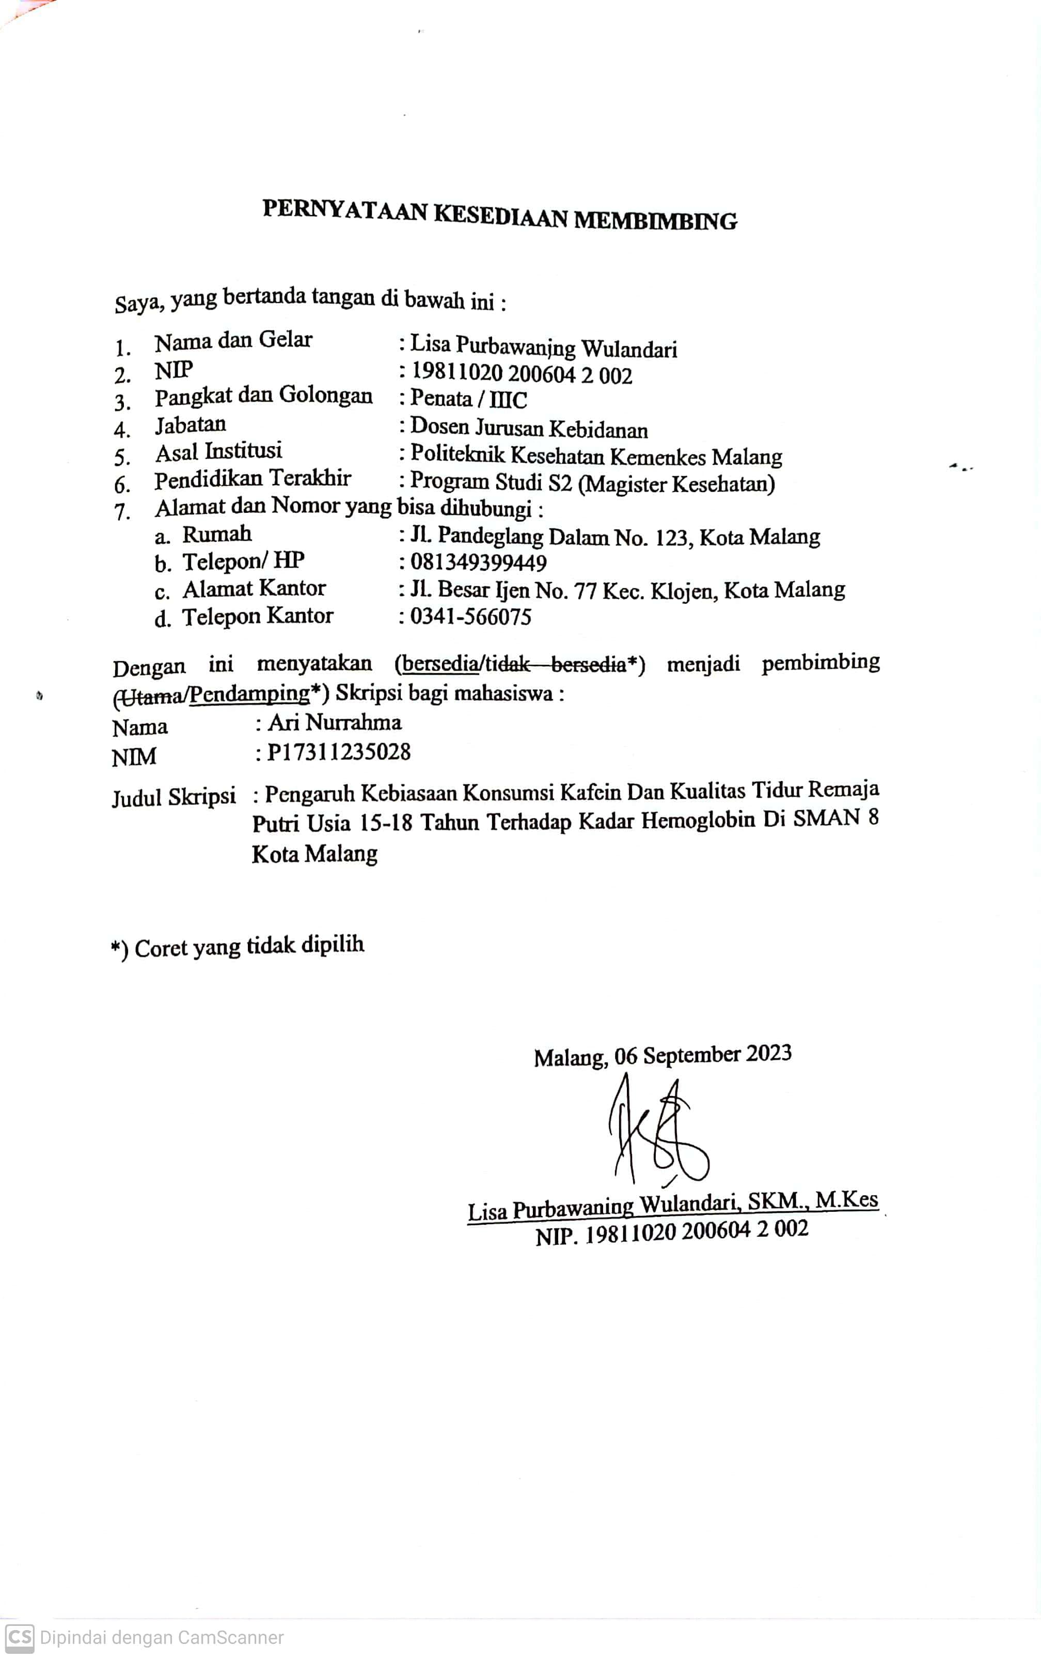

*Lampiran 10*

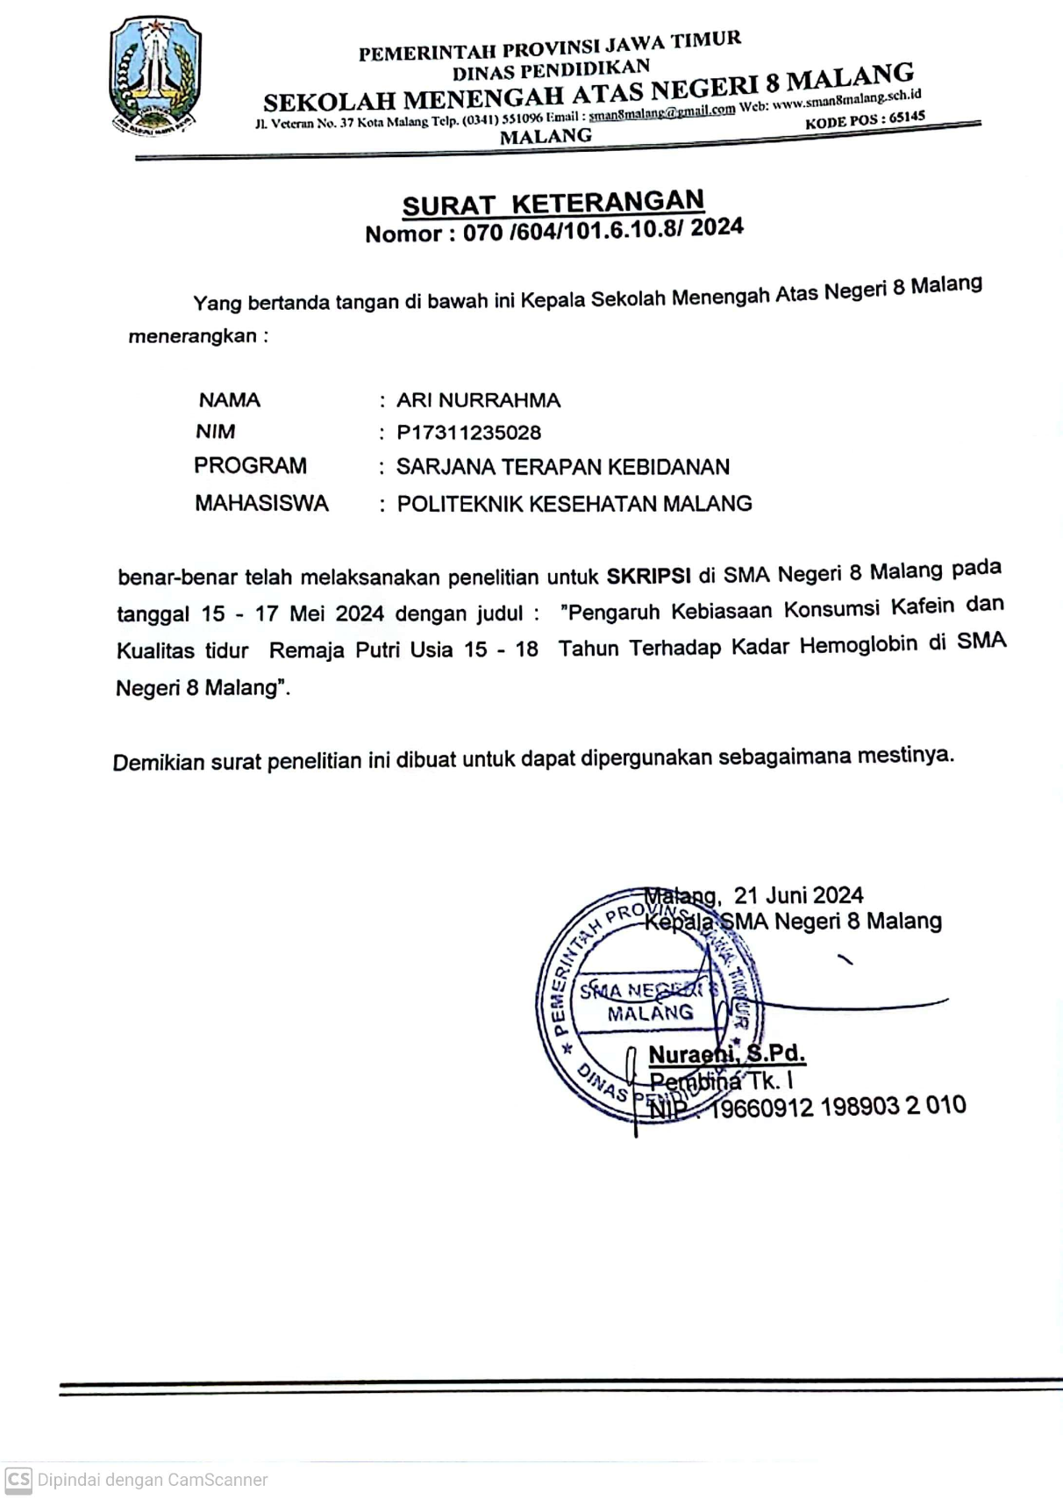**Surat Keterangan Selesai Penelitian**

*Lampiran 11*

**Dokumentasi**

|  |
| --- |
| Keterangan: Penjelasan sebelum Penelitian atau pada gambar ini sebelum dilakukan pemeriksaan kadar Hemoglobin |
| Keterangan: Pengambilan sampel darah untuk pemeriksaan kadar hemoglobin |
| Keterangan: Pengambilan data dengan pengisian kuesioner |

|  |  |
| --- | --- |
|  |  |

